AIR TO WATER HEAT PUMP

Operation manual

V.2308

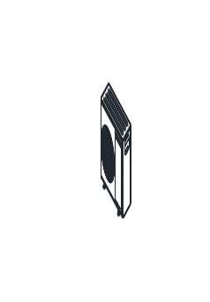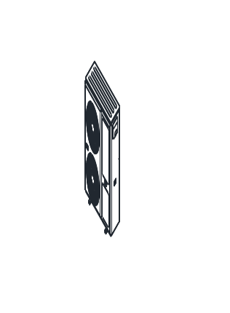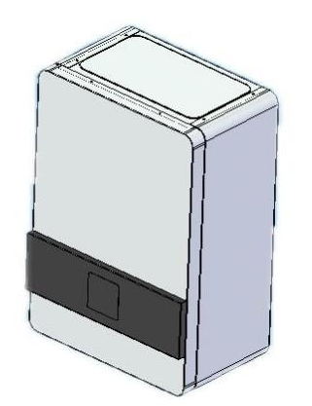
Indoor unit Model:
DSK03-QG
DSKB03-QG

Heat Pump Models:
HS06V-QPNNW
HS08V-QPNNW
HS10V-QPNNW
HS12V-QPNNW
HS12V-DPNNW
HS15V-QPNNW
HS15V-DPNNW

Before operating the system, please read these operating instructions thoroughly and keep them for future reference.



目录
1 Safety Precautions 1
1.1 Intended use 1
1.2 Symbols and Markings 1
1.3 safety instructions 2
1.4 Safety devices 3
1.5 Care and maintenance 4
2 User Guide 6
2.1 Touch screen user interface 6
2.1.1 Display content 6
2.1.2 Setting change operation 7
2.1.3 Setting schedule on/off (space heating/cooling) 7
2.1.4 Copy Schedule from Monday 8
2.1.5 Setting Domestic hot water temperature 9
2.1.6 Setting schedule on/off (DHW) 9
2.1.7 Copy DHW on/off Schedule from Monday 11
2.2 Parameter settings 11
2.2.1 Access Rights 12
2.2.2 User Parameter Table 12
2.3 I/O input/output 13
2.4 Screen brightness and clock setting 15
2.5 Heating compensation curve setting 15
2.6 Cooling compensation curve setting 19
3 Alarms 20
3.1 Alarm query and reset 20
3.1.1View alarms 20
3.1.2 Resetting manual reset alarm 21
3.1.3 Viewing alarm log 21
3.1.4 Auto Reset Alarms 21
3.1.5 Manual Reset Alarms 22
3.2 Alarm code and description 22
4 Electrical schematic diagram 25

1 Safety Precautions

1.1 Intended use
There is a risk of injury or death to the user or others, or of damage to the product and other property in the event of improper use or use for which it is not intended.
The product is the outdoor unit of an air to water heat pump with monoblock design.
The product uses the outdoor air as a heat source and can be used to heat a residential
building and for domestic hot water generation. The air that escapes from the product must
be able to flow out freely, and must not be used for any other purposes.
The outdoor unit is only intended for outdoor installation and the indoor unit is only intended for indoor installation.
The product is intended exclusively for domestic use.

Intended use includes the following:
– observance of the operating instructions included for the product and any other installation components
– compliance with all inspection and maintenance conditions listed in the instructions.
Any other use that is not specified in these instructions, or use beyond that specified in
this document, shall be considered improper use. Any direct commercial or industrial use
is also deemed to be improper.

1.2 Symbols and Markings

Symbol | Importance
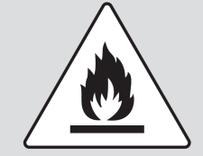 | Warning against flammable substances associated with refrigerant R290
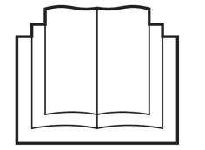 | This symbol indicates that the operating instructions must be read carefully.
 | This symbol indicates that a service staff must handle this equipment with reference to the installation manual.
 | This symbol indicates that information is available, such as the operating manual or installation instructions;.

- The outdoor unit contains easily flammable refrigerant in safety group A3 according to ISO 817 and ANSI/ASHRAE Standard 34. If there is a leak, the escaping refrigerant may form a flammable or explosive atmosphere in the ambient air. A safety zone is defined in the immediate vicinity of the outdoor unit, in which special rules apply when working on the appliance.

1.3 safety instructions
Please follow these safety instructions closely to prevent accidents and material losses。

This appliance can be used by children aged from 8 years and above and persons with reduced physical, sensory or mental capabilities or lack of experience and knowledge if they have been given supervision or instruction concerning use of the appliance in a safe way and understand the hazards involved. Children shall not play with the appliance. Cleaning and user maintenance shall not be made by children without supervision.

The plate heat exchanger, the piping and the hydraulic pump can be damaged by frost, despite the built-in anti-freeze protection of the unit.
In frost prone areas refer to installation location instructions.

To avoid freezing-up of the water contained in the system, one of the precautions must be taken during winter:
- Drain the water from the system, using the drains in the lower part of the unit.
- System separation. With a system separation, an intermediate heat exchanger is installed in the indoor unit. This separates the heating circuit into a primary heating circuit (to the outdoor unit) and a secondary heating circuit (in the building). If the primary heating circuit is filled with a water/frost protection mixture (brine fluid), the outdoor unit is then protected against freezing, even if this is electrically switched off or in the case of a power cut.
- The power to the unit must be on all the time so unit can start circulation pump and auxiliary heater for anti-freeze protection.

Installation and service works of the heat pump should only be done by authorized installer and after sales people.
If the supply cord is damaged, it must be replaced by the manufacturer, its service agent or similarly qualified persons in order to avoid a hazard.
Do not let children to play the heat pump.

Under some conditions, the heat pump will need defrosting. Ice on the evaporator will be melt and a short cloud of condensation from the heat pump will come out. The surface below the heat pump will be wet due to the drained water from evaporator.
Do not attempt to modify, repair or service the appliance yourself.
Do not insert body parts or any other items into the air inlet or air outlet.

Do not start or stop the unit by removing the power cable; always use the controls and switches provided.
Do not operate the unit or controller with wet fingers.
Upon replacement of the fuse, ensure an adequate replacement is used (e.g. not fuse wire).
The electrical supply must be isolated during a heightened risk of lightning strikes.
Do not attempt to move the appliance once installed; this must be carried out by a qualified engineer.
Isolate the electrical supply to the appliance if an odour presents, or scorching is detected.
Only use this appliance for the purpose intended.
Ensure the area around the appliance is clean, well-ventilated and kept free of all obstructions.
Do not keep items on top of the appliance or use it to support other appliances.
Do not under any circumstances stand on the appliance.
Drain the water from the water circuit if power to the unit is to be switched off during very cold weather.
Periodically check the condition of any supports for deterioration.
Do not wash the unit with water, alcohol, benzine, thinners, glass cleaner, polish or powders.
During cleaning, isolate the electrical supply to the appliance.

1.4 Safety devices

Freezing protection function
The unit has freezing protection function with power ON. If the system control fails, the product guarantees limited freezing protection.
At negative outdoor temperatures, there is an increased risk of the unit freezing if a heat pump fault occurs, e.g. due to a power cut or a defective compressor.

Insufficient water flow protection
This function continuously monitors the flow of the heating water. It will stop the compressor and backup heater is there is insufficient flow rate and automatically returns back to work after flow rate returns to normal.

Pump blocking protection
This function prevents the pumps for heating water from sticking. The pumps, which were out of operation for 24 hours, are switched on for a short time, one after the other.

Safety cut-out in the backup heater.
If the temperature in the internal electric back-up heater exceeds the maximum temperature, the safety cut out shuts down the electric back-up heater as a securing measure.

1.5 Care and maintenance

Guaranteeing frost protection
1. If no system separation for guaranteeing the frost protection is present, ensure that the product is switched on and remains switched on.
2. Ensure that no snow accumulates around the air inlet grille and air outlet grille.

Keeping the product clear
1. Regularly remove branches and leaves that have gathered around the product.
2. Regularly remove leaves and dirt from the ventilation grille below the product.
3. Regularly remove snow from the air inlet grille and from the air outlet grille.
4. Regularly remove snow that has gathered around the product.

Cleaning the product
1. Clean the casing with a damp cloth and a little solvent free soap.
2. Do not use sprays, scouring agents, detergents, solvents or cleaning agents that contain chlorine.

Danger!
Risk of injury and risk of material damage due to neglected or incorrect maintenance and repairs.
Neglected or incorrect maintenance work or repairs may lead to personal injury or damage
to the product.

▶ Never attempt to carry out maintenance work or repairs on the product.
▶ Employ an authorised installation company to complete such work. We recommend making a maintenance contract.

Warning
If you need to switch off the power to the appliance, both the heat pump and boiler power must be switched off at the same time. Never leave the boiler on when the heat pump is switched off.

Troubleshooting

Eliminating faults
▶ If you observe a cloud of vapour on the product, you do not have to do anything. This effect may arise during the defrosting process.
▶ If the product will no longer start up, check whether the power supply is interrupted. If required, switch on all of the disconnectors to which the product is connected in the building.
▶ Contact a competent person if the measure that is described is unsuccessful.

Decommissioning
Temporarily decommissioning the product
1. Switch off all of the disconnectors to which the product is connected in the building.
2. Protect the heating installation against frost.
Permanently decommissioning the product
▶ Have a competent person permanently decommission the product.

Recycling and disposal
▶ The competent person who installed your product is responsible for the disposal of the packaging.
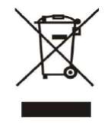
▶ do not dispose of the product with the household waste.
▶ hand in the product to a collection centre for waste electrical or electronic equipment.

Arranging disposal of refrigerant
The product is filled with R290 refrigerant.
▶ Refrigerant must only be disposed of by an authorized competent person.
▶ Observe the general safety information.

2 User Guide

2.1 Touch screen user interface

2.1.1 Display content
A B C

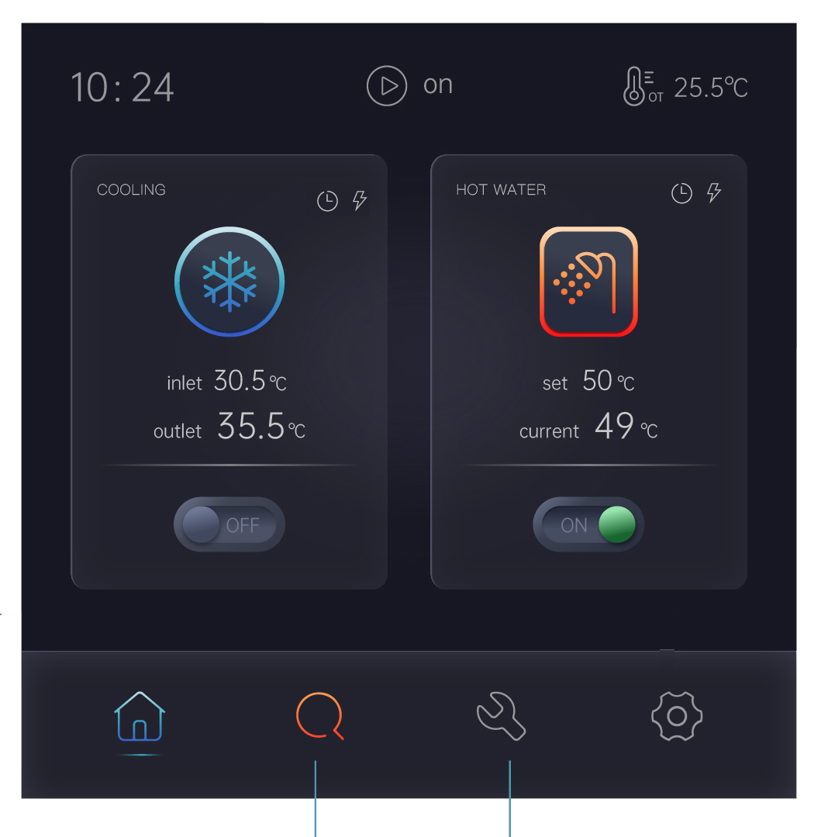
I J K L

D

E

F

G

H

- Heating/cooling schedule and heating auxiliary heater. The icon will appear when the relative function is activated.
- Running status. :defrosting; :off; :on;  standby.
- Ambient temperature
- DHW schedule and DHW electric heater. The icon will appear when the relative function is activated.
- DHW mode. Press the icon to enter DHW temperature setting.
- DHW on/off switch. Press the switch to turn on/off domestic hot water production.
- cooling/heating mode. Press the icon to enter the menu for changing the running mode and the heating/cooling temperature setting
- cooling/heating on/off switch. Press the switch to turn on/off space heating/cooling.
- return to main menu
- check running data
- User, service and manufacturer settings
- screen brightness and clock setting

2.1.2 Setting change operation
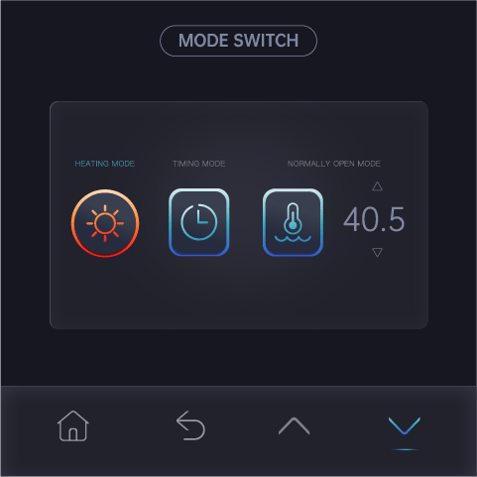
Running mode change operation and heating/cooling temperature adjustment.
Press cooling mode on the main menu,

Press cooling mode again, it display SWITCH TO COOLING MODE, press Confirm to change to heating mode

press the up or down button to adjust the heating/cooling temperature setting.

2.1.3 Setting schedule on/off (space heating/cooling)

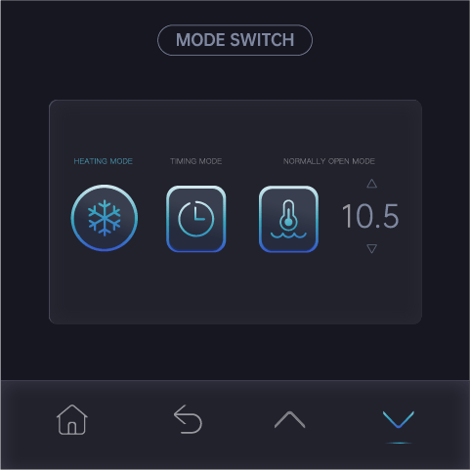

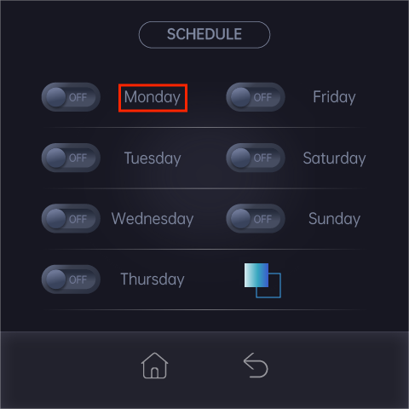

Press the corresponding name to enter below menu.

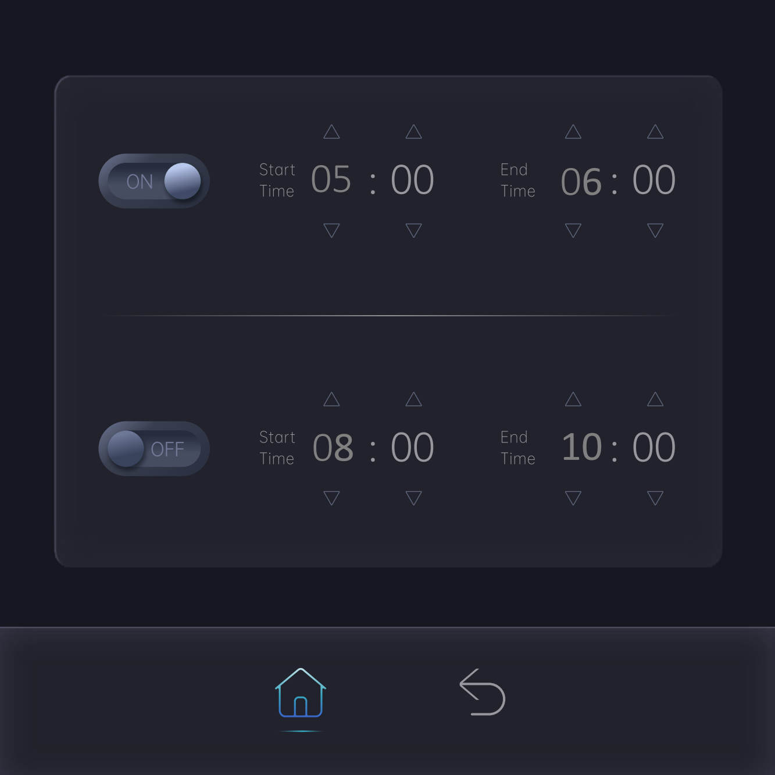

2.1.4 Copy Schedule from Monday
Press  ,
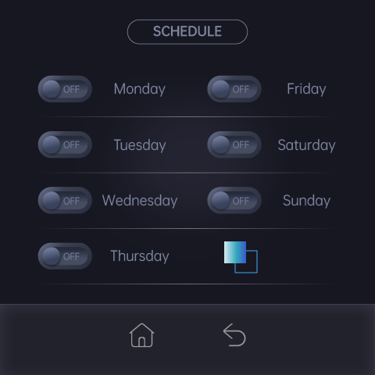

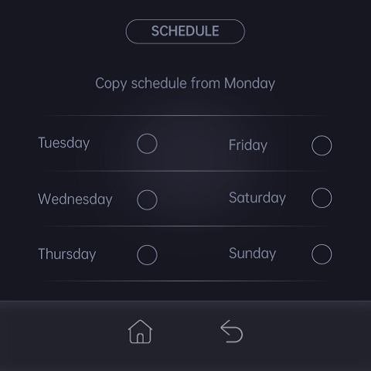

Tick the day that need to copy from Monday, Press  to exit after ticking and the copy is done.

2.1.5 Setting Domestic hot water temperature
Press hot water symbol on main menu,

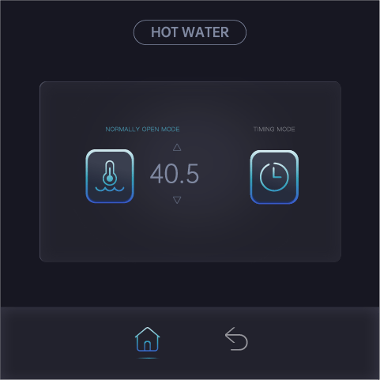
Press or to adjust the Domestic hot water temperature setting.

2.1.6 Setting schedule on/off (DHW)
Press schedule symbol,

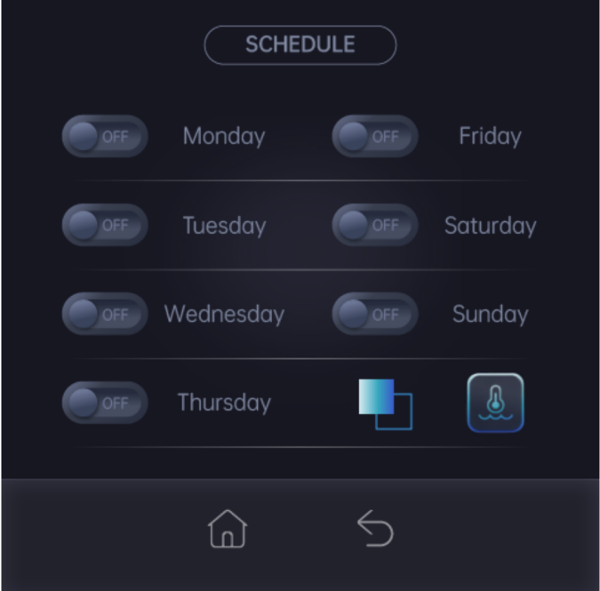

Press <Monday> . Two domestic hot water schedule on/off could be set each day

Press to return to previous menu, press ,

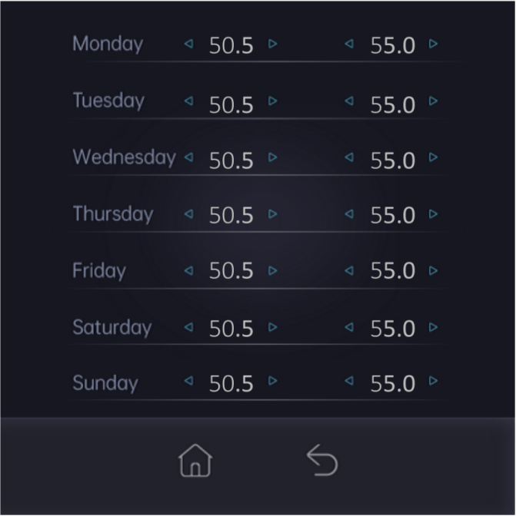

Press or  to adjust each schedule DHW temperature. press to exit

2.1.7 Copy DHW on/off Schedule from Monday

Press ,

Tick the day that need to copy from Monday, Press to exit after ticking and the copy is done.

2.2 Parameter settings

Pressto enter parameter menu:
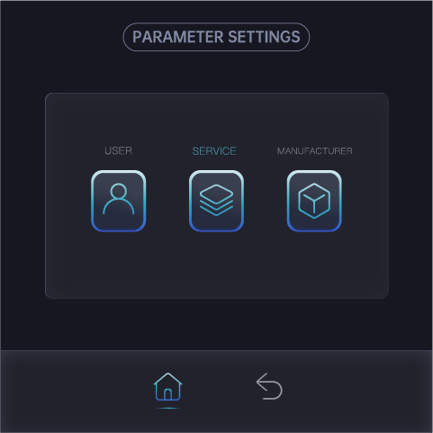

2.2.1 Access Rights

Three groups of users with different privilege levels are described below.

Privilege Level | Main Activities  Special | All
Manufacturer | - Password required  - Configure and commission applications by setting/adjusting parameter values | - View information and status  - Acknowledge warnings and alarms  - Heating /Cooling changeover
Service | - Password required  - Configure and commission applications by setting/adjusting parameter values
User | - No password is required  - Adjust User parameters

2.2.2 User Parameter Table

Descriptions | De- fault | Min. | Max. | Unit | Res
temperature difference Cooling | 2 | 1 | 10 | ºC | 0.1
temperature difference Heating | 2 | 1 | 10 | ºC | 0.1
heating curve factor | 0.6 | 0 | 3 | - | 0.1
Auxiliary electric heater start temp. | 0 | -10 | 20 | ºC | 0.1
cooling curve factor | 0.6 | 0 | 3 | - | 0.1
temperature difference domestic hot water | 3 | 1 | 10 | ºC | 0.1
DHW circulation pump off time | 15 | 0 | 180 | min | 1
DHW circulation pump ON time | 3 | 0 | 180 | min | 1
Weather compensation | No | Yes or No
manual defrosting | No | Yes or No
SG Cooling/heating diff. | 2 | 1 | 10 | ºC | 0.1
SG DHW diff. | 5 | 1 | 10 | ºC | 0.1
Weather compensation is for enable or disable heating curve and cooling curve control. pls refer to weather compensation curve setting chapter
DHW circulation pump
If the DHW circulation pump is installed, DHW circulation pump off time and on time could be set to circulate the DHW from the tank to the tap so there is always hot water when the tap opens.
DHW mode is switched on, DHW circulation pump will be switched on and run as set ON time and then off in set OFF time interval.
If DHW mode is not activated, DHW circulation pump does not run.
Auxiliary back up heater and gas boiler external setup
The space heating internal back up electric heater or gas boiler only could be possible to run when ambient temperature is lower than Auxiliary electric heater start temp. setup.
If the heat pump solely could not meet the heating demand, you could adjust Auxiliary electric heater start temp. setup to switch on auxiliary heater or boiler to activate bivalent mode.
Manual defrost
When there is too humid, heavy frost accumulates on the finned coil heat exchanger, manual defrosting is needed to remove the frost.

Just set manual defrost to ON and it will start to defrost in a few minutes.

2.3 I/O input/output

Press on the main menu
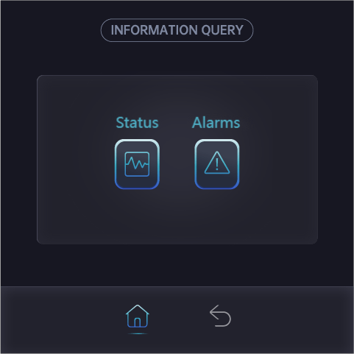

Press Status, it displays the unit measured temperature sensors value, digital switch on/off state, components on/off state.
B1 | RT | inlet water temperature
B2 | ST | outlet water temperature
B3 | OT | Ambient temperature
B8 | ET | Suction gas temperature
B5 | PT | Discharge gas temperature
B6 | LPS | Suction gas pressure
B7 | HPS | Discharge gas pressure
B9 |  | water flow rate
 |  | Evaporation temperature
 |  | Condensation temperature
 |  | Expansion valve 1 step
 |  | Expansion valve 1 super heat
 |  | Compressor running frequency
Y3 |  | Pump PWM out
Y1 |  | Fan speed voltage signal
 |  | Compressor operating hours
 |  | Actual control temperature
 |  | Expansion valve 2 step
 |  | Expansion valve 2 super heat
 |  | Compressor frequency order
 |  | IPM temperature
 |  | Compressor
NO2 |  | Circulation pump
 |  | Fan motor
DI5 |  | DI5 HW switch
DI4 |  | DI4 heating/cooling switch
NO3 |  | Four way valve
NO4 |  | Auxiliary electric heater
NO5 |  | Crankcase heater
NO1 |  | DHW circulation pump
NO7 |  | Three way valve
NO8 |  | DHW electric heater
NO6 |  | De-icing heater
 |  | EVI solenoid valve
DI6 |  | DI6 SG1
DI7 |  | DI7 SG2
DI1 |  | Flow switch
 |  | produced heat
 |  | energy consumption

2.4 Screen brightness and clock setting
Press  on main screen,

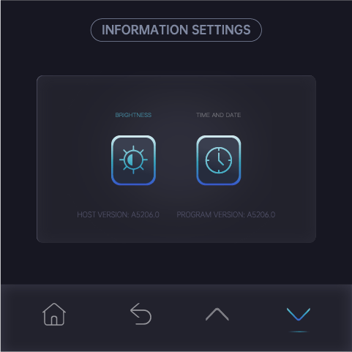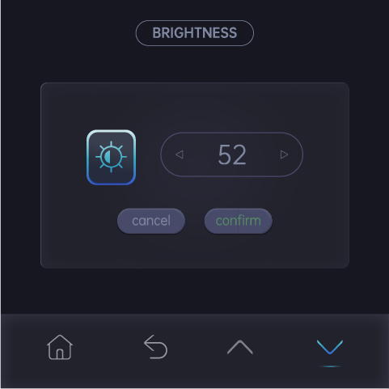

Press or to adjust the brightness of screen.

Press <clock>
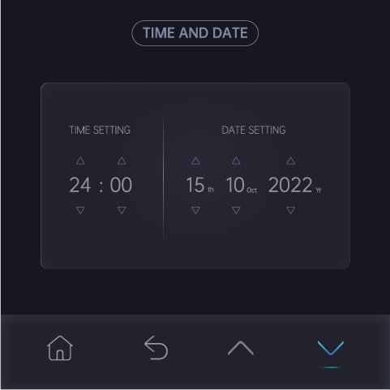

Press or to adjust the time and date.

2.5 Heating compensation curve setting
The control temperature for heating and cooling mode has two methods: fixed and changeable temperature. The fixed temperature is a fixed value and directly set by the user from the set area. The changeable temperature is determined by values of ST01 cooling setpoint, ST02 heating setpoint, ST06 heating curve factor and the actual outdoor temperature measured by the OT sensor probe.
This function could be turned on/off on user menu: weather compensation

Set temperature at heating =ST02+ST06 *(20-OT).
●ST02 is indoor temperature that the user feels comfortable
●ST06 is the heating compensation coefficient curve factor you select for the heat pump to work with. Increasing ST06 will increase compensation temperature and RT will increase relatively.
●OT is the outside temperature.
The calculated temperature can be used for the control reference, but the maximum data will not exceed ST14 ( max. heating setpoint).

For example:
Set the heating compensation coefficient ST06 =0.5, ST02=20
1.) When outdoor temperature is 0℃, the control temperature is ST02+ST06*(20 - OT) =20+0.5*(20-0)=30℃;
2.) When outdoor temperature is -10℃, the control temperature is
ST02+ST06*(20-OT)=20+0.5*(20-(-10))=35℃;
3.) When outdoor temperature is –20℃, the control temperature is
ST02+ST06*(20-OT)=20+0.5*(20-(-20))=40℃;
Calculated result as above could be checked from curve below.
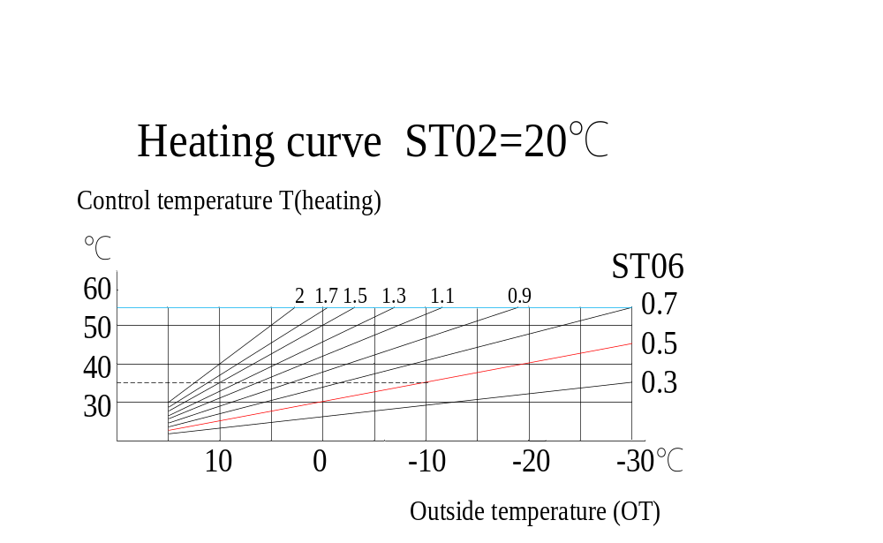
With the drop of the outdoor temperature, the control temperature become higher and higher to meet the large heating requirement.
With the increase of the outdoor temperature, the control temperature become lower and lower, so that the heat pump works under low pressure to keep low energy consumption.
Changing ST02 or ST06 could change the heating curve.
Increase ST02 will lift up the curve
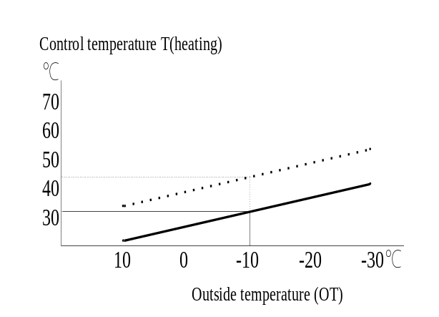

Increase ST06 will increase the grade of the curve
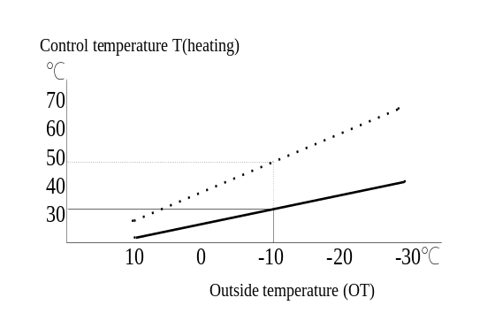
The calculated control water temperature will not be over ST14，will not be lower than ST13 (min. heating set point, default 20).
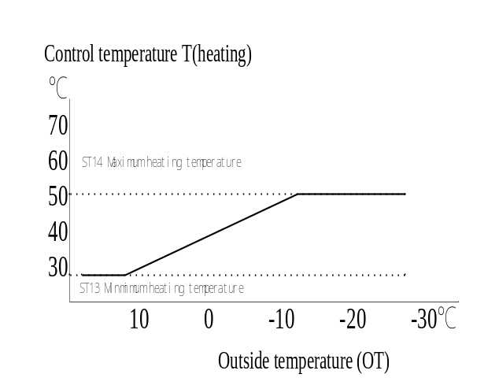
Cold weather conditions
●When the room temperature is too low, you could increase ST06.
●When the room temperature is too high, you could decrease ST06.

Warm weather conditions
●If the room temperature is too low, you could increase ST02.
●If the room temperature is too high, you could decrease ST02.


The temp. of the room with floor heating need a long time to stabilize. After a ST02 ST06 adjustment, Please wait 24 hours before you take another adjustment again.
The heating curve setting
Just adjust heating set point ST02 and heating curve factor ST06 to set up the heating curve.

- Press on the main screen,

- Press user to enter user parameter menu, adjust ST06 heating curve factor.
- Scroll to main menu, press heating symbol to enter heating set point adjustment menu to adjust heating set point ST02.

- Scroll to main menu ,Press on the main screen,

Press Status, it displays the unit measured temperature sensors value, digital switch on/off state, components on/off state. Find the Actual control temperature under present ambient temperature on this menu. This is the calculation result of heating curve setup and the actual control inlet water temperature setup under present ambient temperature.

2.6 Cooling compensation curve setting
Just adjust ST01 cooling set point and ST08 cooling curve factor and then check actual control temperature under current ambient temperature on I/O input output menu.
Set temperature at cooling =ST01+（35-OT）xST08.
The calculated control water temperature will be be limited by ST11 (min. cooling setpoint, default 12) and ST12 (max.cooling setpoint ,default 30).

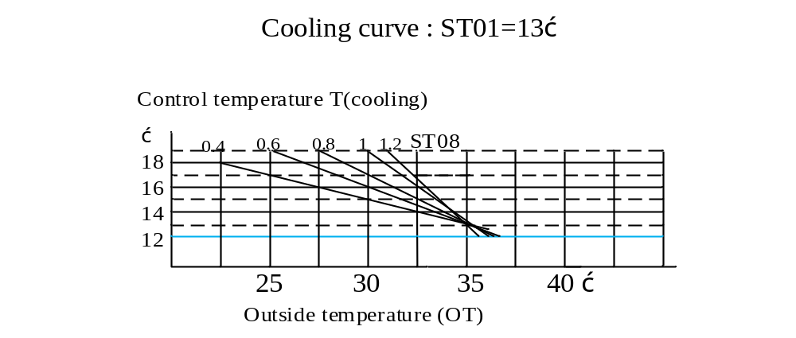

3 Alarms

3.1 Alarm query and reset
The alarms are divided into two groups: auto reset alarms and manual reset alarms.
- Auto reset alarm, the user is not required to acknowledge and reset it.
- The unit will automatically restart once the alarm status disappears.
- Once a manual reset alarm is detected, the system will stop automatically. The user needs to record and contact the supplier on actions what to do.
When an alarm is detected, the icon will continuously flash.

3.1.1View alarms
Press on the main menu
Press <alarms>, it displays current alarm code if the alarm is active.

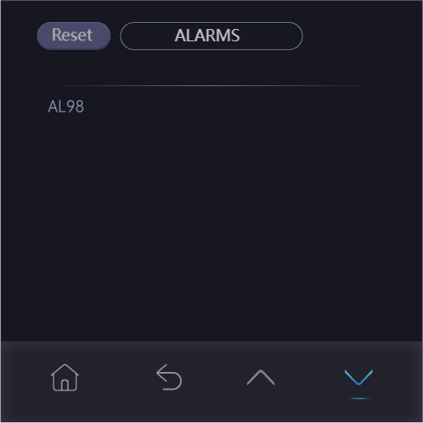

3.1.2 Resetting manual reset alarm
Press <reset>to reset the manual reset alarm if the alarm cause has been removed.

3.1.3 Viewing alarm log
Press ,

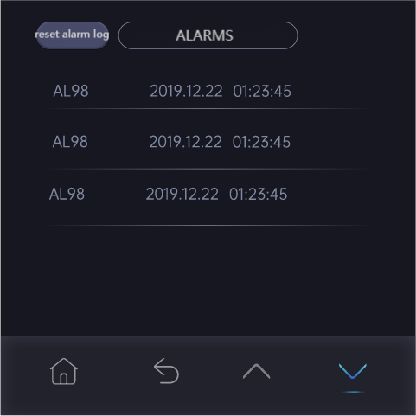

Alarm logs could be cleaned by pressing <reset alarm log>.

3.1.4 Auto Reset Alarms
The following are codes for auto reset alarms with their meanings.
Codes | Meaning
AL01 | Low pressure
AL02 | High pressure
AL03 | Low outlet water temperature (ST<AR01 default 5.5)
AL05 | High outlet water temperature (ST>AR03 default 72)
AL17 | Water flow is short
WN01 | Antifreeze
AL20 | Low evaporation temperature (only cooling mode)
AL21 | High discharge gas temperature
AL57 | inverter offline
AL30 | Touch screen and main board communication trouble.
AL79 | water pump fault

Alarms relating to inverter board (auto reset)
AL100 | IPM overcurrent
AL101 | comp. drive failure
AL102 | comp. overcurrent
AL103 | power phase loss
AL104 | IPM current sampling error
AL105 | radiator overheat
AL106 | pre-charging failure
AL107 | DC bus overvoltage
AL108 | DC bus under voltage
AL109 | AC input under voltage
AL110 | AC input overcurrent
AL111 | voltage sampling error
AL112 | Fan motor 1 fault
AL113 | temp. sensor error
AL114 | Fan motor 2 fault
AL115 | communication fault
AL116 | IPM module overheat
AL117 | Fan motor 1 fault

3.1.5 Manual Reset Alarms
The following are codes for manual reset alarms with their meanings.
Codes | Meaning
AL18 | Low pressure alarms times within 24 hours is over the limit
AL19 | High pressure alarms times within 24 hours is over the limit
AL31 | Low evaporation temperature alarm times within 24 hours is over the limit

3.2 Alarm code and description
1.) Low pressure protection (Code: AL01)
After starting the compressor, it checks the low pressure after AR09 delay. If LPS≤AR31 in continual 120 seconds, then compressor is switched off, 5 seconds later, fan motor is switched off, other parts keep their original state. Alarm code AL01 display on the touch screen. After LPS≥AR31+AR32 in continual 10 seconds, the unit returns to normal operation.

2.) High pressure protection (Code: AL02)
It does not trigger high pressure protection on defrosting process and within 10 seconds after end of defrosting .
At other time if HPS≥AR33 in continual 5 seconds , the compressor is switched off ,after 5 seconds' delay, the fan motor is switched off, other parts keep their original state. Alarm code AL02 display on the touch screen. After HPS≤AR33-AR34, the unit re turns to normal operation.
3.) Low pressure protection (serious) (Code: AL18)
In 24 hours' time, if AL01 is triggered over AR06 times, manual reset alarm AL18 is triggered,
then compressor is switched off, 5 seconds later, fan motor is switched off, other parts keep their original state. Alarm code AL18 display on the touch screen.
4.) High pressure protection (serious) (Code: AL19)
In 24 hours’ time, if AL02 is trigger over AR07 times, manual reset alarm AL19 is triggered,
the compressor is switched off, 5 seconds later, fan motor is switched off, other parts keep their original state. Alarm code AL19 displays on the touch screen.
5.) Water flow protection (Code: AL17)
A.) AR04 time delay after circulation pump is switched on and circulation pump PWM output is 100% in continual 5 seconds, if feedbacked pump flow is lower than EV06*0.8 in continual 5 seconds, AL17 alarm is triggered.
B.) On the running process, when pump PWM output is 100% , if feedbacked pump flow is lower than EV06*0.8 in continual 5 seconds, AL17 alarm is triggered.
the compressor is switched off, 5 seconds later, fan motor is switched off, other parts keep their original state. Alarm code AL17 displays on the touch screen. Unit could returns to normal operation if feedbacked pump flow is over EV06 in continual 5 seconds.
6.) Indoor circuit anti-freezing protection (code：WN01）
1.) If pump has been switched off over AR29 time and OT<SF06, pump is switched on and runs with PWM 100%. 180 seconds later, if RT>AR01, pump is switched off. If RT<AR01, WN01 warning is triggered and unit is switched on to run on heating mode until RT＞20℃ ,then warning is reset.
2.) If RT sensor is faulted, ST is used instead of RT for anti-freezing protection water temperature reference. If ST sensor is faulted too when OT<SF06, pump runs continually with PWM 100% .
7.) High discharge gas temperature protection（code：AL21）
If Discharge gas temperature PT>AR13 in continual 5 seconds, high Discharge gas temperature protection alarm AL21 is triggered,
the compressor is switched off, 5 seconds later, fan motor is switched off, other parts keep their original state. Alarm code AL21 displays on the touch screen.
It will recover to normal operation if PT<AR13-AR14 in continual 5 seconds.
8.) Low evaporation temperature protection (Code: AL20)
The protection function will be valid on COOLING mode .AL20 low evaporation temperature protection is triggered when condition below is met:
1.) LPS ≤AR08 in continual 60 seconds；
2.)LPS≤AR08-2 in continual 40 seconds；
3.)LPS≤AR08-4 in continual 10 seconds；
4.)outlet water temp. < 8℃
the compressor is switched off, 5 seconds later, fan motor is switched off, other parts keep their original state. Alarm code AL20 displays on the touch screen. It will recover to normal operation 5 minutes later.

9.) Low evaporation temperature protection (serious) (Code: AL31)
In 24 hours’ time, if AL20 is trigger over AR16 times, manual reset alarm AL31 is triggered,
the compressor is switched off, 5 seconds later, fan motor is switched off, other parts keep their original state. Alarm code AL31 displays on the touch screen.
10.) Low outlet water temperature protection (Code: AL03)
If ST≤AR01 and LPS < 0℃ in continual 5 seconds, the compressor is switched off ,after 5 seconds' delay, the fan motor is switched off, water pump runs with PWM 100%, other parts keep their original state. Alarm code AL03 displays on the touch screen. It records the instant inlet water temperature RT1 when unit just stops and returns to normal working after inlet water temperature RT≥RT1+ ST03.
11.) High outlet water temperature protection (Code: AL05)
If ST≥AR03 in continual 5 seconds, the compressor is switched off , after 5 seconds delay, the fan motor is switched off, water pump runs with PWM 100% ,other parts keep their original state. Alarm code AL05 display on touch screen. It records instant inlet water temperature RT2 when unit just stops and returns to normal working after inlet water temperature RT≤RT2-ST04.
12.) Display offline - Touch screen and main board communication trouble.
After this trouble happen, unit still can work normally but the touch screen can not be used to operate the unit.
13.) Temperature Sensor fault (B1-B8 fault is auto reset)
If the temperature sensor is below -35C or higher than 120C , sensor fault is triggered.

sensor | code | Unit's action to deal with the fault
B1  (RT) | AL71 | ST replaces RT as temperature control reference. control water temperature +5C on heating mode, -5C on cooling mode. If ST sensor faulted too, unit is switched off.
B2  (ST) | AL72 | Cooling mode is invalid  Heating and DHW mode is valid ,no high outlet water temperature protection and pump PWM = 100%.
B3  (OT) | AL73 | T(heating)=ST02  Aux. electric backup heater, crankcase heater and anti-freezing function etc works without OT condition limitation.
B4  (HT) | AL74 | Hot water mode is invalid. Alarm code does not display if SF05=0.
B5  (PT) | AL75 | Switch off the unit
B6 (LPS) | AL37 | Switch off the unit
B7 (HPS) | AL38 | Switch off the unit
B8  (ET) | AL76 | Relative function is canceled.

4 Electrical schematic diagram

