AIR TO WATER HEAT PUMP

installation &maintenance manual

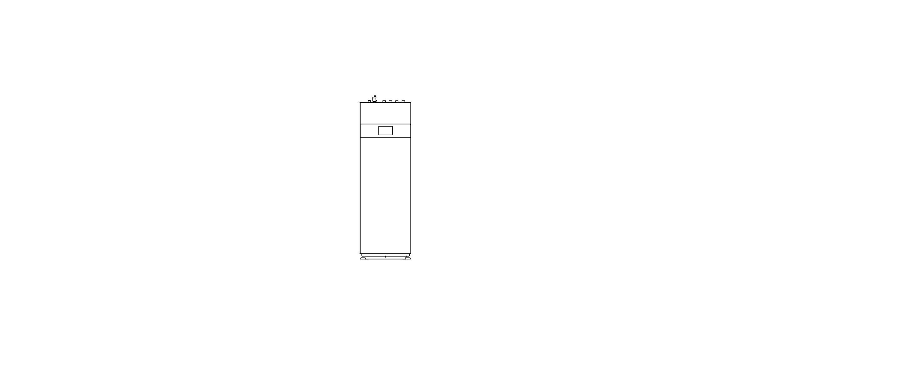
V.2503-LS



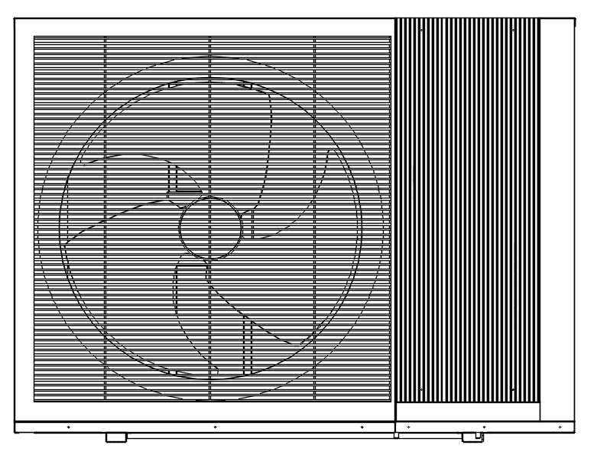

Hydraulic Station Models:
DSK06-DPVTSG
Hydraulic Tower Models:
DSK06-DPVTSL200

Heat Pump Models:

HSL08V-DNANW
HSL10V-DNANW
HSL12V-DNANW
HSL15V-DNANW

The outdoor units could be combined with control box, Hydraulic station and tower.
Pls refer to the relative indoor unit information chapter as per your purchase.
Before operating the system, please read these operating instructions thoroughly and keep them for future reference.



Index

1 Safety Precautions 1
1.1 Intended use 1
1.2 Symbols and Markings 1
1.3 safety instructions 2
1.4 Security measures 3
1.5 Work on the refrigerant circuit 4
1.6 Emergency measures 6
1.7 Safety zone 7
1.8 Safety devices 8
1.8.1 Freezing protection function 8
1.8.2 Insufficient water flow protection 8
1.8.3 Pump blocking protection 8
1.8.4 Safety cut-out in the backup heater 9
1.9 Working principle 9
1.10 Care and maintenance 10
1.11 Safety qualification confirmation 11
2 Product Information Description 13
2.1 Refrigerant circuit diagram 13
2.2 Components 14
2.2.1 Outdoor unit 14
2.2.2 Indoor unit components 15
2.3 Dimensions 17
2.4 Water Pressure Plots 18
2.5 Pump Curve 18
2.6 Operating range 19
2.7 Heat pump outdoor unit and indoor unit specification 20
3 Pre-Installation 22
3.1 Movement and Storage 22
3.2 Installation Location 23
3.3 Outdoor unit setup 25
3.4 Connect drainage pipe 26
3.5 Steps to open the cabinet 27
3.6 Control box installation 30
3.7 Hydraulic station installation 31
3.7.1 Hydraulics installation 33
3.7.2 Expansion tank 34
3.8 Hydraulic tower installation 35
3.8.1 Hydraulics installation 37
3.8.2 Expansion tank 38
3.8.3 Domestic Hot Water Tank Pipework 38
3.8.4 Drain water pipe installation 38
3.9 Hydraulic installation notice 38
4 Systems Overview 39
4.1 Hydraulic station 39
4.2 Hydraulic tower 41
4.3 Control box 42
4.4 System Overview : Heating, Cooling with DHW Production 43
5 Electrical Connections 45
5.1 Terminal diagram 45
5.2 Recommended power cables and fuse 49
5.2.1 For heat pump outdoor units: 49
5.2.2 For hydraulic station: 50
5.2.3 For hydraulic tower: 50
5.3 Power Connection 50
5.3.1 DHW temperature sensor 52
5.3.2 DHW circulation Pump Connection 52
5.3.3 Boiler 53
5.3.4 DHW heater 53
5.3.5 Modbus communication connection (10-11) potential free 54
5.3.6 Indoor and outdoor unit communication connection (A- B) 54
5.3.7 AC switch 54
5.3.8 Mode output (4-5) 230VAC 54
5.3.9 SG READY -Smart Grid 55
5.3.10 AC heater – only for control box 56
5.3.11 three way valve – only for control box 56
5.3.12 Secondary pump – only for control box 56
5.3.13 Primary pump – only for control box 56
5.3.14 Mode input 56
6 System program information 57
6.1 Unit operation logic 57
6.1.1 Cooling demand 57
6.1.2 Heating demand 57
6.1.3Domestic hot water demand 58
6.2 Control process 58
6.2.1 Turn on process on heating mode 58
6.2.2 Turn off process on heating mode 58
6.2.3 Turn on process on cooling mode 58
6.2.4 Turn off process on cooling mode 58
6.2.5 Turn on process on hot water mode 58
6.2.6 Turn off process on hot water mode 59
6.2.7 Hot water priority: 59
6.2.8 Water pump control 59
6.2.9 Compressor running control 59
6.2.10 4 way valve control 59
6.2.11 Auxiliary Electric backup heater control 60
6.2.12 Crankcase heater running control 60
6.2.13 3 way valve control 60
6.2.14 DHW circulation pump control 60
6.2.15 DHW electric heater control 60
6.2.16 De-icing heater running control 61
6.2.17 Defrosting control 61
6.2.18 Automatic optimizing defrosting parameter data 62
6.3 System parameter list 62
7 Information on servicing 65
7.1 Security check 65
7.2 Device maintenance 67
7.2.1 Repairs to sealed components 67
7.2.2 Repair to intrinsically safe components 67
7.2.3 Cabling 67
7.2.4 Detection of flammable refrigerants 67
7.2.5 Leak detection methods 68
7.2.6 Removal and evacuation 68
7.2.7 Charging procedures 68
7.2.8 Decommissioning 69
7.2.9 Labelling 69
7.2.10 Recovery 70
8 Commissioning and Adjusting 70
9 Inspection and maintenance work 71
10 Commissioning Form 73
11 Maintenance 74
11.1 Exterior Maintenance 74
11.2 Unit Refrigerant Checks 74
11.3 Verify the Alarm Status 75
11.4 Electrical Maintenance 75
11.5 Mechanical Maintenance 75
11.6 Evaporator Coil 75
11.7 Water Circuit Checks 76
12 Temperature and sensor resistance table 78
13 Disposal and Recycling 84
14 Nameplate information 85
15 Electrical schematic diagram 88

1 Safety Precautions

1.1 Intended use
There is a risk of injury or death to the user or others, or of damage to the product and other property in the event of improper use or use for which it is not intended.
The product is the outdoor unit of an air to water heat pump with monoblock design.
The product uses the outdoor air as a heat source and can be used to heat a residential
building and for domestic hot water generation. The air that escapes from the product must be able to flow out freely, and must not be used for any other purposes.
The product is only intended for outdoor installation.
The product is intended exclusively for domestic use.

Intended use includes the following:
– observance of the operating instructions included for the product and any other installation components
– compliance with all inspection and maintenance conditions listed in the instructions.
Any other use that is not specified in these instructions, or use beyond that specified in
this document, shall be considered improper use. Any direct commercial or industrial use
is also deemed to be improper.

1.2 Symbols and Markings

Symbol | Importance
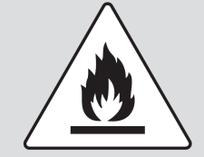 | Warning against flammable substances associated with refrigerant R290
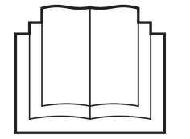 | This symbol indicates that the operating instructions must be read carefully.
 | This symbol indicates that a service staff must handle this equipment with reference to the installation manual.
 | This symbol indicates that information is available, such as the operating manual or installation instructions;

The outdoor unit contains easily flammable refrigerant in safety group A3 according to ISO 817 and ANSI/ASHRAE Standard 34. If there is a leak, the escaping refrigerant may form a flammable or explosive atmosphere in the ambient air. A safety zone is defined in the immediate vicinity of the outdoor unit, in which special rules apply when working on the appliance.

1.3 safety instructions

Please follow these safety instructions closely to prevent accidents and material losses。

This appliance can be used by children aged from 8 years and above and persons with reduced physical, sensory or mental capabilities or lack of experience and knowledge if they have been given supervision or instruction concerning use of the appliance in a safe way and understand the hazards involved. Children shall not play with the appliance. Cleaning and user maintenance shall not be made by children without supervision.

The plate heat exchanger, the piping and the hydraulic pump can be damaged by frost, despite the built-in anti-freeze protection of the unit.
In frost prone areas refer to installation location instructions.

To avoid freezing-up of the water contained in the system, one of the precautions must be taken during winter:
Drain the water from the system, using the drains in the lower part of the unit.
System separation. With a system separation, an intermediate heat exchanger is installed in the indoor unit. This separates the heating circuit into a primary heating circuit (to the outdoor unit) and a secondary heating circuit (in the building). If the primary heating circuit is filled with a water/frost protection mixture (brine fluid), the outdoor unit is then protected against freezing, even if this is electrically switched off or in the case of a power cut.
The power to the unit must be on all the time so unit can start circulation pump and auxiliary heater for anti-freeze protection.

Installation and service works of the heat pump should only be done by authorized installer and after sales people.
If the supply cord is damaged, it must be replaced by the manufacturer, its service agent or similarly qualified persons in order to avoid a hazard.
Do not let children to play the heat pump.

Under some conditions, the heat pump will need defrosting. Ice on the evaporator will be melt and a short cloud of condensation from the heat pump will come out. The surface below the heat pump will be wet due to the drained water from evaporator.
Do not attempt to modify, repair or service the appliance yourself.
Do not insert body parts or any other items into the air inlet or air outlet.

Do not start or stop the unit by removing the power cable; always use the controls and switches provided.
Do not operate the unit or controller with wet fingers.
Upon replacement of the fuse, ensure an adequate replacement is used (e.g. not fuse wire).
The electrical supply must be isolated during a heightened risk of lightning strikes.
Do not attempt to move the appliance once installed; this must be carried out by a qualified engineer.
Isolate the electrical supply to the appliance if an odour presents, or scorching is detected.
Only use this appliance for the purpose intended.
Ensure the area around the appliance is clean, well-ventilated and kept free of all obstructions.
Do not keep items on top of the appliance or use it to support other appliances.
Do not under any circumstances stand on the appliance.
Drain the water from the water circuit if power to the unit is to be switched off during very cold weather.
Periodically check the condition of any supports for deterioration.
Do not wash the unit with water, alcohol, benzine, thinners, glass cleaner, polish or powders.
During cleaning, isolate the electrical supply to the appliance.

Risk of explosion!!!

1.4 Security measures

Take the following measures to prevent fire and explosion in the safety zone:
■ Keep ignition sources away, e.g. naked flames, hot surfaces, electrical devices not free of ignition sources, mobile devices with integrated batteries (e.g. mobile phones, fitness watches, etc.).
■ Permissible tools:
All tools for working in the safety zone must be designed and explosion protected in accordance with the applicable standards and regulations for refrigerant in safety groups A2L and A3, e.g. brushless machines (cordless screwdrivers), extraction equipment, disposal containers, installation aids, vacuum pumps, conductive hoses, mechanical tools of non-sparking material, etc.
Note:
The tools must also be suitable for the pressure ranges in use.
Tools must be in perfect maintenance condition.
■ The electrical equipment must meet the requirements for areas at risk of explosion, zone 2.
■ Do not use flammable materials, e.g. sprays or other flammable gases.
■ Discharge static: Before beginning work, touch earthed objects, such as heating or water pipes.
■ Do not remove, block or bridge safety equipment.
■ Do not make any changes:

Do not modify the outdoor unit, inlet/ outlet lines, electrical connections/cables or the surroundings. Do not remove any components or seals.

• Work on the refrigerant circuit with flammable refrigerant in safety group A3 may only be carried out by authorised heating contractors. These heating contractors must be trained in accordance with EN 378 Part 4 or IEC 60335-2-40, Section HH. The certificate of competence from an industry accredited body.

• Strict compliance of the domestic laws must be observed when disposing the appliance.
• Do not use means to accelerate the defrosting process or to clean, other than those recommended by the manufacturer.
• The appliance shall be stored in a room without continuously operating ignition sources (for example: open flames, an operating gas appliance or an operating electric heater.)
• Do not pierce or burn.
• Be aware that refrigerants may not contain an odour.
• Spaces where refrigerant pipes shall be compliance with national gas regulations.
• Servicing shall be performed only as recommended by the manufacturer.
• The appliance shall be stored in a well-ventilated area where the room size corresponds to the room area as specified for operation.
• All working procedure that affects safety means shall only be carried by competent persons.
• The staff in servicing operations must hold the national qualification or other relevant qualifications.
The maximum number of pieces of equipment permitted to be stored together will be determined by local regulations.
• During tests, NEVER pressurize the product with a pressure higher than the maximum allowable pressure (as indicated on the nameplate of the unit).

1.5 Work on the refrigerant circuit
R290 refrigerant (propane) is an air displacing, colourless, flammable, odourless gas which forms explosive mixtures with air.
Refrigerant drained must be properly disposed of by authorised contractors.

Perform the following measures before beginning work on the refrigerant circuit:
■ Check the refrigerant circuit for leaks.
■ Ensure very good ventilation especially in the floor area and sustain this for the duration of the work.
■ Secure the area surrounding the work area.
■ Inform the following persons of the type of work to be carried out:
– All maintenance personnel
– All persons in the vicinity of the system.
■ Inspect the area immediately around the heat pump for flammable materials and ignition sources: Remove all flammable materials and ignition sources.
■ Before, during and after the work, check the surrounding area for escaping refrigerant using an explosion-proof refrigerant detector suitable for R290. This refrigerant detector must not generate any sparks and must be suitably sealed.
A CO2 or powder extinguisher must be to hand in the following cases:
– Refrigerant is being drained.
– Refrigerant is being topped up.
– Soldering or welding work is being carried out.
■ Display signs prohibiting smoking.

Escaping refrigerant can lead to fire and explosions that result in very serious injuries or death.
■ Do not drill or apply heat to a refrigerant circuit filled with refrigerant.
■ Do not operate Schrader valves unless a fill valve or extraction equipment is attached.
■ Take measures to prevent electrostatic charge.
■ No smoking! Prevent naked flames and sparks. Never switch lights or electrical appliances on or off.
■ Components that contain or contained refrigerant must be labelled, and stored and transported in well ventilated areas in accordance with the applicable regulations and standards.
DANGER: RISK OF EXPLOSION
• Pump down – Refrigerant leakage. If you want to pump down the system, and there is a leakage in the refrigerant circuit:
▪ Do NOT use the unit's automatic pump down function, with which you can collect all refrigerant from the system into the outdoor unit. Possible consequence: Self-combustion and explosion of the compressor because of air going into the operating compressor.
▪ Use a separate recovery system so that the unit's compressor does NOT have to operate.
▪ To avoid compressor breakdown, do NOT charge more than the specified amount of refrigerant.
▪ When the refrigerant system is to be opened, refrigerant MUST be treated according to the applicable legislation.
▪Make sure there is no oxygen in the system. Refrigerant may only be charged after performing the leak test and the vacuum drying.
▪Only use tools exclusively for the refrigerant type used in the system, this to ensure pressure resistance and prevent foreign materials from entering into the system.
▪Do NOT touch the air inlet or aluminum fins of the unit
▪Do NOT place any objects or equipment on top of the unit.
▪ Do NOT sit, climb or stand on the unit.
▪Make sure the field piping and connections are NOT subjected to stress
▪In case recharge is required, see the nameplate of the unit. It states the type of refrigerant and necessary amount.

1.6 Emergency measures

What to do if refrigerant escapes
Danger
Escaping refrigerant can lead to fire and explosions that result in very serious injuries or death. There is a risk of asphyxiation if it is breathed in.

■ Ensure very good ventilation especially in the floor area of the outdoor unit.
■ No smoking! Prevent naked flames and sparks. Never switch lights or electrical appliances on or off.
■ Evacuate any people from the danger zone.
■ From a safe position, switch off the electricity supply for all system components.
■ Remove ignition sources from the danger zone.
■ Let the system user know that no ignition source may be brought into the danger zone for the duration of the repair.
■ Repair work must be carried out by an authorised contractor.
■ Only recommission the system after it has been repaired.

Danger
Direct contact with liquid and gaseous refrigerant can cause serious damage to health, e.g. frostbite and/or burns. There is a risk of asphyxiation if it is breathed in.

■ Prevent direct contact with liquid and gaseous refrigerant.
■ Never breathe in refrigerant vapours.
Safety instructions for storage of the outdoor unit
The outdoor unit is charged at the factory with refrigerant R290 (propane).
Danger
Escaping refrigerant can lead to fire and explosions that result in very serious injuries or death. There is a risk of asphyxiation if it is breathed in.

Store the outdoor unit in the following conditions:
■ An explosion prevention plan must be in place for storage.
■ Ensure there is sufficient ventilation at the storage location.
■ Temperature range for storage: –25 °C to 70 °C
■ Only store the outdoor unit in its ex-factory protective packaging.
■ Protect the outdoor unit against damage.
■ The maximum number of outdoor units that may be stored in one place is determined by local conditions.

1.7 Safety zone

The refrigerant circuit in the outdoor unit contains easily flammable refrigerant in safety group A3 according to ISO 817 and ANSI/ASHRAE Standard 34.

Note that this refrigerant has a higher density than air. In the event of a leak, escaping refrigerant may collect near the ground.

The refrigerant must not collect in any way that may lead to a dangerous, explosive, suffocating or toxic atmosphere.

The refrigerant must not get inside the building via building openings. The refrigerant must not collect in grooves.

Therefor a safety zone is defined in the immediate vicinity of the outdoor unit, in which special requirements apply.

The following conditions must not be present or occur within the safety zone:
■ Building openings, e.g. windows, doors, light wells, flat roof windows, etc.
■ Outdoor air and exhaust air apertures from ventilation and air conditioning systems
■ Property boundaries, neighbouring properties, footpaths and driveways
■ Pump shafts, inlets to waste water systems, downpipes and waste water shafts, etc.
■ Other slopes, troughs, depressions, shafts
■ Electrical house supply connections
■ Electrical systems, sockets, lamps, light switches
■ Snowfall from roofs

Do not introduce ignition sources into the safety zone:
■ Naked flames or burner gauze assemblies
■ Grills
■ Tools that generate sparks
■ Electrical devices not free of ignition sources, mobile devices with integrated batteries (e.g. mobile phones, fitness watches, etc.)
■ Objects with temperatures above 360 °C

Note
The particular safety zone is dependent on the surroundings of the outdoor unit.

■ The safety zones below are shown with floor standing installation. These safety zones also apply to other types of installation.
■ In the case of wall installation, the requirements listed above also apply to the area below the outdoor unit, down to the ground.
In the protective zone, you are not permitted to make any subsequent structural alterations which infringe the stated rules for the protective zone.
Freestanding positioning of the outdoor unit:

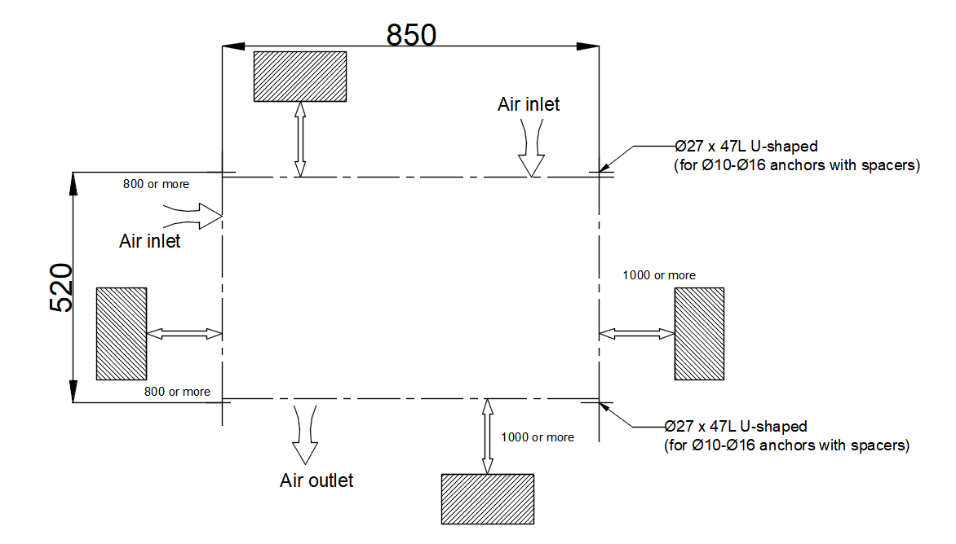

1.8 Safety devices

1.8.1 Freezing protection function
The unit has freezing protection function with power ON. If the system control fails, the product guarantees limited freezing protection.
At negative outdoor temperatures, there is an increased risk of the unit freezing if a heat pump fault occurs, e.g. due to a power cut or a defective compressor.

1.8.2 Insufficient water flow protection
This function continuously monitors the flow of the heating water. It will stop the compressor and backup heater is there is insufficient flow rate and automatically returns back to work after flow rate returns to normal.

1.8.3 Pump blocking protection
This function prevents the pumps for heating water from sticking. The pumps, which were out of operation for 24 hours, are switched on for a short time, one after the other.

1.8.4 Safety cut-out in the backup heater
If the temperature in the internal electric back-up heater exceeds the maximum temperature, the safety cut out shuts down the electric back-up heater as a securing measure.

1.9 Working principle
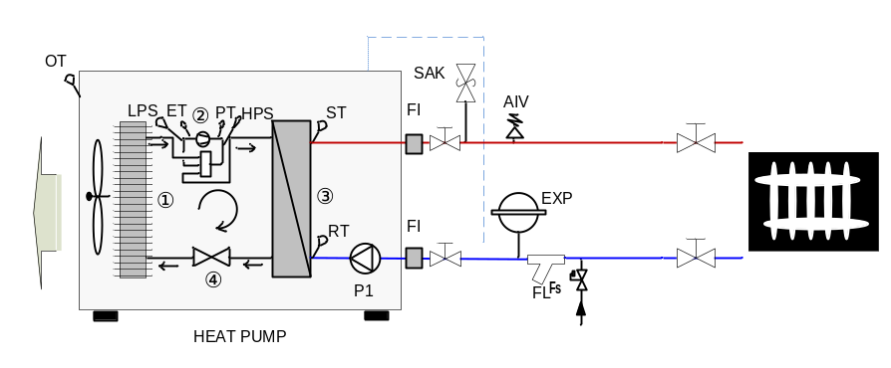
- The low pressure and low temperature liquid refrigerant coming out of expansion valve exacts heat energy from the air through finned coil heat exchanger ① and evaporates into gas state.
- The gas state refrigerant is sucked into compressor ② and compressed to high pressure and high temp. gas.
- The high pressure and high temp. gas discharged by compressor releases its heat energy to water in plate exchanger ③ and condensed to liquid state.
- The liquid state refrigerant is expanded in thermostatic expansion valve ④ and become low pressure and low temperature liquid refrigerant.
- The cycle repeats.

The control logic and function is inside the outdoor unit board.
Indoor unit I/O board just communicate with outdoor unit board to execute the commands from outdoor unit board and offer wiring center function.
The control function and logic is same for 3 Indoor units. Just the built-in parts are different as below table:

configurations | Hydraulic station | Hydraulic tower
touch screen | 7”
I/O board | included, with wifi module
buffer tank | 18L in the indoor unit | 26L in the indoor unit
DHW tank | X | 200L
Back up DHW e-heater | X | in the DHW tank
Back up heating e-heater | in the indoor unit
3 way valve | in the indoor unit
expansion tank | 8L in the indoor unit
Circulating pump | in the indoor unit
secondary pump | in the indoor unit

1.10 Care and maintenance

Guaranteeing frost protection
1. If no system separation for guaranteeing the frost protection is present, ensure that the product is switched on and remains switched on.
2. Ensure that no snow accumulates around the air inlet grille and air outlet grille.

Keeping the product clear
1. Regularly remove branches and leaves that have gathered around the product.
2. Regularly remove leaves and dirt from the ventilation grille below the product.
3. Regularly remove snow from the air inlet grille and from the air outlet grille.
4. Regularly remove snow that has gathered around the product.

Cleaning the product
1. Clean the casing with a damp cloth and a little solvent free soap.
2. Do not use sprays, scouring agents, detergents, solvents or cleaning agents that contain chlorine.

Danger!
Risk of injury and risk of material damage due to neglected or incorrect maintenance and repairs.
Neglected or incorrect maintenance work or repairs may lead to personal injury or damage
to the product.

▶ Never attempt to carry out maintenance work or repairs on the product.
▶ Employ an authorised installation company to complete such work. We recommend making a maintenance contract.
Troubleshooting
Eliminating faults
▶ If you observe a cloud of vapour on the product, you do not have to do anything. This effect may arise during the defrosting process.
▶ If the product will no longer start up, check whether the power supply is interrupted. If required, switch on all of the disconnectors to which the product is connected in the building.
▶ Contact a competent person if the measure that is described is unsuccessful.

Decommissioning
Temporarily decommissioning the product
1. Switch off all of the disconnectors to which the product is connected in the building.
2. Protect the heating installation against frost.
Permanently decommissioning the product
▶ Have a competent person permanently decommission the product.

Recycling and disposal
▶ The competent person who installed your product is responsible for the disposal of the packaging.
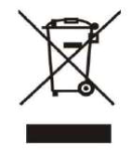
▶ do not dispose of the product with the household waste.
▶ hand in the product to a collection centre for waste electrical or electronic equipment.

Arranging disposal of refrigerant
The product is filled with R290 refrigerant.
▶ Refrigerant must only be disposed of by an authorized competent person.
▶ Observe the general safety information.

1.11 Safety qualification confirmation

Risk caused by inadequate qualifications
The following work must only be carried out by competent persons who are sufficiently
qualified to do so:
– Set-up
– Dismantling
– Installation
– Start-up
– Inspection and maintenance
– Repair
– Decommissioning

Risk caused by inadequate qualifications for the R290 refrigerant
Any activity that requires the unit to be opened must only be carried out by competent persons who have knowledge about the particular properties and risks of R290 refrigerant. Specific expert refrigeration knowledge in compliance with the local laws is required when carrying out work on the refrigerant circuit.
This also includes specialist knowledge
about handling flammable refrigerants, the corresponding tools and the required personal
protective equipment.
▶ Comply with the corresponding local laws and regulations.

Risk of death from electric shock
There is a risk of death from electric shock if you touch live components.
Before commencing work on the product:
▶ Disconnect the product from the power supply by switching off all power supplies at all poles (electrical partition in overvoltage category III for full partition, e.g. fuse or circuit breaker).
▶ Secure against being switched back on again.
▶ Wait for at least 3 minutes until the capacitors have discharged.
▶ Check that there is no voltage.

Risk of death caused by fire or explosion if there is a leak in the refrigerant circuit
The product contains the combustible refrigerant R290. In the event of a leak, escaping
refrigerant may mix with air to form a flammable atmosphere. There is a risk of fire and
explosion. A safe zone is defined for the area close around the product. See section "safe zone".
▶ If you are working on the product when it is open, before starting work, use a gas sniffer to ensure that there is no leak.
▶ The gas sniffer itself must not be an ignition source. The gas sniffer must be calibrated
to R290 refrigerant and set to ≤ 25% of the lower explosive limit.
▶ Keep all ignition sources away from the safety zone. In particular, open flames, hot surfaces with temperatures above 370 °C, electrical devices or tools that are not free from electrical sources, static discharges.

Risk of death caused by fire or explosion when removing the refrigerant
The product contains the combustible refrigerant R290. The refrigerant may mix with air
to form a flammable atmosphere. There is a risk of fire and explosion.
▶ Only carry out the work if you are competent at handling R290 refrigerant.
▶ Wear suitable personal protective equipment and bring a fire extinguisher with you.
▶ Only use tools and units that are permitted for R290 refrigerant and are in proper working condition.
▶ Ensure that no air gets into the refrigerant circuit, into refrigerant-carrying tools or units, or into the refrigerant cylinder.
▶ Note that the refrigerant R290 must never be introduced into the sewage system.

Risk of death due to lack of safety devices
The basic diagrams included in this document do not show all safety devices required for correct installation.
▶ Install the necessary safety devices in the installation.
▶ Observe the applicable national and international laws, standards and directives.

Risk of burns, scalds and frostbite due to hot and cold components
There is a risk of burns and frostbite from some components, particularly uninsulated pipelines.
▶ Only carry out work on the components once these have reached environmental temperature.

Regulations (directives, laws, standards)
▶ Observe the national regulations, standards, directives, ordinances and laws.
▶Transport of equipment containing flammable refrigerants
Compliance with the transport regulations

▶ Marking of equipment using signs
Compliance with local regulations

▶Disposal of equipment using flammable refrigerants
Compliance with national regulations
▶Storage of equipment/appliances
The storage of equipment should be in accordance with the manufacturer’s instructions.

▶Storage of packed (unsold) equipment
Storage package protection should be constructed such that mechanical damage to the equipment inside the package will not cause a leak of the refrigerant charge. The maximum number of pieces of equipment permitted to be stored together will be determined by local regulations.

2 Product Information Description

2.1 Refrigerant circuit diagram
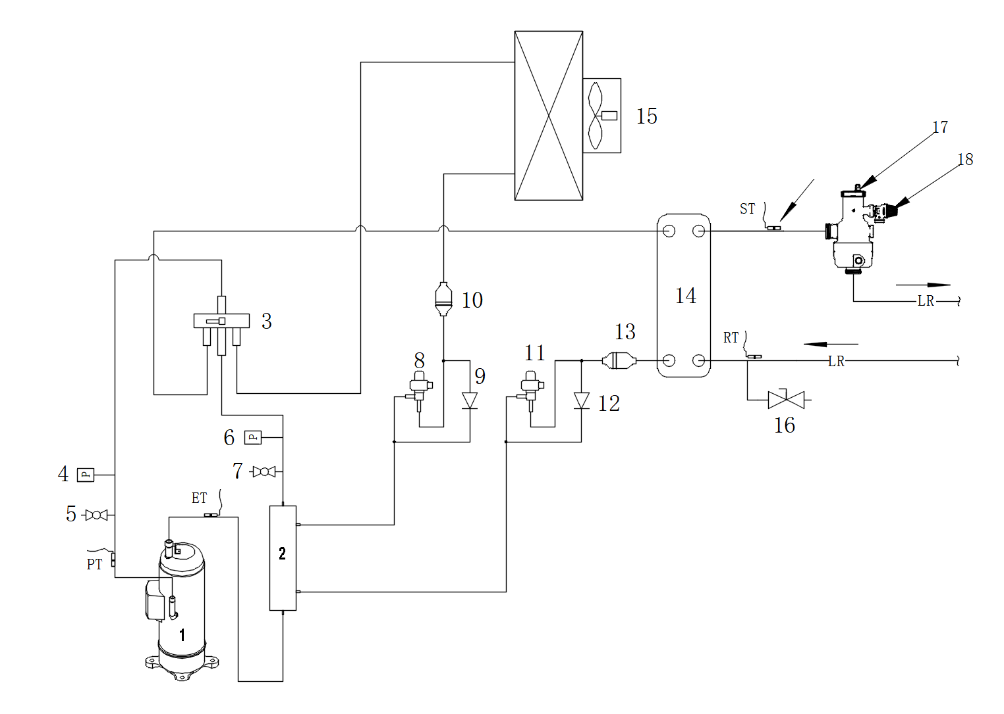

1.compressor
2.heat exchanger
3.4 way valve
4.High pressure transducer
5.HP service connection
6.Low pressure transducer
7.LP service connection
8.EEV2
9.single way valve
10.filter
11.EEV1
12.single way valve
13.filter
14.plate heat exchanger
15.finned coil heat exchanger
16.drainage valve
17.Microbubble valve
18.Safety valve

2.2 Components

2.2.1 Outdoor unit
HSL08V-D/ HSL10V-D / HSL12V-D / HSL15V-D
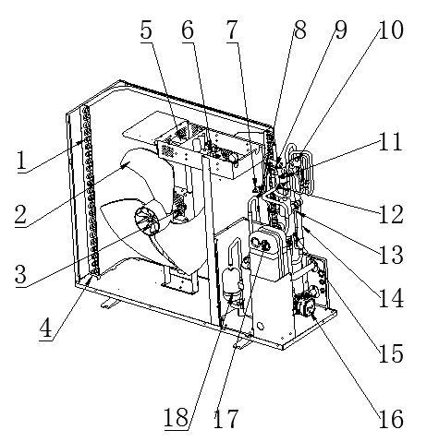

1.Finned coil heat exchanger
2.Fan blade
3.EC Fan motor
4.De-icing heater
5.Reactor
6.Inverter / control board
7.HP transducer
8.HP service connection
9.4 way valve
10.EEV2
11.LP service connection
12.LP transducer
13.EEV1
14.heat exchanger
15. Microbubble valve
16. Circulating pump
17.Plate heat exchanger
18.Compressor

2.2.2 Indoor unit components
Hydraulic station
1.Air vent valve
2.Safety thermostat
3.Bufffer tank
4.Auxiliary heater
5.Primary pump
6.Expansion tank
7.Three way valve
8.Secondary pump
9.Relay/ A/C contactor
10.Terminal block
11.I/O board
12.Switching power supply
13.Touch screen

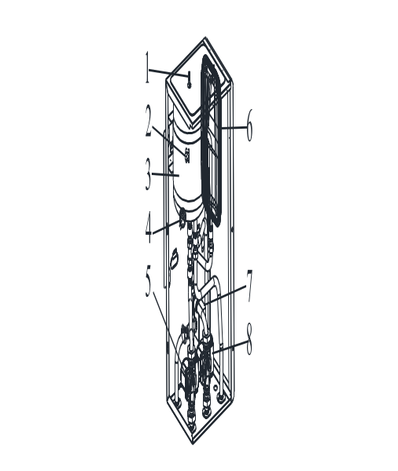

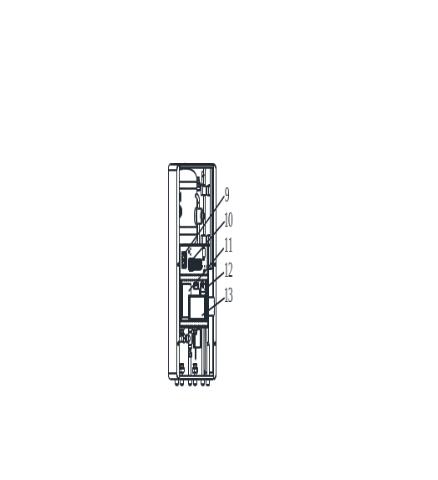

Hydraulic tower

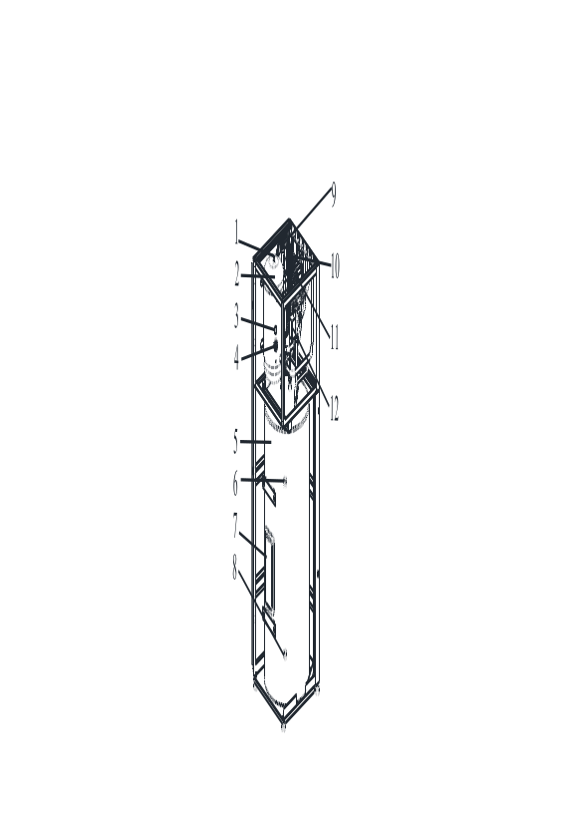

1.Air vent valve
2.Buffer tank
3.Safety thermostat
4.Auxiliary heater
5.DHW tank
6.T/P valve
7.DHW heater and safety thermostat
8.Drain valve
9.Expansion tank
10.Primary pump
11.Secondary pump
12.Three way valve

Hydraulic tower

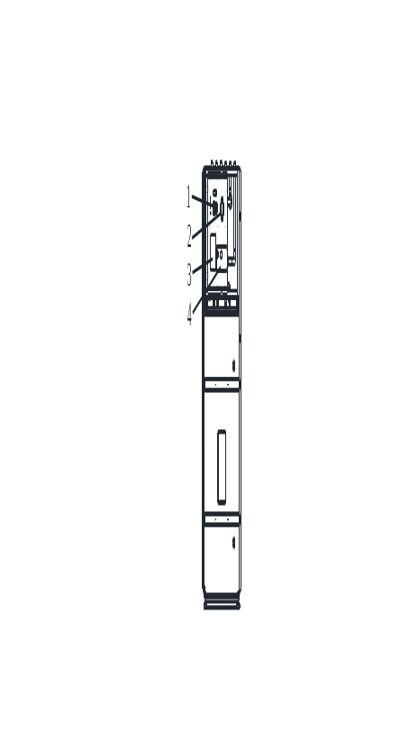

1.Terminal block
2.Switching power supply
3.I/O board
4.Touch screen

2.3 Dimensions

Heat pump dimensions
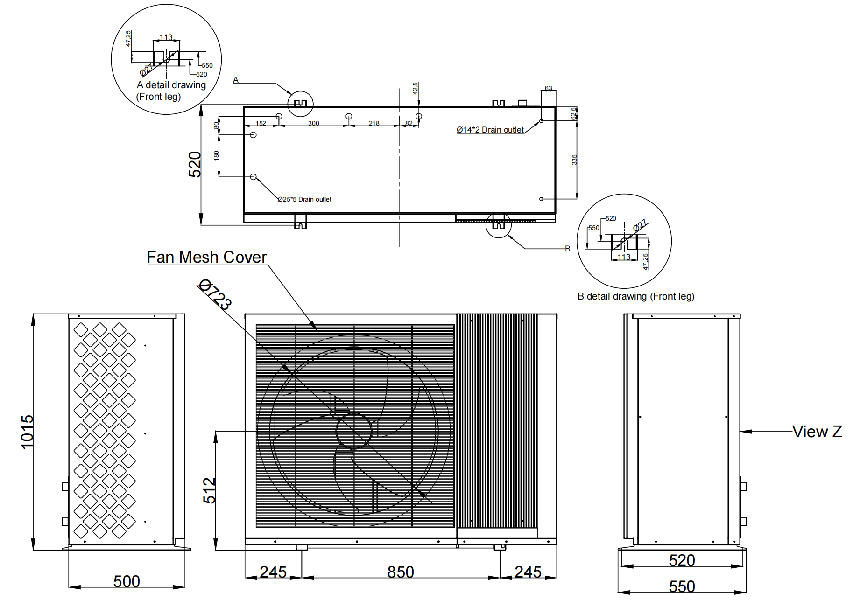

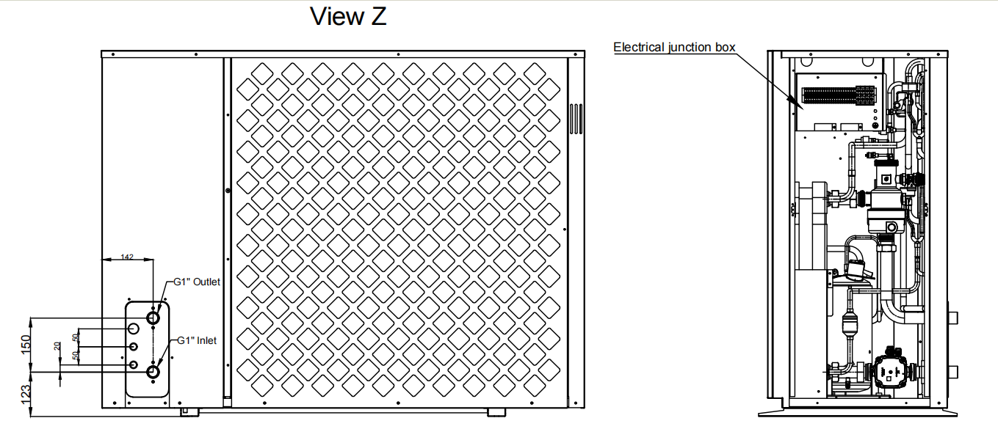

2.4 Water Pressure Plots

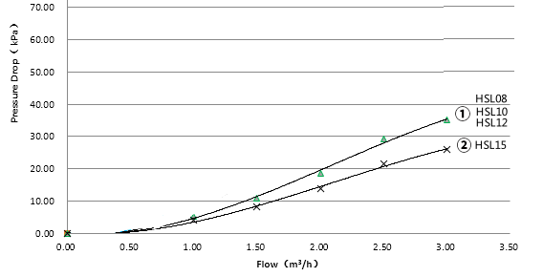

2.5 Pump Curve

DSK03-QPVTSG, DSK09-DPVTSG, DSK03-QPVTSL200 & DSK09-DPVTSL200 primary circulation pump
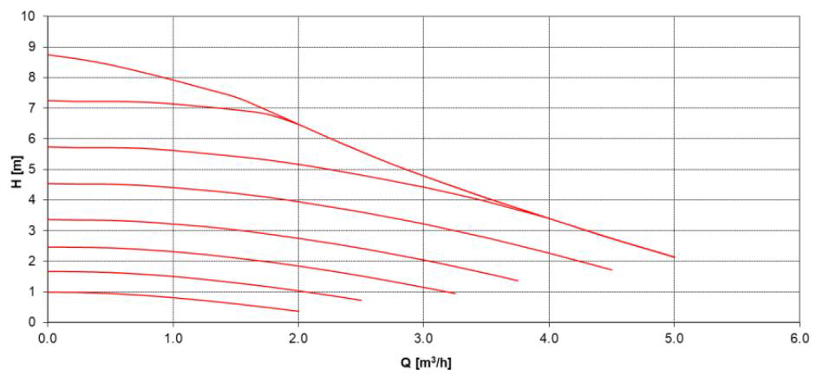

2.6 Operating range

The product works between a minimum and maximum outdoor temperature. These outdoor temperatures define the application limits for the heating mode and cooling mode. Operating outside of the application limits leads to the compressor switching off.

Heating mode
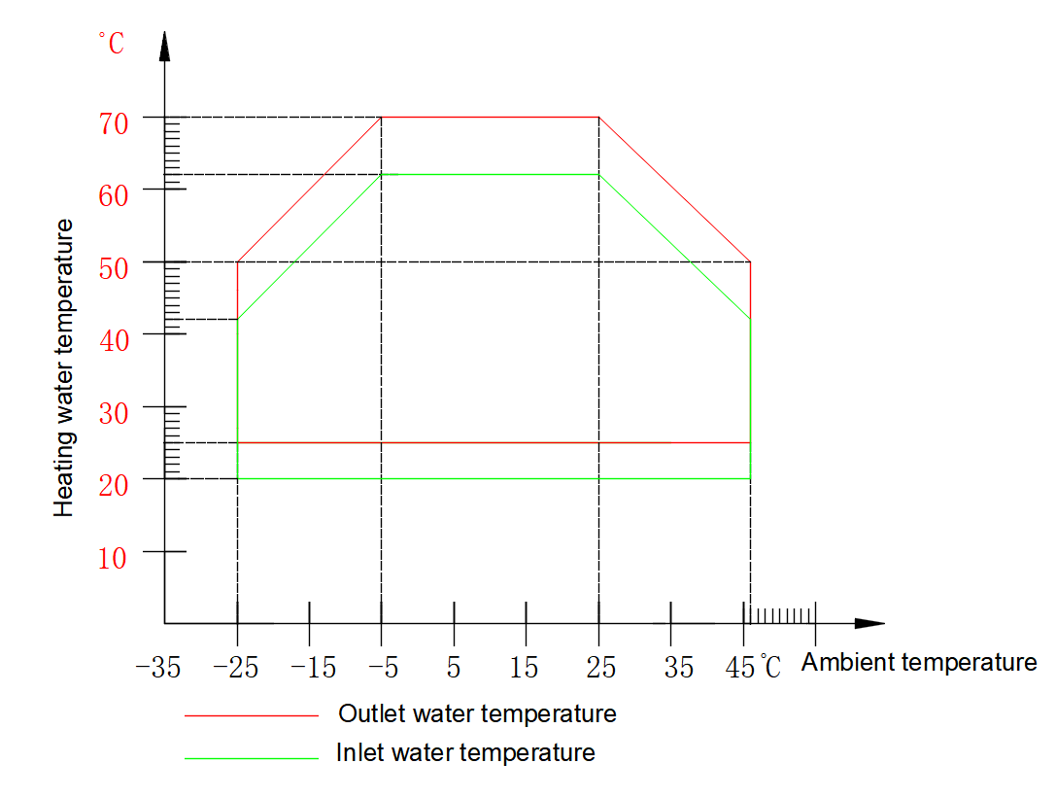
The maximum outlet water temperature made by the compressor is subject to the ambient temperature as per this running envelope. The unit will follow this envelope to automatically adjust the maximum outlet water temperature. If the user set heating setpoint is higher than the operating limit temperature, the unit could not meet the setpoint and will go to standby after meeting this operation envelope value.

Cooling mode
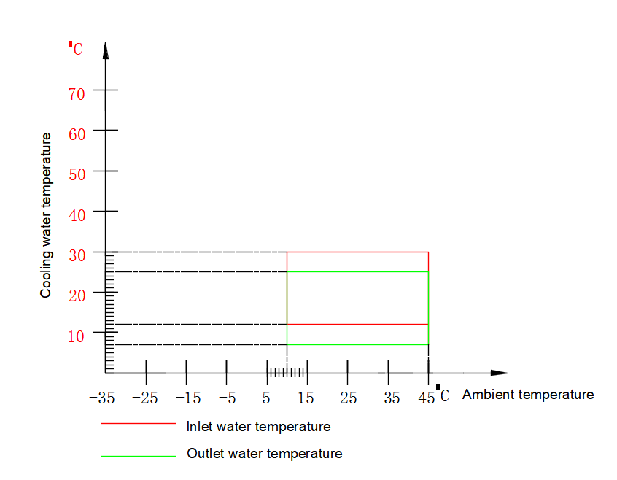

2.7 Heat pump outdoor unit and indoor unit specification

Efficiency data |  | Range | 6kW(1 Ø) | 7kW(1 Ø) | 9kW(1 Ø)  9kW(3 Ø) | 12kW(1 Ø)  12kW(3 Ø)
Seasonal space heating eff. class (35℃ / 55℃) |  | - | A+++ / A+++ | A+++ / A+++ | A+++ / A+++ | A+++ / A+++
Seasonal efficiency of space heating (ηS) (35℃ / 55℃) |  | % | 209/159 | 208/159 | 204/162 | 209/161
SCOP (35℃ / 55℃) |  |  | 5.31/4.05 | 5.29/4.06 | 5.18/4.12 | 5.29/4.09
Sound power level  (outdoor unit) | Rated / low noise mode | dB(A) | 50/49 | 52/51 | 53/52 | 54/53
Sound pressure level at 3 m 1)  (outdoor unit) | Rated / low noise mode | dB(A) | 31/30 | 33/32 | 33/32 | 34/33
Sound power level  (indoor unit) | Rated | dB(A) | 40
Sound pressure level at 1 m 1)  (indoor unit) | Rated | dB(A) | 33
Test Conditions |  | Unit | Nominal capacity and COP / EER
Air +7℃ / water +35℃ | Heating capacity / COP | kW / - | 6.9/4.97 | 7.5/5.22 | 9.95/4.95 | 12.8/4.93
Air -7℃ / water +35℃ | Heating capacity / COP | kW / - | 6.5/3.55 | 7.0/3.49 | 8.8/3.46 | 12.1/3.57
Air +7℃ / water +55℃ | Heating capacity / COP | kW / - | 5.8/3.28 | 6.8/3.25 | 8.69/3.31 | 11.8/3.34
Air -7℃ / water +55℃ | Heating capacity / COP | kW / - | 5.6/3.02 | 6.6/2.78 | 8.14/2.86 | 11.1/2.85
Air +35℃ / water +18℃ | Cooling capacity / EER | kW / - | 6.2/3.43 | 7.0/3.45 | 9.2/3.48 | 11.8/3.5
Air +35℃ / water +7℃ | Cooling capacity / EER | kW / - | 5.5/3.06 | 6.6/3.02 | 8.12/2.87 | 10.8/2.98
Outdoor unit |  | Unit | HSL08V | HSL10V | HSL12V | HSL15V
Refrigerant | Type | - | R290
Refrigerant | GWP | - | 3
Refrigerant | Precharged amount | kg | 0.8 | 0.83 | 0.92 | 1.25
Refrigerant | t-CO2 eq. | - | 0.0024 | 0.0025 | 0.0028 | 0.0038
Piping connections (water) | Inlet / outlet diameter | inch | Male thread 1"
Operation range | Heating & DHW (Min. ~ Max.) | ℃ | -28~40
(outdoor air temperature) | Cooling (Min. ~ Max.) | ℃ | 10~45
Dimension | W × H × D | mm | 1340*1015*500
Weight | Empty | kg | 140 | 145 | 151 | 176
Power supply | Voltage, phase, frequency | V, Ø, Hz | 400, 3, 50
 | Recommended circuit breaker | A | 1 Ø:4 | 1 Ø:5 | 3 Ø: 8.5 | 3 Ø: 11.5
Exterior | Color of chassis / RAL code | - | Anthracite Grey/RAL 7016A
Exterior | Color of front grille / RAL code | - | Anthracite Grey/RAL 7016A
Indoor unit |  | Unit | DSK06-DPVTSG |  | DSK06-DPVTSL200/300
Operation range  (leaving water temperature) | Heating (Min. ~ Max.) | ℃ | 15 ~ 75
Operation range  (leaving water temperature) | Cooling (Min. ~ Max.) | ℃ | 12 ~ 27
Operation range  (leaving water temperature) | DHW (Min. ~ Max.) | ℃ | 15 ~ 65
Built-in water tank | Buffer tank | L | 18 |  | 26
Built-in water tank | DHW tank3) | L | - |  | 200/300
Built-in water tank | PCM Precharged amount | kg | 16 |  | 23
Backup heater | Capacity combination | kW | 6
Backup heater | Power supply | V, Ø, Hz | 400, 3, 50
Backup heater | Rated running current | A | 9
Piping connections (water) | Heating circuit outlet pipe | inch | Male thread 1"
Piping connections (water) | Heating circuit inlet pipe | inch | Male thread 1"
Piping connections (water) | Outlet pipe to outdoor unit | inch | Male thread 1"
Piping connections (water) | Inlet pipe from outdoor unit | inch | Male thread 1"
Piping connections (water) | DHW outlet pipe | inch | Male thread 1" |  | Male thread 3/4"
Piping connections (water) | DHW inlet pipe | inch | Male thread 1" |  | Male thread 3/4"
Dimension | W × H × D | mm | 450*360*900 |  | 600*610*1870
Weight | Empty | kg | 57 |  | 197
Power supply | Voltage, phase, frequency | V, Ø, Hz | 220 ~ 240, 1, 50
Power supply | Recommended circuit breaker | A | 1.8 |  | 14.8
Exterior | Color / RAL code | - | Signal White

3 Pre-Installation

3.1 Movement and Storage

Danger
The outdoor unit is filled with refrigerant R290 (propane): Mechanical loading can lead to leaks in the refrigerant circuit. Where leaks of refrigerant occur, there is the risk of explosion or asphyxiation.
■ Prevent vibration during transport.
■ Position the outdoor unit carefully after transport.
■ When being transported, protect the evaporator on the rear side of the outdoor unit against mechanical loading, e.g. with cardboard packaging or bubble wrap.
■ Equipment damaged in transit should not be used. Shock, pressure and tensile loads can damage the equipment.
■ Do not load the appliance top, front and side panels as well as the evaporator on the rear side of the equipment.
■ In order to avoid damage to the air outlet grill, always fit the sack truck to the rear side of the outdoor unit.
Do not damage the evaporator when doing so. Scratches on the surface coating will lead to corrosion.
■ Only remove the packaging from the outdoor unit after transporting.
■ Protect the outdoor unit against direct contact with tools and transporting equipment, e.g. using cardboard packaging or bubble wrap.
The unit must not be transported, moved or stored at greater than a 30° angle from the upright position. Store the unit in a dry area until required.
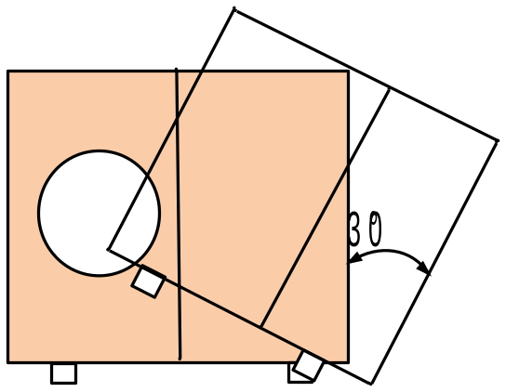

The unit must be installed by a suitably qualified tradesperson and all electrical wiring must be completed by a licensed electrical contractor in accordance with all local Standards.

Do not use oxygen to purge lines or to pressurize a unit for any purpose. Oxygen gas reacts violently with oil, grease and other common substances. Use only dry nitrogen for testing.

Wear adequate personal protective equipment (protective gloves, safety glasses) when installing, maintaining or servicing the system.
Tear apart and throw away plastic packaging bags so that nobody, especially children, can play with them. Possible risk: suffocation.

Do not un-weld or flame cut the refrigerant lines including any refrigerant circuit components until the entire refrigerant (liquid and vapour) has been removed from unit. Traces of vapour should be displaced with dry nitrogen.
Refrigerant in contact with an open flame will produces toxic gases and fire.

Ensure that the necessary safety protection equipment is available when servicing. Have the appropriate fire extinguishers for that system.
Do not siphon refrigerant.

Avoid spilling liquid refrigerant onto the skin or splashing it into the eyes. Use safety goggles. Wash any spills from the skin with soap and water. If liquid refrigerant enters the eyes, immediately and abundantly flush the eyes with water and consult medical advice.

Note: Never apply an open flame or live stream to a refrigerant container. This can dangerously overpressure and cause an explosion.

Compressor oil filling quantity:
HSL08V-D、HSL10V-D：HAF68 840ml
HSL12V-D：HAF68 840ml
HSL15V-D：HAF68 1150ml
The heating system must be pressure tested and air vented completely.
Filling water and supplemented water must be drinking water quality (colourless, clear, free from sediments).
Must use water that complies with European water quality standard 98/83 EC. The lifespan of the Unit will be shorter if groundwater (include spring water and well water) is used.
Indoor unit shall not be used with the tap water containing contaminants such as salt, acid, and other impurities which may corrode the tank and its component.
Filling water and supplemented water must be pre-filtered. (pore size max. 5um)

3.2 Installation Location

- The unit must be installed on a solid level surface on a concrete pad foundation not connected to the house foundation. Rubber cushions can be added to reduce vibration and noise if required.

- The unit should be placed so that it is well away from bedrooms or noise sensitive areas including neighbour’s section boundaries. (The unit will produce noise that is above the minimum 45 decibel rating).

- The unit should be well ventilated with no obstructions and kept level at all times.

- Ensure there is good drainage around installation area and make sure this water cannot run out onto paths as it may cause ice or slime build up which is undesirable. (The unit can produce large volumes of condensation water when running in high humidity zones. There is also a large run off when the unit melts ice during a defrost cycle).

- Avoid locations exposed to machine oil vapour, salty air, thermal springs sulphur gases or other harsh substances

- If operation in temperatures below 0°C for prolonged periods or locations where the snow may fall the unit must be raised at least 300mm off the ground. This is necessary to avoid ice build-up on the unit’s chassis.

- The unit must be installed level in both axes (less than 2mm tolerance per meter)

- Locations exposed to strong winds should be avoided otherwise baffles may be necessary to deflect strong winds and to prevent snow from blowing directly into the unit. They must not restrict air flow into the unit.

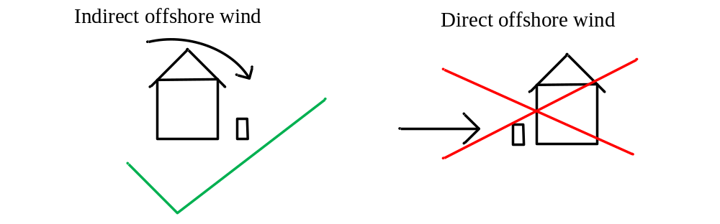

- Keep suitable distance between the unit and the building to ensure the normal running of the unit and enough room is available for maintenance.

Minimum clearance of the outdoor unit:

In accordance with EN 378-3:2016, the outdoor unit should only be installed in the open air.
■ The refrigerant circuit in the outdoor unit contains easily flammable refrigerant in safety group A3 according to ANSI/ASHRAE Standard34. Therefore a safety zone is defined in the immediate vicinity of the outdoor unit, in which special requirements apply: See chapter "Safety zone".

3.3 Outdoor unit setup
Floor standing installation
Place the unit on a solid level base that can take the weight, preferably a concrete foundation. If concrete slabs are used they must rest on asphalt or shingle.
Do not place unit directly on the lawn or other non solid surface.
Make sure that the inclination of the heat pump in the horizontal and vertical direction is no more than 1%.
Installation problems/faults if installed on sloping surface! The condensate drainage and functionality will be impaired.
Particularly in adverse climatic environments (minus temperatures, snow and humidity) a distance to the substrate of at least 300 mm is required.

Screw the heat pump to the subsurface using suitable screws. Rubber cushion /pads should be applied to reduce vibration and noise. Align the heat pump horizontally.

Protect the intake side with a wall or similar to prevent strong winds from blowing directly on the heat pump.

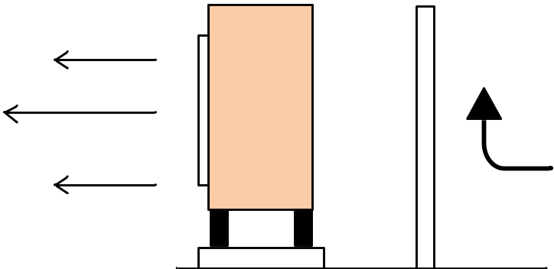

3.4 Connect drainage pipe

Find the plastic adapters inside the heat pump and plug it into the holes of the unit drain pan. connect a water hose (field supply,16mm inner diameter) to this plastic adapter

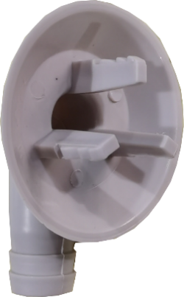
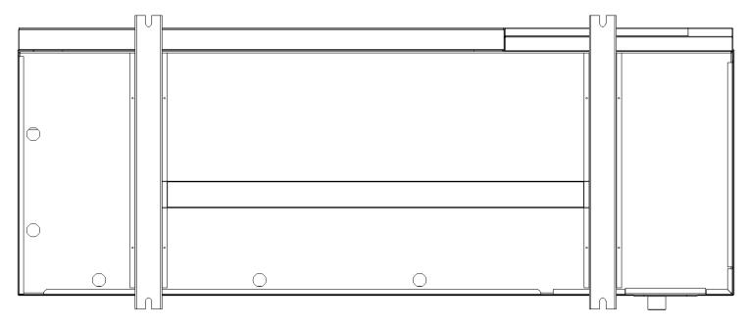

condensate discharges Plastic adapter

The condensate collected in the collector shall be drained via a pipe to an appropriate drains where the shortest possible outdoor stretch is recommended.
■ The part of the pipe that is not frost-free must be heated by a heating cable to prevent freezing.
■ Lay the pipe with a drop from the heat pump
■ The outlet of the condensate pipe must be in frost-free depth or alternatively indoors (subject to local regulations and regulations).
■ Use a water trap in installations where air circulation may occur in the condensate pipe.
■ The insulation must be connected close to the condensate collector.
Danger of injury due to frozen condensate!
Frozen condensate on the pavement can result in falls.
Make sure that running condensate does not end up on the pavement where it can freeze to ice.
Condensate drainage recommendations:

Stone Caisson Gutter drainage
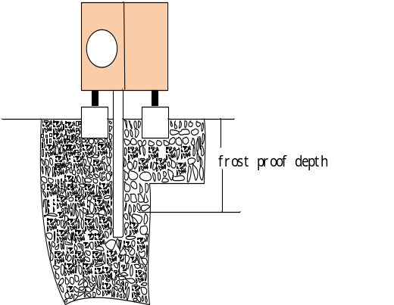
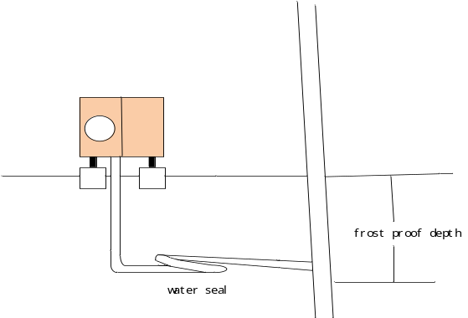

3.5 Steps to open the cabinet

If needed, the panels could be opened by a serviceman

The panels could be removed as the order: top panel- plastic cover- right panel – front panel - fan panel

- Unscrew the screws as below indication and top panel could be removed.
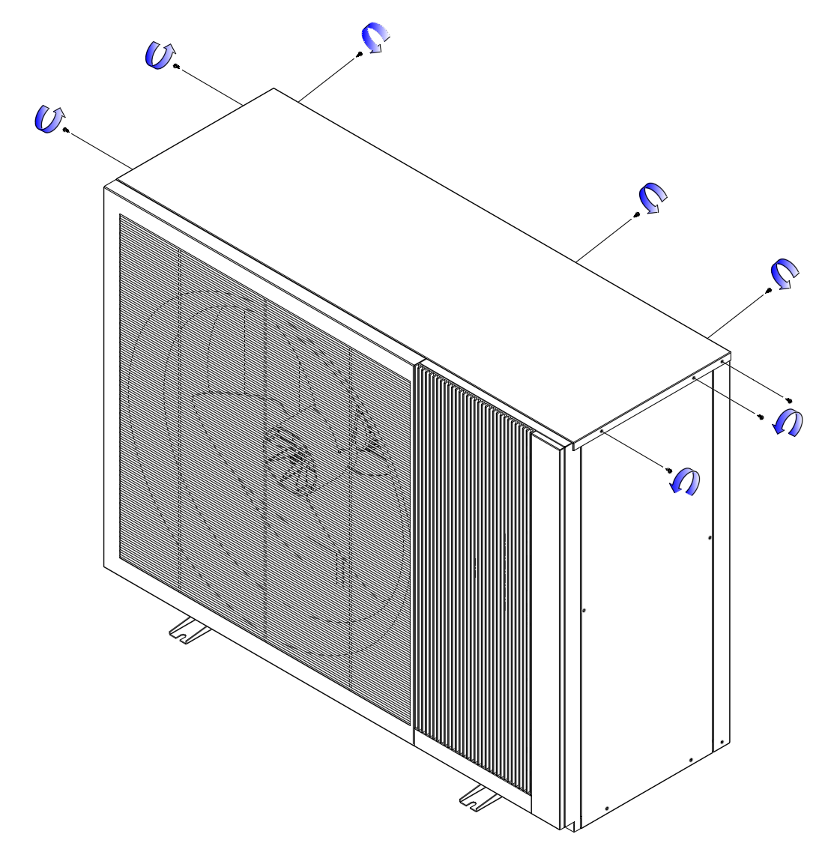

- Unscrew the screws as below indication, remove plastic cover first, and then right panel could be removed.

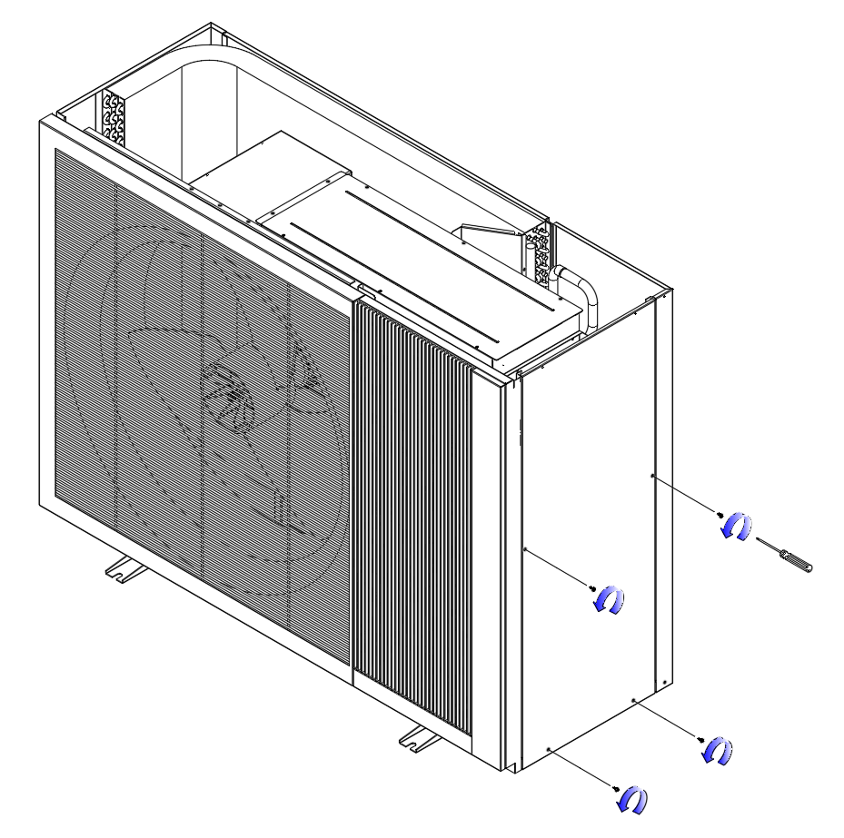

- Unscrews the screws as below indication. Front panel could be removed by pushing the panel upward.

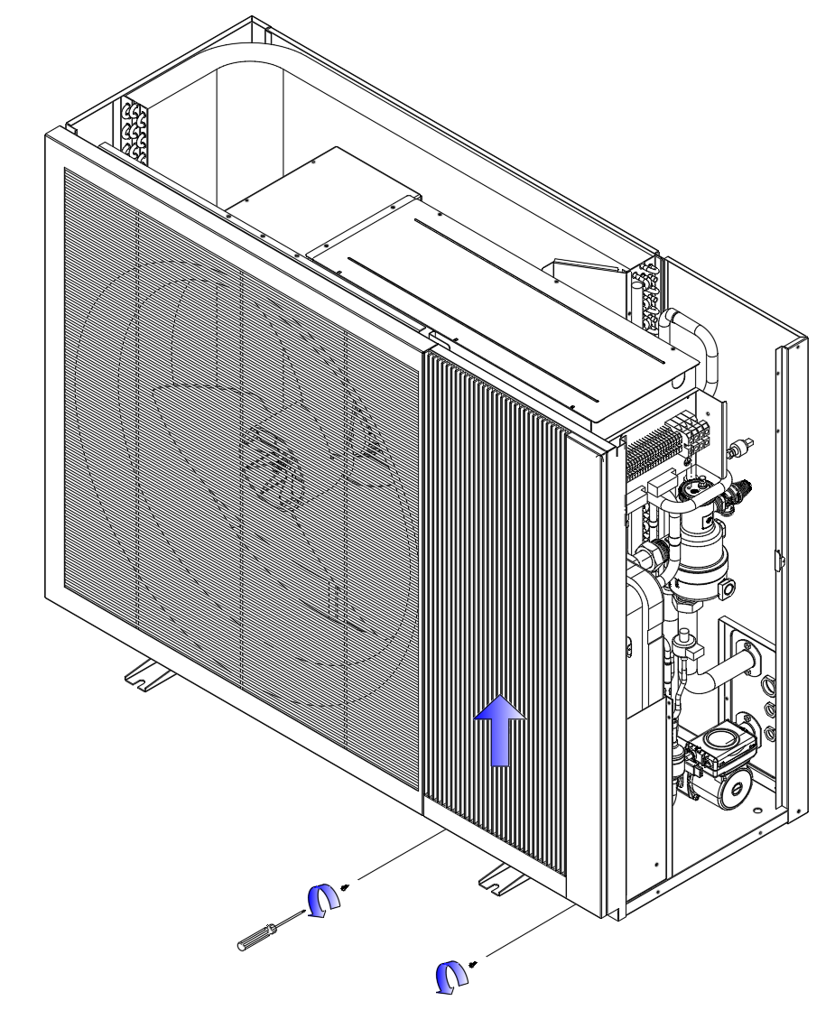

- Unscrews the screws as below indication. Fan panel could be removed by pushing it upward.
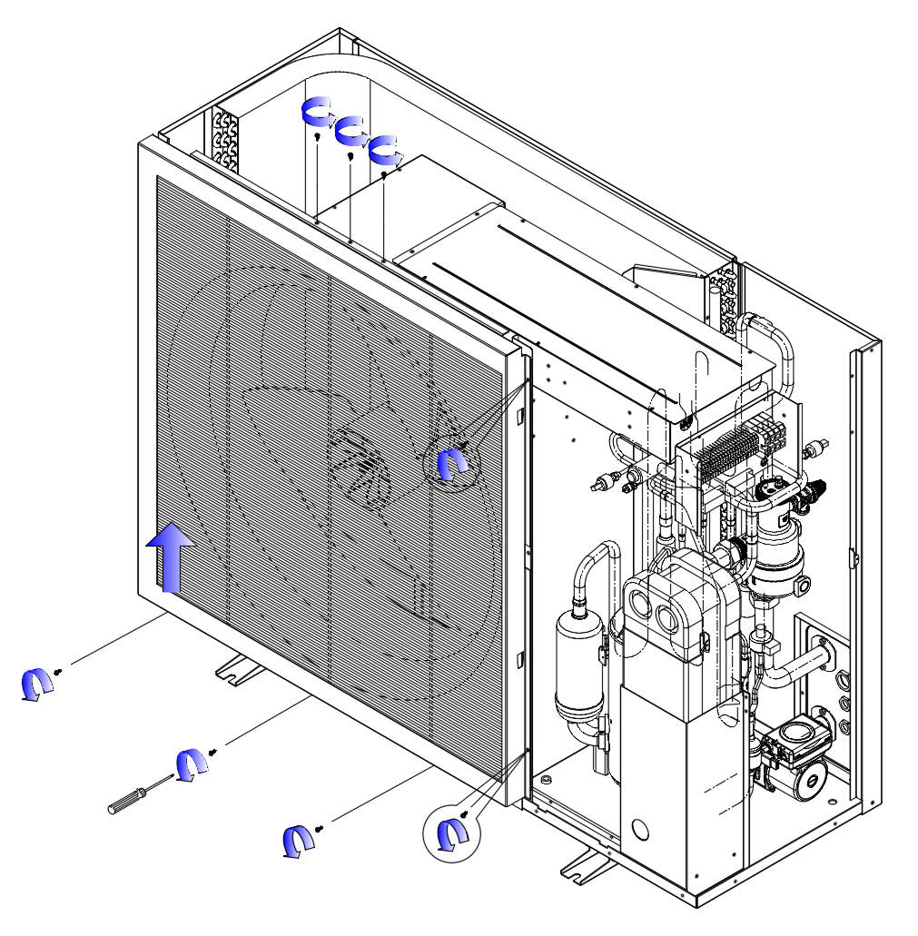

- Unscrews the screws as below indication. The cover of control box could be removed

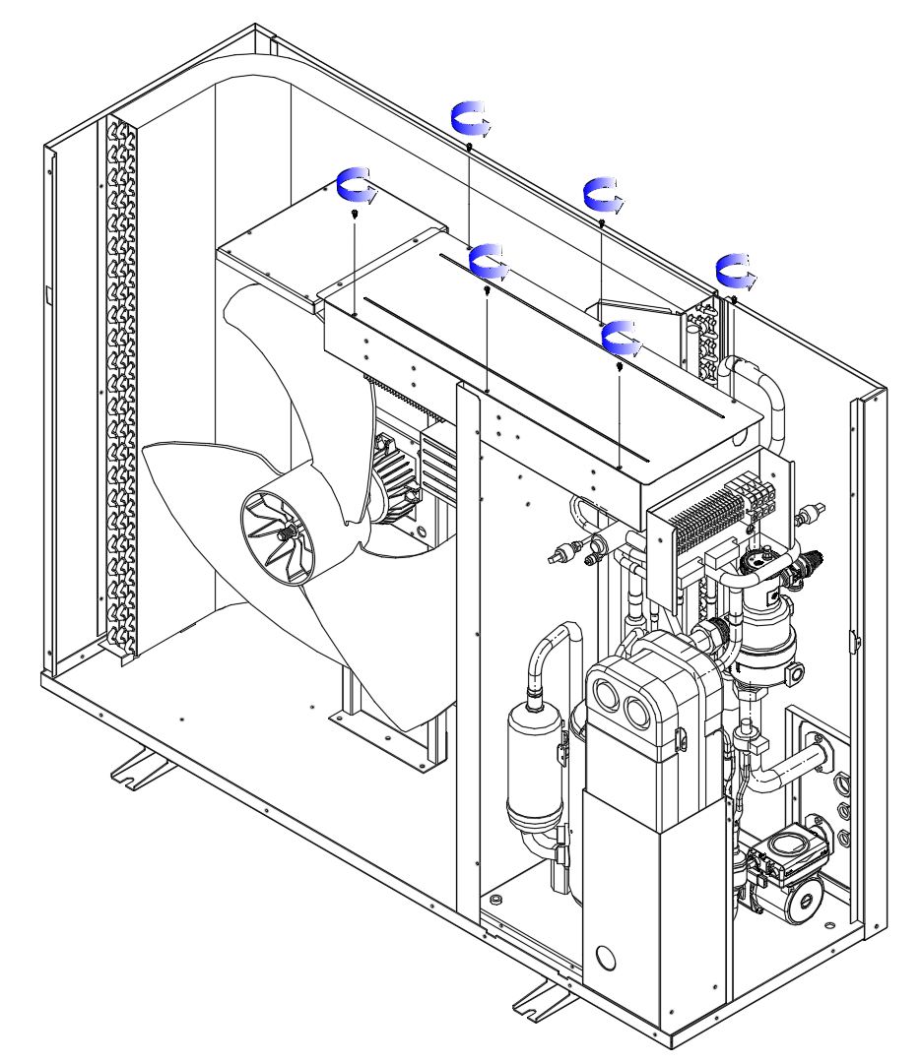

- All panels removed.

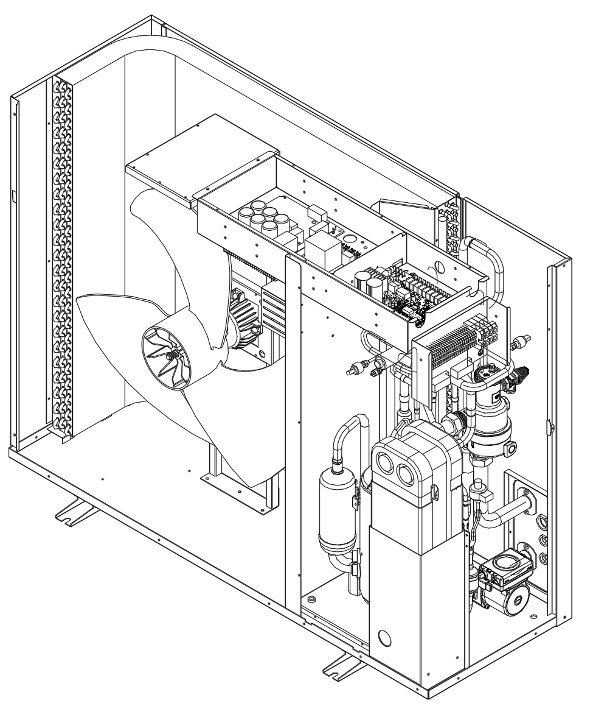

3.7 Hydraulic station installation

Hydraulic station dimension unit:mm
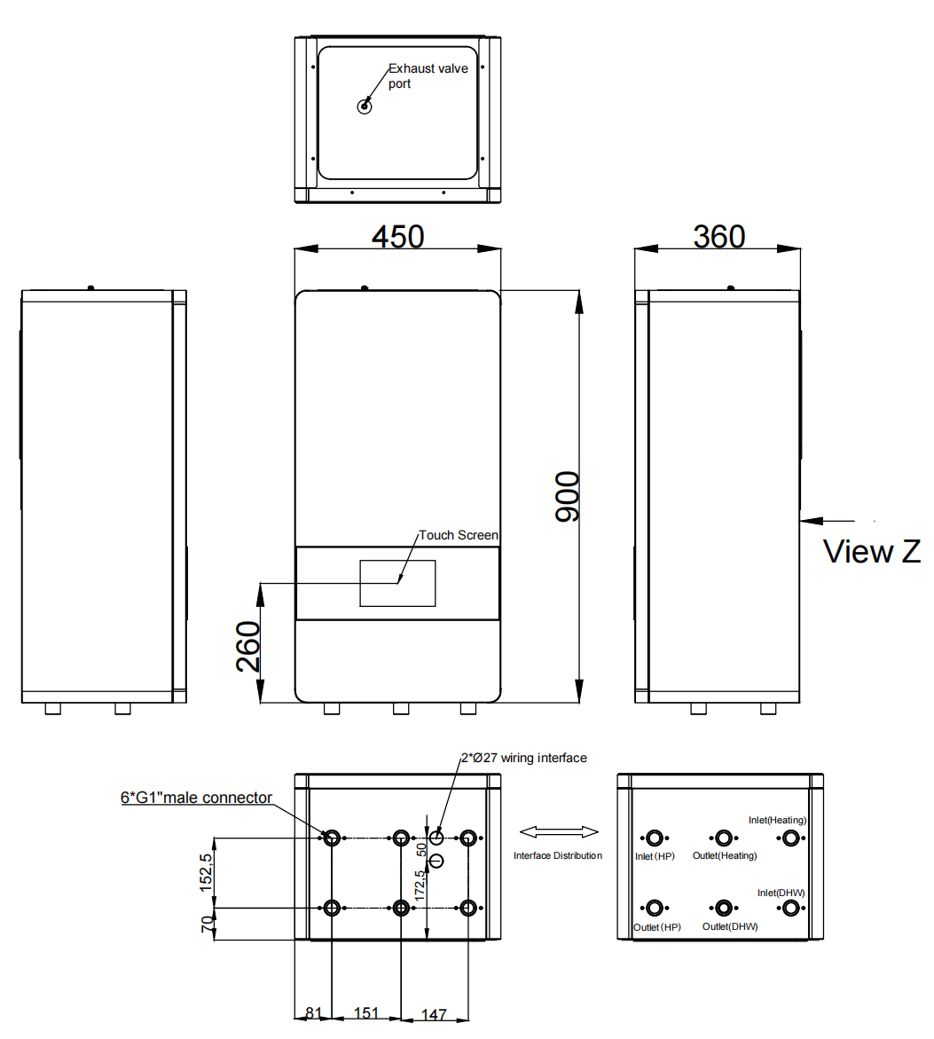

Unscrew the screws fixing the front panel on the top and Push the front panel upward to open the front panel to access electric terminal.

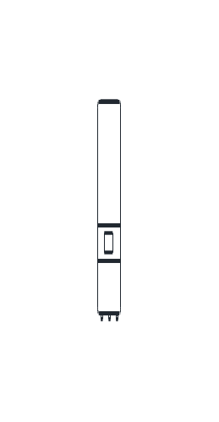
Selecting the installation site
▶ The installation site must be below 2000 metres above sea level.
▶ Select a dry room that is frost-proof throughout and in which the maximum installation height is not exceeded and the environmental temperature 7 … 35 ℃
– Permissible relative air humidity: 40 … 75 %
▶ Ensure that the required minimum clearances can be maintained.
▶ The permissible height difference between the indoor unit and outdoor unit must not be greater than 15 m.
▶ When selecting the installation site, you must take into consideration that when the heat pump is in operation, it will transfer vibrations to the walls.
▶ Ensure that the wall is even and offers sufficient loadbearing capacity to bear the weight of the product.
▶ Ensure that the pipes are routed appropriately.
▶ Do not install the product above another unit that may damage it (e.g. above a cooker that produces water vapour and grease) or in a room with a high level of exposure to dust or in a corrosive environment. There should not be any heat source or steam near the unit.
▶Do not install this appliance in a laundry room or other high humidity location. This condition will cause rust and damage to the unit.
▶ Do not install the product below a unit from which liquids may flow.
▶ There is wifi module inside the hydraulic station, be sure that the wifi signal is covered on the installation place.

Minimum clearances and installation clearances
unit:mm

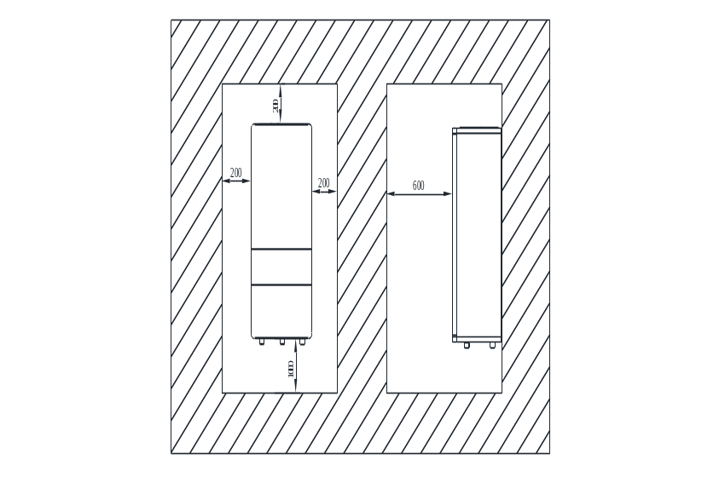

▶ Provide sufficient clearance on both sides of the product in order to facilitate access for
maintenance and repair work.
▶ When using the accessories, observe the minimum clearances/ installation clearances.
▶ Ensure that no highly flammable parts come into contact with the components as these may reach temperatures of over 70°C.
▶ Ensure that there is a minimum clearance between the highly flammable parts and the hot components.
Check the load-bearing capacity of the wall.
Note the total weight of the product.
Only use fixing material that is permitted for the wall.
If required, ensure that mounting apparatus on-site has sufficient load-bearing capacity.
Fix the wall bracket (accessory) to the wall (level) with 4 Ø8 mm bolts (field supply)

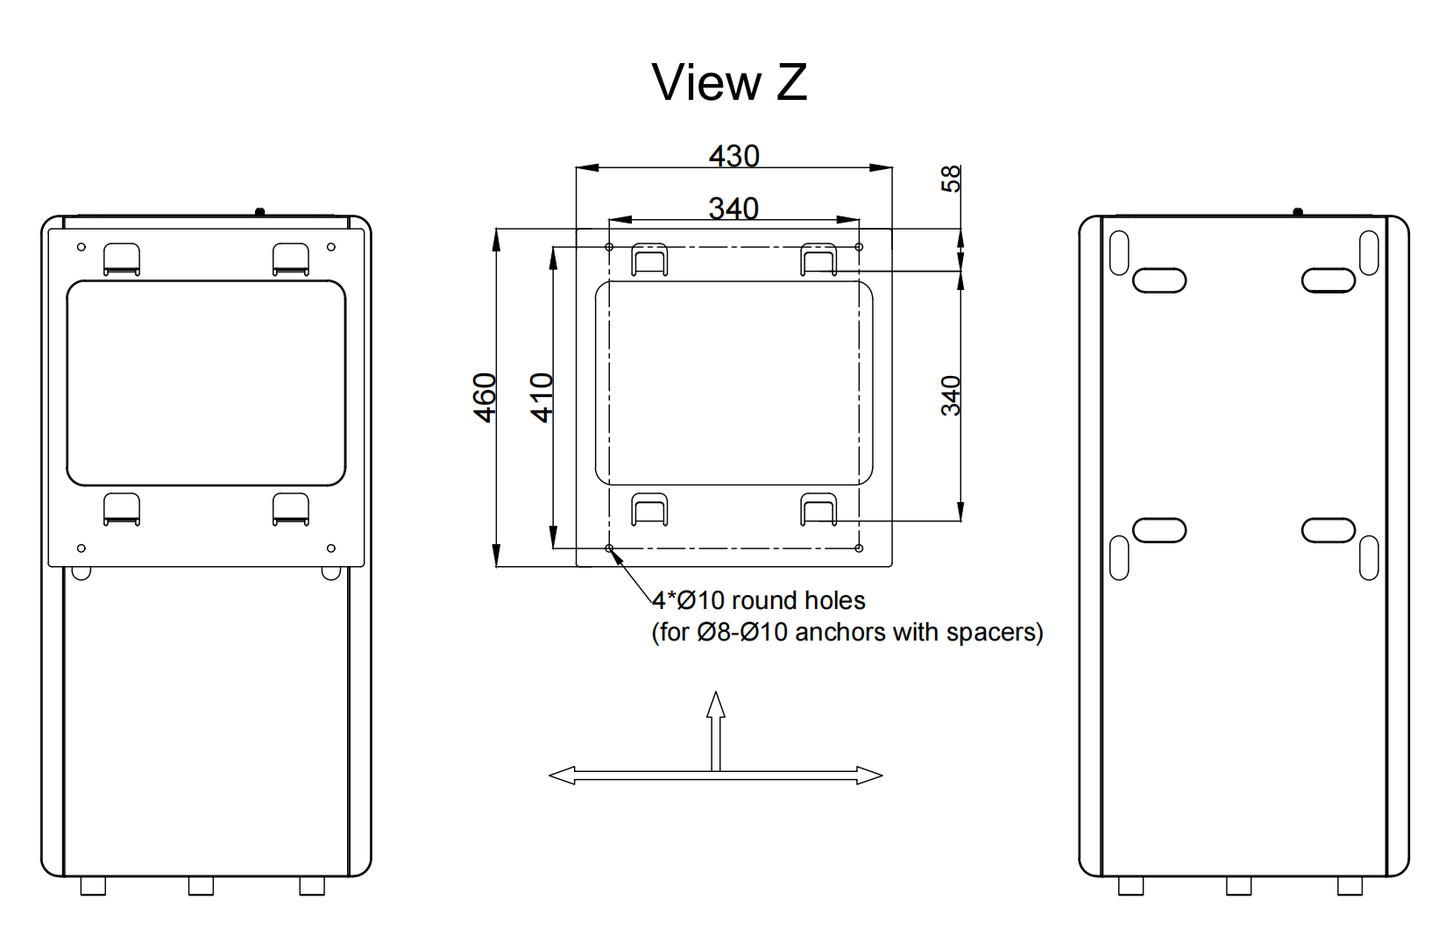

▪ Lift up the hydraulic station
▪ Attach the hydraulic station to the wall bracket:
▪ Tilt the top of the unit against the wall at the position of the wall bracket.
▪ Slide the bracket on the back of the unit over the wall bracket. Make sure the unit is fixed properly.

3.7.1 Hydraulics installation
Make sure to connect the pipes correctly and in correct flow direction as below diagram:
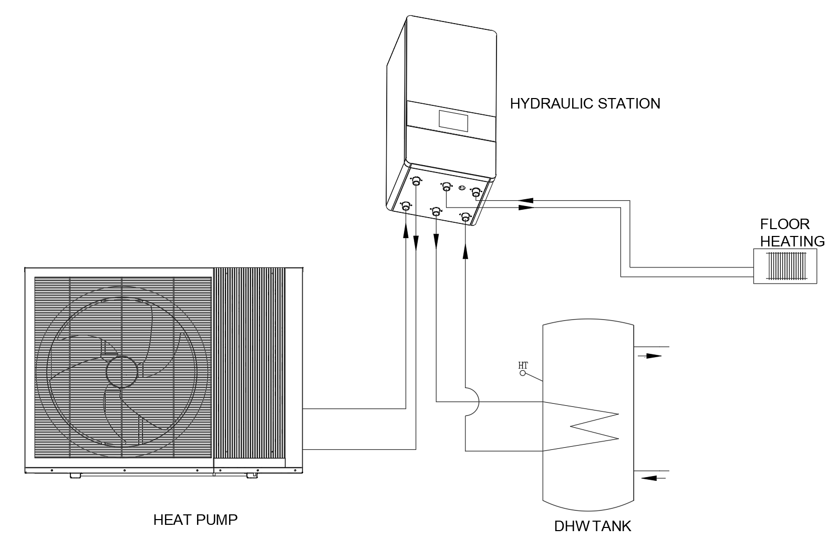

Carrying out the installation preparations
▶ Prepare the shut off valves, pressure reducing valve, non return valve, Y type fitler,etc.
▶ Check whether the volume of the installed expansion vessel is sufficient for the heating system. If required, install an additional expansion vessel, connected as close to the product as possible, in the heating return.
▶ Install the connection pipes such that they are free from mechanical stress.
▶ If you are using metallic pipes to connect the pipe to the outdoor unit, earth the pipes.
▶ Heat-insulate the pipes.
▶ Only solder connectors if the connectors are not yet screwed to the service valves.
▶ Carefully flush the heating installation before connecting the product.
▶ Check whether the expansion relief valve's drain pipework opposite the outdoor air remains open, is installed in a frost-free environment, always runs downwards and visibly ends in an open drain.
▶ For heating installations with solenoid valves or thermostatically controlled valves, install a bypass with bypass valve in order to guarantee a volume flow of at least 40%.

Model | Water piping between outdoor unit and indoor unit
Model | Rated flow rate (m³/h) | Inner diameter | Maximum length | Maximum Elevation
HSL08V-DNANW | 1.34 | 26mm | 30 m | 10 m
HSL10V-DNANW | 1.2 | 26mm | 30 m | 10 m
HSL12V-DNANW | 1.7 | 26mm | 30 m | 10 m
HSL15V-DNANW | 2.12 | 33mm | 30 m | 10 m

3.7.2 Expansion tank
The internal expansion tank in the hydraulic station and tower for space Heating / Cooling is 8L air capacity and initial pressure is 1 bar.
Total amount of water in system should be below 160 L.If total amount of water is over 160 L, please add another expansion tank. (field supply)
Please keep the installation height difference of system water circuit within 10 m. (Extra pump may be required).

3.8 Hydraulic tower installation
Dimension unit:mm
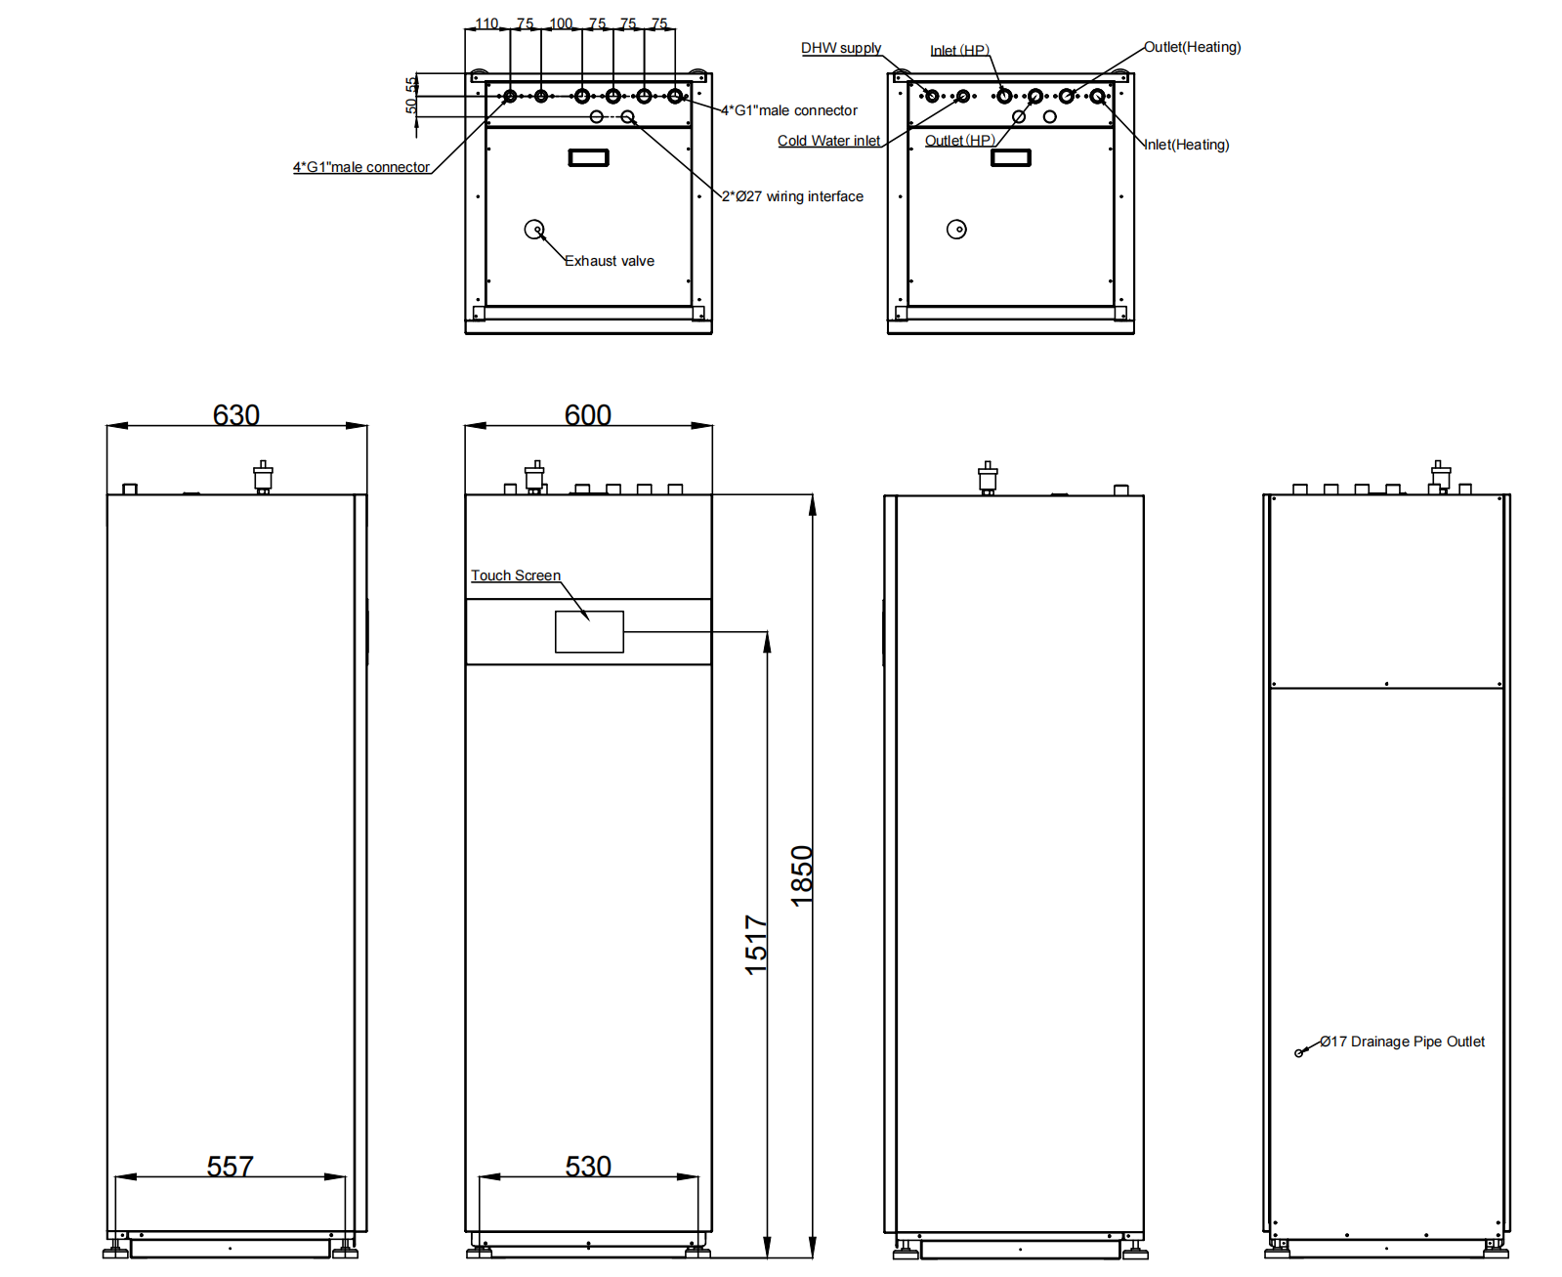

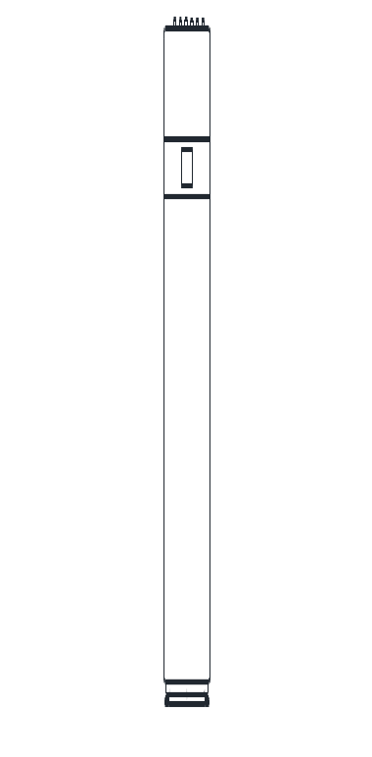

Unscrew the screws fixing the front panel on the bottom and Push the front panel upward to open the front panel to access electric terminal.

Carrying out the installation preparations
▶ Prepare the shut off valves, pressure reducing valve, non return valve, Y type fitler,etc.
▶ Check whether the volume of the installed expansion vessel is sufficient for the heating system. If required, install an additional expansion vessel, connected as close to the product as possible, in the heating return.
▶ Install the connection pipes such that they are free from mechanical stress.
▶ If you are using metallic pipes to connect the pipe to the outdoor unit, earth the pipes.
▶ Heat-insulate the pipes.
▶ Only solder connectors if the connectors are not yet screwed to the service valves.
▶ Carefully flush the heating installation before connecting the product.
▶ Check whether the expansion relief valve's drain pipework opposite the outdoor air remains open, is installed in a frost-free environment, always runs downwards and visibly ends in an open drain.
▶ For heating installations with solenoid valves or thermostatically controlled valves, install a bypass with bypass valve in order to guarantee a volume flow of at least 40%.
Selecting the installation site
▶ The installation site must be below 2000 metres above sea level.
▶ Select a dry room that is frost-proof throughout and in which the maximum installation height is not exceeded and the environmental temperature is neither above nor below the permitted range.
– Permissible environmental temperature: 7 … 35 ℃
– Permissible relative air humidity: 40 … 75 %
▶ Ensure that the required minimum clearances can be maintained.
▶ The permissible height difference between the indoor unit and outdoor unit must not be greater than 15 m.
▶ When selecting the installation site, you must take into consideration that, when the product is in operation, it transfers vibrations to the floor and the nearby walls.
▶ Ensure that the floor is even and offers sufficient loadbearing capacity to bear the weight of the product.
▶ Ensure that the pipes are routed appropriately.
▶ Do not install the product above another unit that may damage it (e.g. above a cooker that produces water vapour and grease) or in a room with a high level of exposure to dust or in a corrosive environment. There should not be any heat source or steam near the unit.
▶Do not install this appliance in a laundry room or other high humidity location. This condition will cause rust and damage to the unit.
▶ There is wifi module inside the hydraulic station, be sure that the wifi signal is covered on the installation place.
Minimum clearances and installation clearances
unit:mm
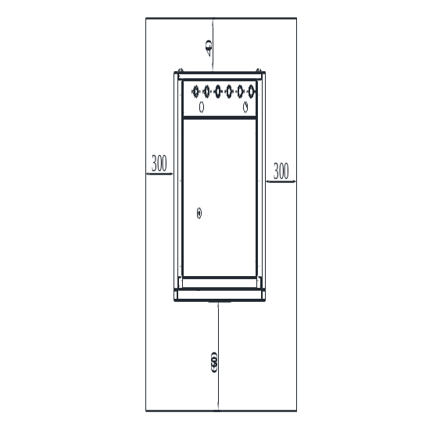
Setting up the hydraulic tower
When setting up the product, take its weight, including the water content, into account
Orientate the product horizontally by adjusting the adjustable feet.
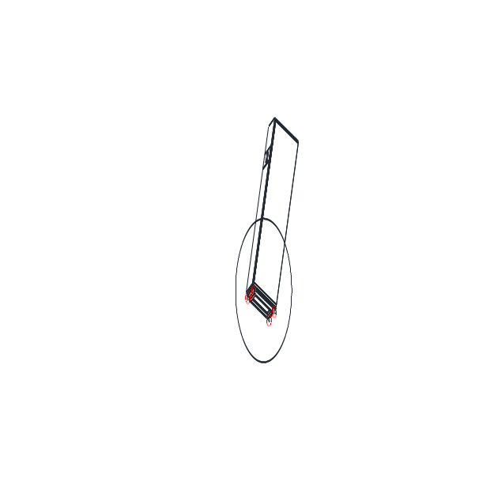

3.8.1 Hydraulics installation
Make sure to connect the pipes correctly and in correct flow direction as below diagram:

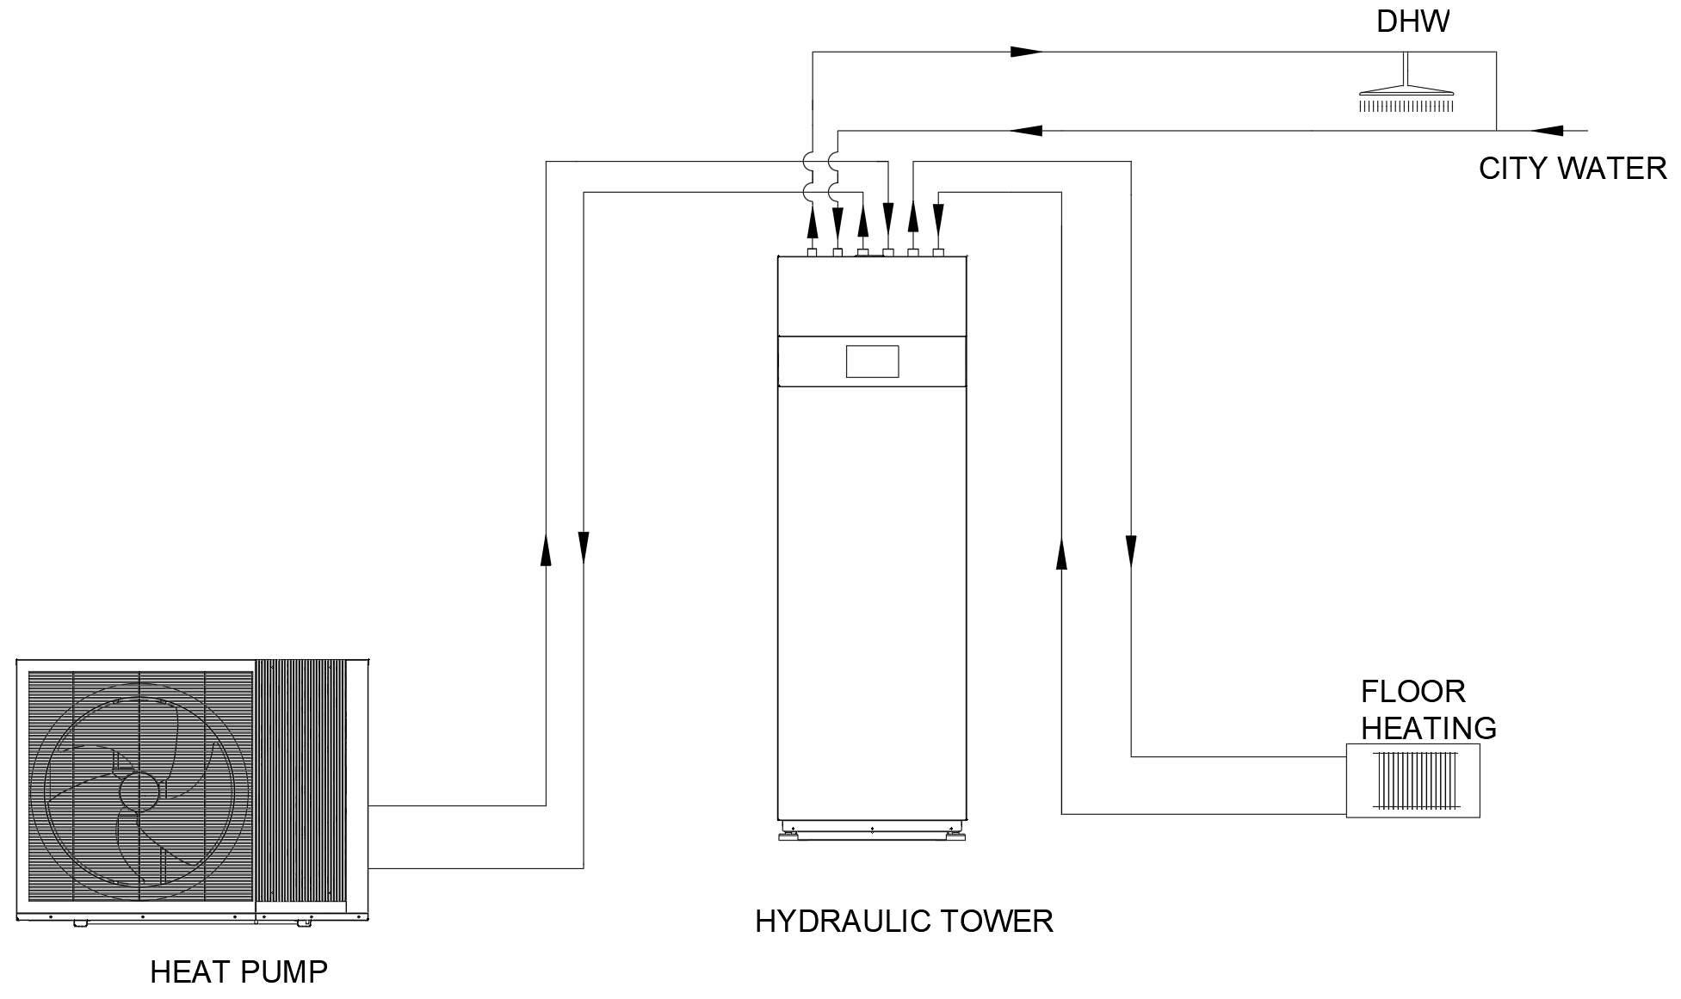

Model | Water piping between outdoor unit and indoor unit
Model | Rated flow rate (m³/h) | Inner diameter | Maximum length | Maximum Elevation
HSL08V-DNANW | 1.34 | 26mm | 30 m | 10 m
HSL10V-DNANW | 1.2 | 26mm | 30 m | 10 m
HSL12V-DNANW | 1.7 | 26mm | 30 m | 10 m
HSL15V-DNANW | 2.12 | 33mm | 30 m | 10 m

3.8.2 Expansion tank
The internal expansion tank in the hydraulic station and tower for space Heating / Cooling is 8L air capacity and initial pressure is 1 bar.
Total amount of water in system should be below 160 L.If total amount of water is over 160 L, please add another expansion tank. (field supply)
Please keep the installation height difference of system water circuit within 10 m. (Extra pump may be required).

3.8.3 Domestic Hot Water Tank Pipework
-It’s strongly recommended to install an expansion vessel (field supply) in the Domestic Hot Water Tank circuit. Refer system overview section to locate the expansion vessel. Recommended pre-charge pressure of the expansion vessel (field supply) = 3.5bar (0.35MPa)
- In high water pressure or water supply is above 5bar, please install the Pressure Reducing Valve for water supply. If the pressure higher than that, it might damage the hydraulic tower. Recommended Pressure Reducing Valve specifications: Set pressure: 3.5bar (0.35MPa)
- Must connect a faucet to DHW tank hot water outlet and city water supply, in order to supply water with appropriate temperature for shower or tap usage. Failure to do so might cause scalding.
- Failure to connect the tube appropriately might causing the hydraulic tower malfunction

3.8.4 Drain water pipe installation
The plastic drain pipe on the back of the hydraulic tower from its DHW tank temperature and pressure expansion relief valve must be connected to a tundish (field supply). The tundish must be installed vertically, as close to the hydraulic tower as possible and with a maximum clearance of 600 mm from the hydraulic tower. It must be installed in the same room as the hydraulic tower, but at a sufficient distance from electrical components. The drain pipes from the temperature and pressure expansion relief valve can be connected above the tundish using a T-piece.
The drain pipe from the tundish must consist of pipes with a diameter of at least 22mm and be connected to a safe and visible drainage point.
The vertical section of pipe beneath the tundish must be at least 300 mm long before any bends or diversions in the line.
When installing the drain pipework, comply with the standards, directives and laws that are applicable in your country.

3.9 Hydraulic installation notice
Important:
1.The pipe installation must adhere to the local Building Code, standards and any local council requirements.
2.The water supplied to the system must be clean and not contain heavy metals that could cause harm to the unit. The water must be treated with an approved inhibitor and tested annually to prevent corrosion, fouling and deterioration of the pump fittings.
3.Protection devices are to be installed to protect the unit from operating outside of its running parameter such as control devices; shutoff valve, bleed valves, safety valves and expansion tanks.
4.The pipe installation should be designed to have the least number of elbows and joiners as they reduce flow. Install drain connections at low points to allow the system to be drain if required.
5.Flexible connections should be used where possible to reduce vibration transmission.
6.Insulate all pipe work and exposed areas to protect against both thermal heat loss and to prevent condensation on chilled pipes.
7.When filling the water system, use air vents and flushing procedure to evacuate any residual air pockets.
8.The heat pump is not fitted with shutoff valves and therefore these must be fitted outside of the heat pump to facilitate future service requirement.
9.– Min. heating circuit pressure: ≥ 0.05 MPa (≥ 0.50 bar)
– Min. heating circuit operating pressure: ≥ 0.07 MPa(≥ 0.70 bar)
– Max. heating circuit pressure: < 0.3 MPa (< 3 bar)
– Max. heating circuit operating pressure: < 0.3 MPa (< 3 bar)
– Max. DHW tank in the hydraulic tower pressure: < 0.7 MPa (< 7 bar)
– Max. DHW tank in the hydraulic temperature: <70℃
10. Do not install automatic air purge valves on indoor water pipes. In the unlikely event that the R290 refrigerant leaks into the water circuit, there is a risk that the refrigerant will leak indoors

4 Systems Overview

4.1 Hydraulic station
4.1.1 without external buffer tank

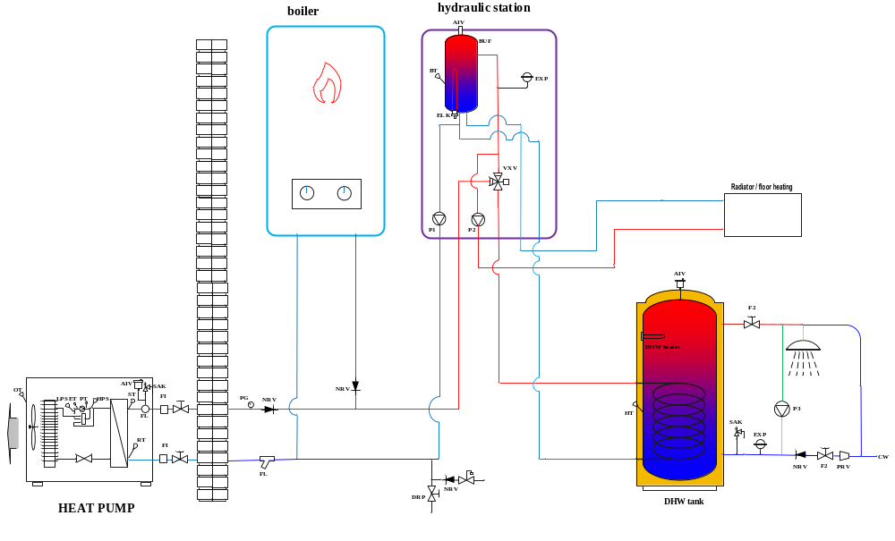

4.1.2 with external buffer tank.

If a large external buffer tank is required for the system, the external buffer tank could be connected to the secondary circuit as below:

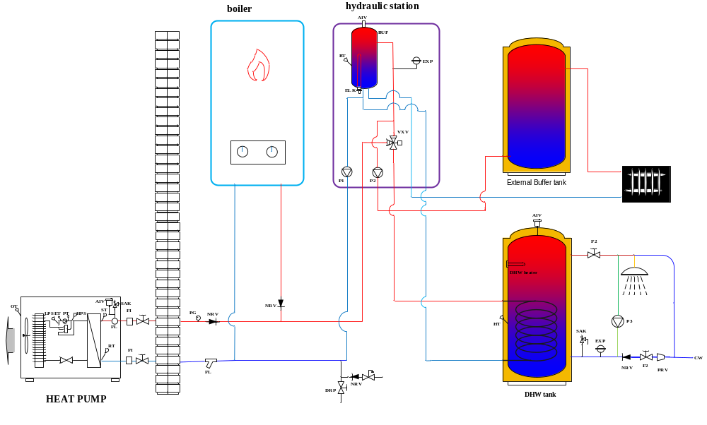

Name | Description | Included | Name | Description | Included
P1 | Primary Circulation pump | included | RT | Inlet water temperature sensor | included
VXV | 3 way valve | included | ST | Outlet water temperature sensor | included
BUF | Buffer tank | included | OT | Ambient temperature sensor | included
FI | Soft joint | NO | HT | Domestic hot water temperature sensor | included
F2 | Shut-off valve | NO | PT | Discharge gas temperature sensor | included
SAK | Safety valve | NO | ET | Suction gas temperature sensor | included
FL | Filter | NO | BT | Buffer tank water temperature sensor | included
AIV | Air vent valve | NO | HP | High pressure transducer | included
FS | Automatic water supplement valve | NO | LP | Low pressure transducer | included
ELK | Aux heater | included | EXP | Diaphragm expansion vessel | included
PG | pressure gauge | NO | DRP | drain pipe | NO
P2 | secondary pump | included | P3 | DHW circulation pump | NO
DPR | drain pipe | NO | NRV | non-return valve | NO
 |  |  | PRV | pressure reduction valve | NO

4.2 Hydraulic tower

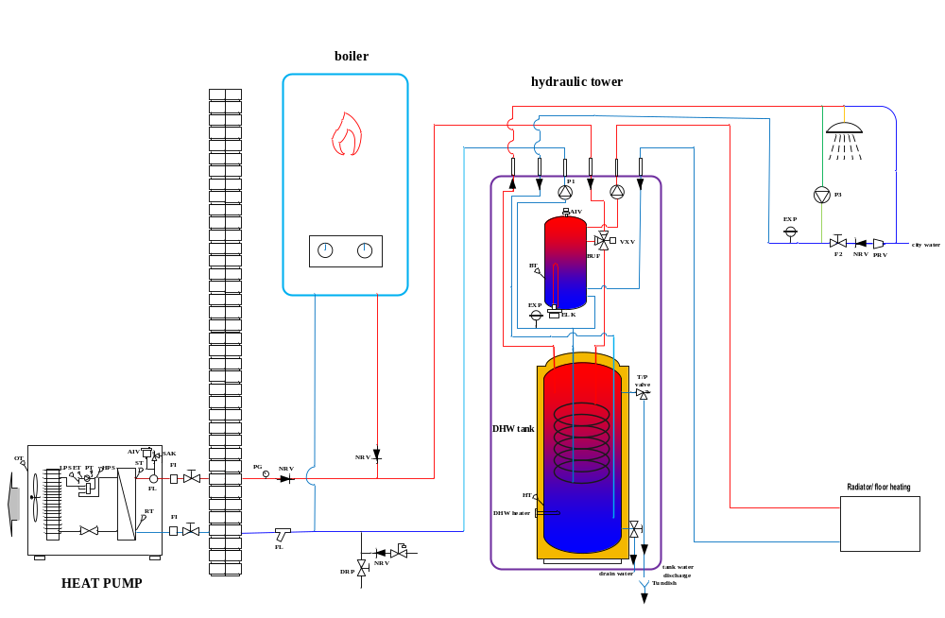

Name | Description | Included | Name | Description | Included
P1 | Primary Circulation pump | included | RT | Inlet water temperature sensor | included
VXV | 3 way valve | included | ST | Outlet water temperature sensor | included
BUF | Buffer tank | included | OT | Ambient temperature sensor | included
FI | Soft joint | NO | HT | Domestic hot water temperature sensor | included
F2 | Shut-off valve | NO | PT | Discharge gas temperature sensor | included
PRV | pressure reduction valve | NO | ET | Suction gas temperature sensor | included
FL | Filter | NO | BT | Buffer tank water temperature sensor | included
AIV | Air vent valve | NO | HP | High pressure transducer | included
FS | Automatic water supplement valve | NO | LP | Low pressure transducer | included
ELK | Aux heater | included | EXP | Diaphragm expansion vessel | included
PG | pressure gauge | NO | DRP | drain pipe | NO
P2 | secondary pump | included | P3 | DHW circulation pump | NO
DPR | drain pipe | NO | NRV | non-return valve | NO

4.4 System Overview : Heating, Cooling with DHW Production

Heating Mode Working Principle:
On heating mode, 3 way valve (VXV) will turn to heating circuit.
Unit On : when inlet water temp. (inside the buffer tank )＜T(heating) - ST04( temp. diff. heating).
（T(heating) is the user set control water temperature on heating mode)
Unit Off: inlet water temp.＞T(heating) + 2℃.

T(heating) calculation:
1.) When SF04 weather compensation=OFF. T(heating)= user set heating water temperature.
2.) When SF04 weather compensation=ON, heating curve is activated,
T(heating) ＝calculated control water temperature as per the user menu weather compensation calculation result.

The max. outlet water temperature TL is subject to the unit heating operating range envelope.

Auxiliary Electric backup heater control
Auxiliary backup heater only could be switched on when all of conditions below are met.
1.) Heating mode running and compressor has been running on the maximum workable frequency.；
2.) Compressor has run over 300s
3.) OT (Ambient temp.) ≤ST07（Back up heater external setup）；
4.) inlet water temp. ≤T(heating)-ST04(temp. diff. heating)-2；
5.) Compressor has run over 5 minutes.

Auxiliary backup heater is switched off when any of conditions below is met.
1.) A/C flow alarm.
2.) inlet water temp. ≥T(heating) - 2；

Boiler control
If a boiler is set up with the system, parameter SF224 Enable gas boiler should be set to ON.
After boiler is enabled, it works on hybrid mode or takeover mode as per the ambient temp. and parameter setting:
- Hybrid mode
Boiler only could be switched on when all of conditions below are met.
1.) Heating mode running and compressor has been running on the maximum workable frequency.
2.) Compressor has run over 300s.
3.) OT≤ST200 (Boiler external temp. setup, default 0℃ ).
4.) Inlet water temp. ≤T(heating)-ST04 (temp. diff. heating)-2.

Boiler is switched off when any of conditions below is met.
1.) OT≥ST200+2℃
2.) Inlet water temp. ≥ T(heating) – ST04；

- Boiler takeover mode
Boiler takes over heating job and compressor is switched off when all of conditions below are met.
1.) OT≤ST201 (Boiler takeover external setup, default -10℃ ) ；
2.) Compressor is running on heating mode.

It returns to hybrid mode when OT≥ST201+2℃

Cooling Mode Working Principle:
On cooling mode, 3 way valve (VXV) will open AB-A.
Unit On: Inlet water temp.>T(cooling)+ST03(temp. diff. cooling)
（T(cooling) is the user set control water temperature on cooling mode)
Unit Off: Inlet water temp.＜T(cooling)-1.5℃.

T(cooling) calculation:
1.) When SF04 weather compensation=OFF. T(cooling)= user set cooling water temperature.
2.) When SF04 weather compensation=ON, cooling curve is activated,
T(cooling) ＝calculated control water temperature as per the user menu weather compensation calculation result.

Hot water production working principle:
On hot water mode, 3 way valve (VXV) will open AB-B.

TL - the max. operating outlet water temperature as per compressor heating operating range envelope.
On DHW mode, compressor runs with ST=ST09+5 as outlet water temperature target PID compressor speed control. If ST09+5 > TL, then TL is the target PID control outlet water temp.
1.) Compressor On: HT≤ST09 (DHW set point)-ST10
Compressor Off conditions:
A.) HT＞ST09
B.) HT<ST09 but outlet water ST ≥ TL+2 .It records HT1 – the instant HT when the compressor off and will restart to heat DHW when HT1<HT1-ST10. If DHW heater is installed, it is switched on to heat DHW up to ST09 when compressor stops.

5 Electrical Connections

5.1 Terminal diagram

5.1.2 3-phase outdoor unit and hydraulic station DSK09-DPVTSG wiring
connection overview:

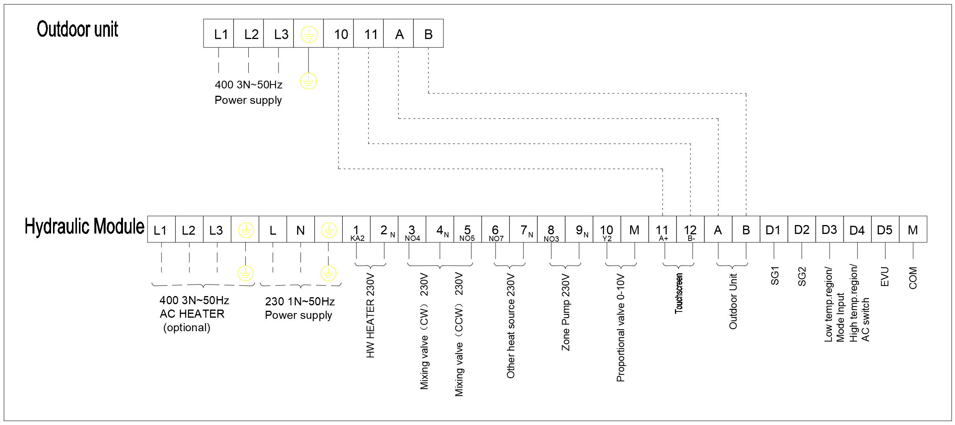
Remark:L1 L2 L3 does not need to connect if no need to connect to an AC heater.

5.1.4 3-phase outdoor unit and hydraulic tower DSK06-DPVTSL200 wiring
connection overview:

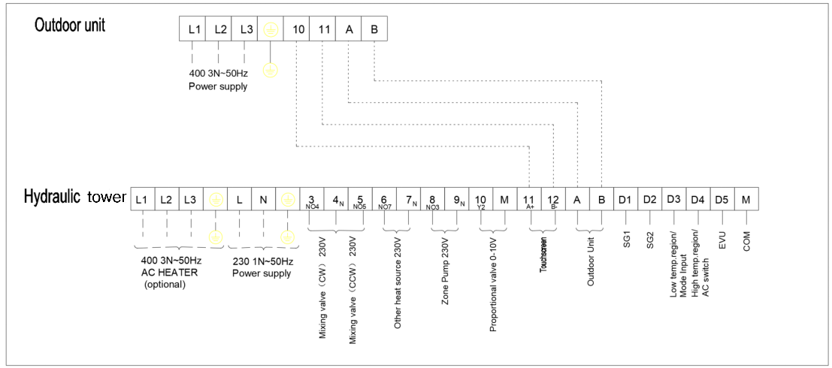

Remark: L1 L2 L3 does not need to connect if no need to connect to an AC heater.

5.1.5 IO board function description

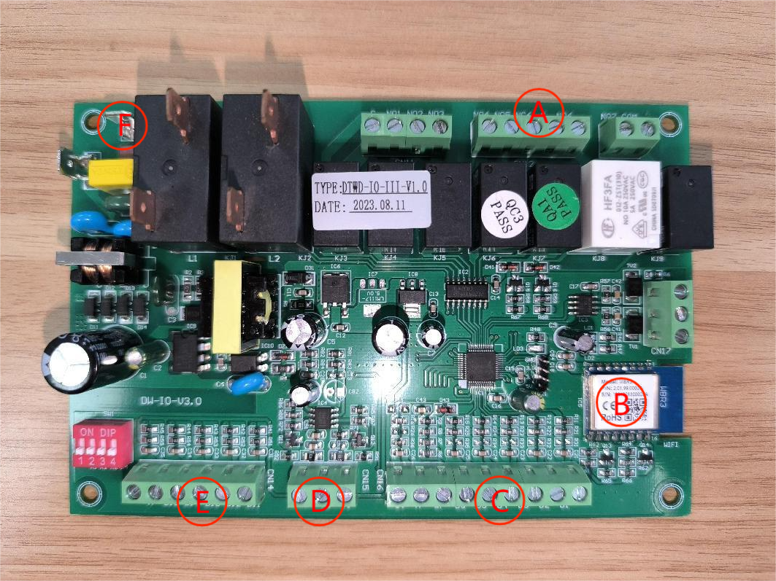

A: Switch signal output point;
B: WIFI chip;
C: Analog signal input point;
D: Analog signal output point;
E: Switch signal input point;
F: power supply input point;

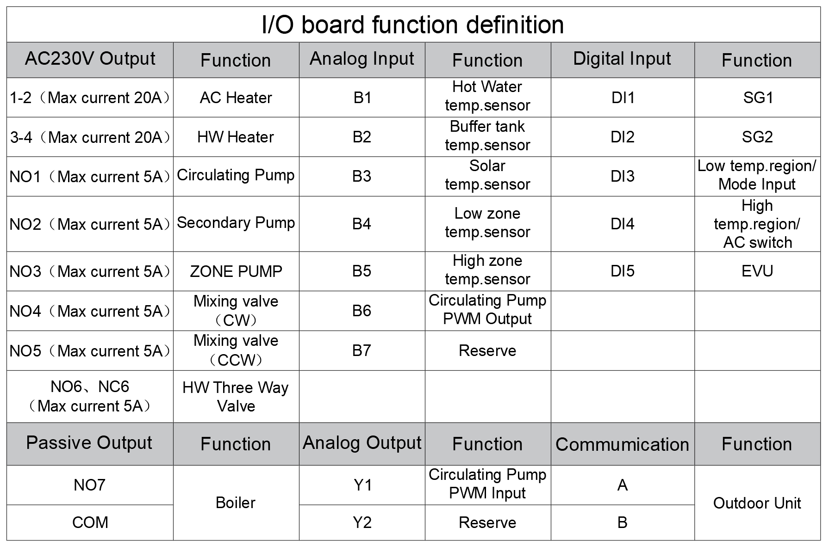

5.2 Recommended power cables and fuse

5.2.1 For heat pump outdoor units:
Model |  |  | HSL08V | HSL10V | HSL12V-Q | HSL15V-Q
Rated voltage | V | 400V/50Hz 3~/N/PE
Rated power, Max | KW |  | 2.86 | 3.22 | 4.15 | 7.10
Rated current ,Max. | A |  | 12.5 | 14 | 18 | 32
Fuse | A |  | 4 | 5 | 8.5 | 11.5
power cable with temperature resistance of 90 °C | mm² | 5X4
indoor/outdoor unit communication cable （A+ B-） | mm² | 2X0.5
Other control device Modbus communication A1-B1 | mm² | 2X0.5
fuse type |  | C characteristics, slow blow

Model |  | HSL12V-D | HSL15V-D
Rated voltage | V | 400V/50Hz 3~/N/PE
Rated power, Max | KW | 5.30 | 6.50
Rated current , Max. | A | 9.0 | 11.5
Fuse | A | 10 | 13
power cable with temperature resistance of 90 °C | mm² | 5X4
indoor/outdoor unit communication cable （A+ B-） | mm² | 2X0.5
Other control device Modbus communication A1-B1 | mm² | 2X0.5
fuse type |  | C characteristics (slow blow),  3-pole switching

5.2.2 For hydraulic station:
Model |  | DSK06-DPVTSG
Rated voltage | V | power supply X1：220-240V/50Hz 1~/N/PE
Rated voltage | V | power supply X2:380-415V/50Hz 3~/N/PE
Rated power，Max. | KW | power supply X1:0.3
Rated power，Max. | KW | power supply X2:6
Rated current , Max. | A | power supply X1:1.3
Rated current , Max. | A | power supply X2:9
Fuse | A | power supply X1: 5
Fuse | A | power supply X2:10
power cable with temperature resistance of 90 °C | mm2 | power supply X1:3X2.5
power cable with temperature resistance of 90 °C | mm2 | power supply X2:3X2.5
Max. cable length | m | 30
fuse type |  | B characteristics
Connector 1-2,3-4,4-5,6-7 | mm2 | 2X1
connector D1-M,D2-M,D3-M,D4-M | mm2 | 2X0.5

5.2.3 For hydraulic tower:
Model |  | DSK06-DPVTSL200
Terminal contact |  | power supply X1 | power supply X2
Rated voltage | V | 230V/50Hz 1~/N/PE | 400V/50Hz 3~/N/PE
Rated power，Max. | KW | 3.4 | 6
Rated current , Max. | A | 14.8 | 9
Fuse | A | 16 | 10
power cable with temperature resistance of 90 °C | mm2 | 4X2.5
Max. cable length | m | 30
fuse type |  | B characteristics
Connector 1-2,3-4,4-5,6-7 | mm2 | 2X1
connector D1-M,D2-M,D3-M,D4-M | mm2 | 2X0.5

5.3 Power Connection

Single phase: Triple phase:
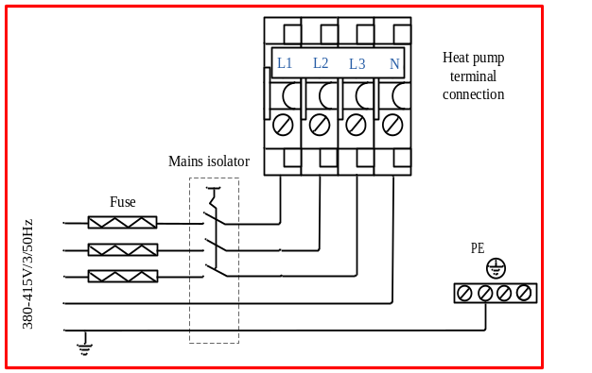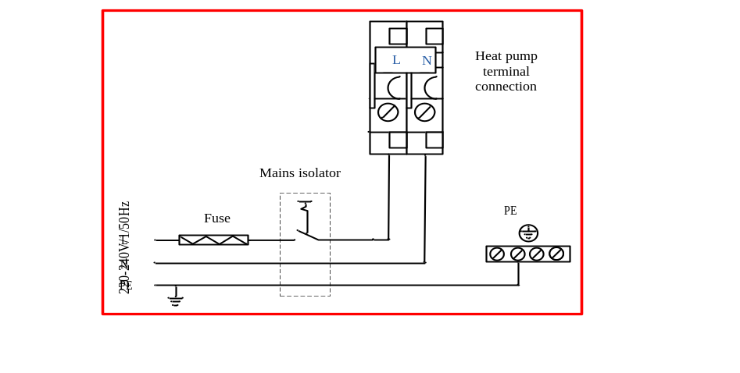

Before connecting the power supply, please confirm the unit suits the power supply.

- The appliance shall be installed in accordance with national wiring regulations.
- An all pole disconnection device which has at least 3mm clearances in all poles, and have a leakage current that may exceed 10mA, the residual current device (RCD) having a rated residual operating current not exceeding 30mA, and disconnection must be incorporated in the fixed wiring in accordance with the wiring rules.
- The appliance includes an inverter for the variable speed compressor. In case of a fault, inverters can cause DC residual currents. RCDs have to be type B AC/DC-sensitive. A DC residual current can block type A RCDs.
- Breaker protection must be installed according to the max value stated in the nameplate attached to the unit inside of the front panel.
- Make sure to install earth wiring. Do NOT earth the unit to a utility pipe, surge absorber, or telephone earth. Incomplete earth may cause electrical shock.
- The power supply must conform to the specification on the unit’s nameplate. The supply voltage must be within the range specified in the electrical data table. For wiring connection, refer to the electric wiring diagram on the inside panel of the unit.
- When the building is equipped with a RCD the heat pump should be equipped with a separate one．
- When installing the earth leakage protector, make sure it is compatible with the inverter (resistant to high frequency electric noise) to avoid unnecessary opening of the earth leakage protector.

IMPORTANT:

During the installation of the unit, first make the water connections and then electrical connections. If the unit is to be removed first disconnect the electrical connections, then the water connections to reduce the chance of an electrical shock.

WARNING:

Disconnect the main power supply switch before servicing the system or handling any internal parts of the unit.
In case of any major malfunction turn the unit off, disconnect the mains power supply and contact a qualified service engineer.

5.3.1 DHW temperature sensor - for hydraulic station and control box
The domestic hot water sensor probe in the hydraulic station and control box
should be put into hot water cylinder temperature sensor probe inlet pocket if DHW system is set up.
If the domestic hot water sensor cable runs close to power cables, then a shielded cable should be used. If a conduit is used then it should be sealed to avoid condensation forming in the temperature sensor probe．

Buffer tank water temperature sensor - only for control box
The buffer tank water sensor probe in the control box is the inlet water temp. for unit heating and cooling on/off control and should be put into buffer tank temperature sensor probe inlet pocket.
If the buffer tank water sensor cable runs close to power cables, then a shielded cable should be used. If a conduit is used then it should be sealed to avoid condensation forming in the temperature sensor probe．

Important:
All temperature sensor must be separated (min 200 mm) from high voltage power cables to avoid interference which will cause measured temperature fluctuating and the heat pump may operate incorrectly.

5.3.2 Mixing Valve Control Signals CW and CCW​
The 3-4 contact on the hydraulic station/tower terminal block is used to connect the clockwise (CW) control signal​ for the zone mixing valve.
The 5-4 contact on the hydraulic station/tower terminal block is used to connect the counterclockwise (CCW) control signal for the zone mixing valve.
The terminal 3 and Terminal 5 are the 230V control power supply outputs, while Terminal 4 is the common neutral (N) line of the power supply.
Adjustments to the mixing valve rotation direction must be made based on the actual installation conditions and requirements of the customer.
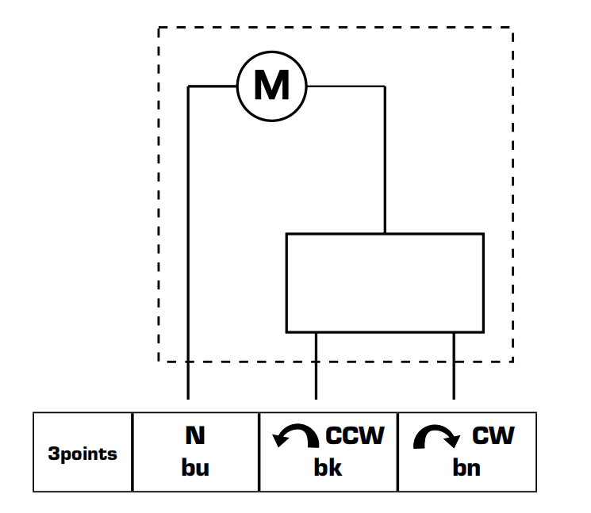

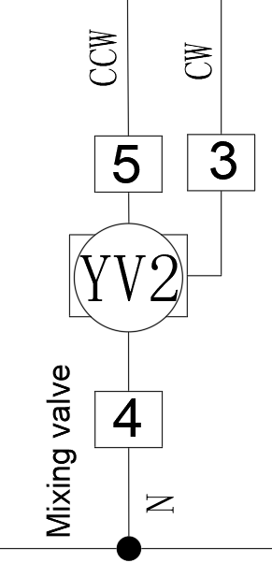

5.3.3 Boiler
Connector (6-7) potential free contact for hydraulic station and tower and NO7-COM potential free IO board connector for control box can be used to activate and de-activate a backup heating device like a boiler (field supply).
Backup boiler control refer to “System overview” chapter
(important: this is potential free contact. do not apply any voltage source to it)

5.3.4 DHW heater
Connector (1-2) 230VAC for hydraulic station can be used to activate and de-activate a DHW electric heater (installed in the water tank) for heating domestic hot water heater via a relay JQ (field supply).

(Triple phase)
(Single phase)

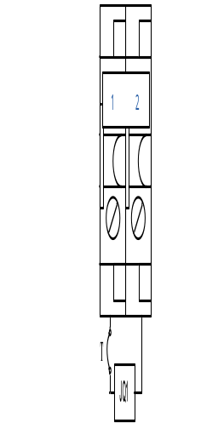
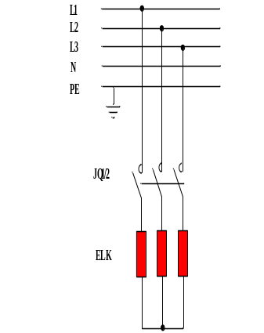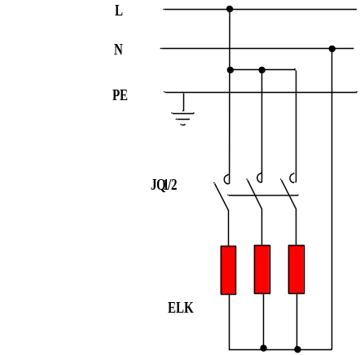

(important: do not connect electric heaters directly to the terminal block that could burn the controller).
Terminal connector could be directly connected to a DHW heater not over 3KW. If DHW heater is connected, then the mains power connector L1-N1 need to connected to an independent power source.

DHW electric heater (Field supply) control refer to “System overview” chapter.

5.3.5 Touchscreen communication connection (10-11) potential free
Terminal connector 10-11 used to connect to the indoor unit touch screen for unit functions and parameter settings.

5.3.6 Indoor and outdoor unit communication connection (A- B)
The A -B potential free contact on the outdoor unit terminal block and hydraulic station terminal block should be connected.

5.3.7 AC switch/High temperature zone switching signal
By default, the unit space heating and cooling function is turned on or off via touch screen on/off button.
It is possible to turn on and off the unit space heating and cooling function as per the room temperature via a room temp. thermostat.
Need to connect a potential free on/off switch signal to the D4-M terminal block of hydraulic station and tower or DI4-M IO board terminal connector of control box and change SF14 in service menu to remote.

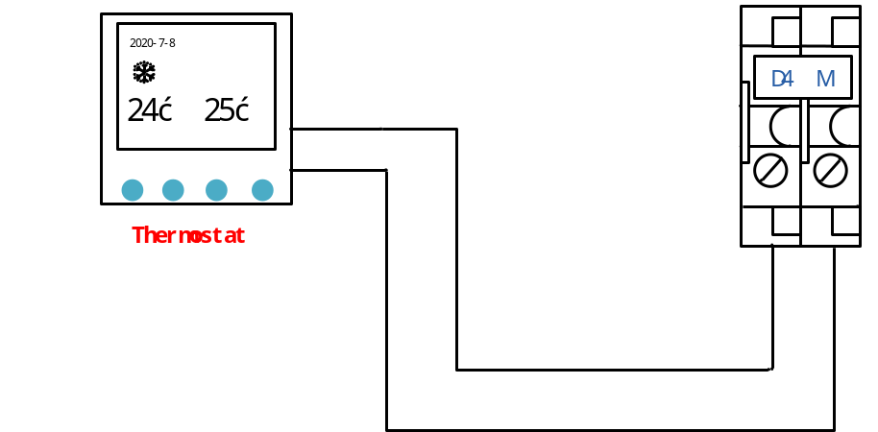
If SF14 set = “remote”. the unit on/off control is taken over by the thermostat and the touch screen can not turn On/Off the heating cooling function and no heating cooling schedule On/Off function.
when D4-M connector (hydraulic station/tower), DI4-M (control box) is bridged by room temp. thermostat, the unit is switched on and will go to standby after the buffer tank water temperature reaches set point.
when D4-M connector (hydraulic station/tower), DI4-M (control box) is disconnected by room temp. thermostat, the unit is switched off.
Important: need to set a good thermostat hysteresis to avoid too short running cycle. The unit needs to run continually at least 20 minutes to permit a defrosting cycle. If the running cycles are always shorter than 20 minutes, the defrosting can not be activated and cause heavily frosted evaporator.

When the zone control function is activated, the input contact signal is switched from the AC Switch to the high-temperature zone control switch. When there is a heating demand in the high-temperature zone (e.g., radiators), a switch signal is sent via this input contact point, prompting the heat pump to initiate startup. Upon receiving the signal, the heat pump begins operation. When the input signal is turned off, the heat pump will either shut down or reduce output (depending on the heating demand of the low-temperature zone).

Note
This is a potential free input contact only. DO NOT PUT 230VAC INTO THIS CONTACT

5.3.9 SG READY -Smart Grid
The units are with SG - smart grid label certification from German heat pump association.
If there is SG signal or PV system signal, they could be connected to the unit.
This function can only be used in mains networks that support the "SG Ready" standard.
"SG Ready" requires two AUX inputs.
In cases where this function is required, it must be connected to terminal block D1-M and D2-M for hydraulic station and tower, DI1-M and DI2-M IO board terminal for control box.
"SG Ready" is a smart form of tariff control, through which your electricity supplier can affect the heating, cooling and hot water temperatures (if applicable) or simply block the heat pump at certain times of the day.

1.) Connectors D1-M for hydraulic station and tower, DI1-M IO board terminal for control box is connected to SG1 and D2-M for hydraulic station and tower and DI2-M IO board terminal for control box is connected to SG2 of the electric meter SG signal.
2.) SF217 parameter in Service menu are used to turn on / off unit SG function.
When SG function is set OFF, SG function is invalid.
When SG function is set ON, SG function is valid. "SG mode" display on touch screen. SG1 SG2 signal status display on I/O menu.

1.) SG1=closed，SG2=open：switch off command
Unit has to stop. but anti-freezing function is still valid so water pump could be switched on if anti-freezing circulation is needed.

2.) SG1=open，SG2=open：normal operation.
unit runs in normal program regulation.

3.) SG1=open，SG2=closed：switch-on recommendation: cheap electricity mode;
A) On heating mode, heating control water temperature automatically increase ST17 (SG cool/heat diff. default 2) to store heating energy. but the maximum heating control water temp. is limited by ST14 (max. heating setpoint, default 60).
B.) On DHW mode, DHW control temperature automatically increase ST18 (SG DHW diff. default 5) to store DHW energy. but the maximum DHW control temperature is limited to 65.
C) On cooling mode, cooling control water temperature automatically decrease ST17 to store cooling energy. but the minimum cooling control water temp. is limited by ST11 (min. cooling setpoint, default 12).

4.) SG1=closed，SG2=closed：switch-on command; very cheap electricity mode
A) On heating mode, heating control water temperature automatically increase ST17+2 to store more heating energy. but the maximum heating control water temp. is limited by ST14.
B.) On DHW mode, DHW control temperature automatically increase to 65 to store maximum DHW energy. DHW electric heater (installed in the water tank) is switched on after compressor stops when ST> TL+2 until DHW temperature reaches 65.
C) On cooling mode, cooling control water temperature automatically decrease ST17-2 to store more cooling energy. but the minimum cooling control water temp. is limited by ST11.

5.3.14 Mode input/Low temperature zone switching signal
The unit cooling or heating mode is possible to change via a potential free signal from a thermostat, etc.
Need to set SF113 enable mode change input to ON.
Connect the mode signal from thermostat to the mode input switch Hydraulic station/tower terminal D3-M or control box terminal DI3-M. When the mode input switch is bridged, it is cooling mode, when the mode input switch is disconnected, it is heating mode.
The mode input signal must be potential free.

When the zone control function is enabled, the input contact signal is switched from the AC Switch to the low-temperature zone control switch. When there is a heating demand in the low-temperature zone (e.g., radiators), a switch signal is transmitted through this input contact point, triggering the heat pump to start up. Upon receiving the signal, the heat pump initiates operation. When the input signal is disabled, the heat pump will either shut down or reduce output (depending on the heating demand of the high-temperature zone).

6 System program information

6.1 Unit operation logic

6.1.1 Cooling demand
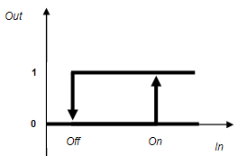

In: RT inlet water temperature (also the buffer tank water temperature）
On: RT>ST01 (cooling setpoint)+ST03 ( cooling diff.)
Off: RT＜ST01-1.5℃

6.1.2 Heating demand
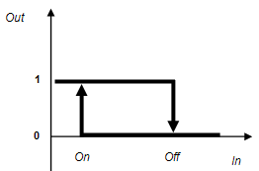
In: RT
On: RT＜T(heating)-ST04（T(heating) is the control water temperature on heating mode）
Off: RT＞T(heating) + 2℃.
T(heating) calculation:
Default ST02=35, ST06=0.6
1.) When SF04=No, there is no heating curve. T(heating)=ST02.
2.) When SF04=Yes, heating curve is activated
T(heating) ＝ST02 +（20-OT）x ST06
If calculated T(heating) is higher than ST14 (max. heating setpoint), ST14 would be T(heating).
Refer to chapter “Heating compensation curve setting”.
The max. outlet water temperature is also subject to “operating range”.

6.1.3 Domestic hot water demand
HT – Hot water temp.
TL - the max. operating outlet water temperature as per compressor heating operating range envelope.
On DHW mode, compressor runs with ST=ST09+5 as outlet water temperature target PID compressor speed control. If ST09+5 > TL, then TL is the target PID control outlet water temp.
1.) Compressor On: HT≤ST09 (DHW set point)-ST10
Compressor Off conditions:
- HT＞ST09
- HT<ST09 but outlet water ST ≥ TL+2 .It records HT1 – the instant HT when the compressor off and will restart to heat DHW when HT1<HT1-ST10. If DHW heater is installed, it is switched on to heat DHW up to ST09 when compressor stops.

6.2 Control process

6.2.1 Turn on process on heating mode
- Start water pump, check water flow
- if water flow meet requirement and there is heating demand, start fan and compressor

6.2.2 Turn off process on heating mode
- Switch off compressor
- After 5 second’s delay, switch off fan motor
- After 30 seconds’ delay, switch off water pump.

6.2.3 Turn on process on cooling mode
- Start water pump and 4 way valve, check water flow
- if water flow meet requirement and there is cooling demand, start fan and compressor

6.2.4 Turn off process on cooling mode
- Switch off compressor
- After 5 seconds' delay, switch off fan motor
- After 30 seconds’ delay, switch off water pump.
- After 120 seconds’ delay, switch off 4 way valve.

6.2.5 Turn on process on hot water mode
1.) start 3 way valve and water pump, check water flow.
2.) if water flow meets requirement, start fan and compressor

6.2.6 Turn off process on hot water mode
- Switch off compressor
- After 5 seconds' delay, switch off fan motor
- After 30 seconds’ delay, switch off water pump and 3 way valve.

6.2.7 Hot water priority:
- When unit is heating, if there is a call for hot water, it starts 3 way valve at once and turn to hot water mode directly. It will revert back to heating mode after hot water reach set temperature.

- When unit is cooling, if there is a call for hot water, it stops compressor first and then start at hot water mode, it stops compressor again when hot water reach set temperature before it reverts back to cooling mode.

6.2.8 Water pump control
- Circulation pump is switched on when cooling, heating or DHW mode is turned on.
Circulation pump continues to run on cooling, heating or DHW mode running.
- When compressor is just turned ON on heating or cooling mode, circulation pump PWM signal output is 100% for the first 3 minutes, and then run PID control
- During defrosting period and 3 minutes after the end of defrosting, circulation pump PWM signal output is 100%.

After circulation pump stops running over 24 hours, circulation pump is switched on and runs 3 minutes. The PWM signal output is 60%. This is to prevent the pump from seizing.

6.2.9 Compressor running control
1.) On cooling mode, when RT≤T (cooling)-0.5℃，compressor runs with minimum frequency.
when RT≤T (cooling)-1.5℃，after running 10 seconds with minimum frequency, compressor is switched off.
when ST≤7℃，compressor runs with minimum frequency.
when ST≥8℃，compressor runs with normal PID control.
2.) On heating mode, when RT≥T(heating)+0.5℃, compressor runs with minimum frequency.
when RT≥T(heating)+2℃，after running 10 seconds with minimum frequency, compressor is switched off.

6.2.10 4 way valve control
4 way valve is OFF under any of below conditions. It is ON under any other conditions.
- Heating mode, hot water mode, or heating + hot water mode
- Producing hot water on cooling + hot water mode.

6.2.11 Auxiliary Electric backup heater control
Auxiliary backup heater only could be switched on when all of conditions below are met.
1.) Heating mode running and compressor has been running with the maximum workable frequency.；
2.) Compressor has run over 300s
3.) OT≤ST07；
4.) RT ≤T(heating)-ST04-2；

Auxiliary backup heater is switched off when any of conditions below is met.
1.) A/C flow alarm.
2.) RT≥T(heating) - 2；
3.) unit is switched off

6.2.12 Crankcase heater running control
When all of conditions below are met, compressor crankcase heater is switched on
1.) Compressor is OFF；
2.) OT≤10℃
When any of conditions below is met, compressor crankcase heater is switched off
1.) Compressor is ON；
2.) OT≥11℃

6.2.13 3 way valve control
3 way valve is ON when there is DHW demand. Otherwise, it is OFF.

6.2.14 DHW circulation pump control
1.) when DHW mode is switched on, DHW circulation pump will be switched on and run ST34 in every ST33 interval.
2.) when DHW mode is switched off, DHW circulation pump is switched off after 3 minutes' delay.

6.2.15 DHW electric heater control

- when HT < ST09, compressor stops heating DHW due to ST>TL+2, DHW electric heater is switched on until HT≥ST09.

- If the unit with fault and there is DHW demand, DHW heater is switched on until HT≥ST09

3.) DHW heater is switched on to kill bacteria until HT≥ST27 after compressor is switched off when ST>TL+2 and HT is not over ST27 in ST26 time interval. If ST26=0, bacteria killing function is not valid. by default ST26=360hours. Disinfection function is only valid when DHW switch is turned on.

6.2.16 De-icing heater running control
When all of conditions below are met, de-icing heater is switched on

1.) Compressor is ON；
2.) Heating or DHW mode running
3.) Ambient temperature OT ≤ 0

When any of conditions below is met, de-icing heater is switched off

1.) Compressor is OFF；
2.) Ambient temperature OT＞2；

6.2.17 Defrosting control
The unit is equipped with hot gas defrosting. When the conditions of defrosting are met,
1.) compressor speed begins to go down.
2.) After compressor speed reduces to 30Hz and last 60 seconds, 4 way valve is switched on, fan motor is switched off and it begins to count defrosting time . the hot gas flows out to the finned coil heat exchanger .
3.) 10 seconds after 4 way valve is switched on , compressor speed increases to rated cooling speed.
4.) When condensation temperature≥25 ,fan motor is switched on and runs in CN02 speed for 10 seconds to blow down the condensed water.
5.) After the conditions of ending defrosting is met, compressor speed reduces and it stop counting defrost time.
6.) After compressor reduces to 30Hz and last 10 seconds, 4 way valve is switched off and fan motor is switched on. The hot gas flows into brazed plate heat exchanger and the unit returns to heating mode operation.
7.) 60 seconds after 4 way valve is switched off, compressor recovers to run with the speed as PID control.
Defrosting mode activation conditions one (all must be met)
a.) The unit running time after previous defrosting ≥DF06
b.) Temperature differential OT minus LPS ≥△T and last 60 seconds .
△T=DF04-4*(CM15-CMF)/(CM15-30),CMF is current compressor running frequency
c.) LPS≤ -2 and last 5 minutes.
d.) Compressor has run more than 5 minutes.
e.)Ambient temperature OT＜12

Defrosting mode activation conditions two (all must be met)
f.) The accumulated compressor running time is over DF16 after LPS≤ -2 and compressor has run more than 5 minutes.
When any of above condition one or two are met, unit will start to defrost.

Defrosting ends condition (any of the following conditions is met)
A.) High pressure HPS≥30 and last 5 seconds.
B.) HPS ≥ DF09 and last 10 seconds
C.) AL17 alarm
D.) ST≤7℃ and last 5 seconds.
E.) Defrost time ≥ 8 minutes

6.2.18 Automatic optimizing defrosting parameter data
Optimization solution one (if the last defrosting is activated by condition one as above)
1.) if previous defrosting time is less than 3 minutes and defrosting is terminated by above condition A or B. It means that there is little frost on the evaporator when unit start defrosting. Then on the next time defrosting, DF04 will add 1℃. After this optimization, next time defrosting will be activated a little later.
2.) if previous defrosting time is between 3 to 5 minutes, on next time defrosting, DF04 does not change.
3.) if previous defrosting time is over 5 minutes and defrosting is terminated by above condition A or B. If on previous defrosting activation, DF06 is the last condition to meet, then DF04 does not change in next defrosting. Otherwise, DF04 value will reduce 1℃ in next defrosting.
4.) DF04 optimized valued is limited by its max setting and min setting value.

Optimization solution two (if the last defrosting is activated by condition two mentioned above)

1.) if previous defrosting time is less than 3 minutes and defrosting is terminated by above condition A or B. It means that there is little frost on the evaporator when unit starts defrosting. Then on the next time defrosting, DF16 will add 10 minutes. After this optimization, next time defrosting will be activated a little later.

2.) if previous defrosting time is between 3 to 5 minutes, on next time defrosting, DF16 does not change.

3.) if previous defrosting time is over 5 minutes and defrosting is terminated by above condition A or B. It means that there is too much frost on the evaporator when the previous defrosting is activated. DF16 value will reduce 10 minutes in next defrosting. After this optimization, next time defrosting will be activated a little earlier.

- ) DF16 optimized valued is limited by its max setting and min setting value.

7 Information on servicing

7.1 Security check
1) Checks to the area
Prior to beginning work on systems containing flammable refrigerants, safety checks are necessary to ensure that the risk of ignition is minimised. For repair to the refrigerating system, the following precautions shall be complied with prior to conducting work on the system.
2) Work procedure
Work shall be undertaken under a controlled procedure so as to minimise the risk of a flammable gas or vapour being present while the work is being performed.
3) General work area
All maintenance staff and others working in the local area shall be instructed on the nature of work being carried out. Work in confined spaces shall be avoided. The area around the workspace shall be sectioned off. Ensure that the conditions within the area have been made safe by control of flammable material.
4) Checking for presence of refrigerant
The area shall be checked with an appropriate refrigerant detector prior to and during work, to ensure the technician is aware of potentially flammable atmospheres. Ensure that the leak detection equipment being used is suitable for use with flammable refrigerants, i.e. non-sparking, adequately sealed or intrinsically safe.
5) Presence of fire extinguisher
If any hot work is to be conducted on the refrigeration equipment or any associated parts, appropriate fire extinguishing equipment shall be available to hand. Have a dry powder or CO2 fire extinguisher adjacent to the charging area.
6) No ignition sources
No person carrying out work in relation to a refrigeration system which involves exposing any pipe work that contains or has contained flammable refrigerant shall use any sources of ignition in such a manner that it may lead to the risk of fire or explosion. All possible
ignition sources, including cigarette smoking, should be kept sufficiently far away from the
site of installation, repairing, removing and disposal, during which flammable refrigerant
can possibly be released to the surrounding space. Prior to work taking place, the area
around the equipment is to be surveyed to make sure that there are no flammable
hazards or ignition risks. “No Smoking” signs shall be displayed.
7) Ventilated area
Ensure that the area is in the open or that it is adequately ventilated before breaking into
the system or conducting any hot work. A degree of ventilation shall continue during the
period that the work is carried out. The ventilation should safely disperse any released
refrigerant and preferably expel it externally into the atmosphere.
8) Checks to the refrigeration equipment
Where electrical components are being changed, they shall be fit for the purpose and to
the correct specification. At all times the manufacturer’s maintenance and service
guidelines shall be followed. If in doubt consult the manufacturer’s technical department
for assistance.
The following checks shall be applied to installations using flammable refrigerants:
– The charge size is in accordance with the room size within which the refrigerant
containing parts are installed;
– The ventilation machinery and outlets are operating adequately and are not obstructed;

– If an indirect refrigerating circuit is being used, the secondary circuit shall be checked
for the presence of refrigerant;
– Marking to the equipment continues to be visible and legible. Markings and signs that
are illegible shall be corrected;
– Refrigeration pipe or components are installed in a position where they are unlikely to
be exposed to any substance which may corrode refrigerant containing components,
unless the components are constructed of materials which are inherently resistant to
being corroded or are suitably protected against being so corroded.
9) Checks to electrical devices
Repair and maintenance to electrical components shall include initial safety checks and
component inspection procedures. If a fault exists that could compromise safety, then no
electrical supply shall be connected to the circuit until it is satisfactorily dealt with. If the
fault cannot be corrected immediately but it is necessary to continue operation, an
adequate temporary solution shall be used. This shall be reported to the owner of the
equipment so all parties are advised.
Initial safety checks shall include:
• That capacitors are discharged: this shall be done in a safe manner to avoid possibility
of sparking;
• That there no live electrical components and wiring are exposed while charging,
recovering or purging the system;
• That there is continuity of earth bonding.

7.2 Device maintenance

7.2.1 Repairs to sealed components
1) During repairs to sealed components, all electrical supplies shall be disconnected from
the equipment being worked upon prior to any removal of sealed covers, etc. If it is absolutely necessary to have an electrical supply to equipment during servicing, then a permanently
operating form of leak detection shall be located at the most critical point to warn of a
potentially hazardous situation.
2) Particular attention shall be paid to the following to ensure that by working on electrical
components, the casing is not altered in such a way that the level of protection is affected.
This shall include damage to cables, excessive number of connections, terminals not made to original specification, damage to seals, incorrect fitting of glands, etc.
Ensure that apparatus is mounted securely.
Ensure that seals or sealing materials have not degraded such that they no longer serve the purpose of preventing the ingress of flammable atmospheres. Replacement parts shall be in accordance with the manufacturer’s specifications.
NOTE: The use of silicon sealant may inhibit the effectiveness of some types of leak
detection equipment. Intrinsically safe components do not have to be isolated prior to working on them.

7.2.2 Repair to intrinsically safe components
Do not apply any permanent inductive or capacitance loads to the circuit without ensuring
that this will not exceed the permissible voltage and current permitted for the equipment
in use.
Intrinsically safe components are the only types that can be worked on while live in the
presence of a flammable atmosphere. The test apparatus shall be at the correct rating.
Replace components only with parts specified by the manufacturer. Other parts may
result in the ignition of refrigerant in the atmosphere from a leak.

7.2.3 Cabling
Check that cabling will not be subject to wear, corrosion, excessive pressure, vibration,
sharp edges or any other adverse environmental effects. The check shall also take into
account the effects of aging or continual vibration from sources such as compressors or
fans.

7.2.4 Detection of flammable refrigerants
Under no circumstances shall potential sources of ignition be used in the searching for or
detection of refrigerant leaks. A halide torch (or any other detector using a naked flame)
shall not be used.

7.2.5 Leak detection methods
The following leak detection methods are deemed acceptable for systems containing
flammable refrigerants.
Electronic leak detectors shall be used to detect flammable refrigerants, but the
sensitivity may not be adequate, or may need re-calibration. (Detection equipment shall
be calibrated in a refrigerant-free area.) Ensure that the detector is not a potential source
of ignition and is suitable for the refrigerant used. Leak detection equipment shall be set
at a percentage of the LFL of the refrigerant and shall be calibrated to the refrigerant
employed and the appropriate percentage of gas (25 % maximum) is confirmed.
Leak detection fluids are suitable for use with most refrigerants but the use of detergents containing chlorine shall be avoided as the chlorine may react with the refrigerant and corrode the copper pipe-work.
If a leak is suspected, all naked flames shall be removed/ extinguished.
If a leakage of refrigerant is found which requires brazing, all of the refrigerant shall be
recovered from the system, or isolated (by means of shut off valves) in a part of the
system remote from the leak. Oxygen free nitrogen (OFN) shall then be purged through
the system both before and during the brazing process.

7.2.6 Removal and evacuation
When breaking into the refrigerant circuit to make repairs – or for any other purpose –
conventional procedures shall be used. However, it is important that best practice is
followed since flammability is a consideration. The following procedure shall be adhered
to:
• Remove refrigerant;
• Purge the circuit with inert gas;
• Evacuate;
• Purge again with inert gas;
• Open the circuit by cutting or brazing.
The refrigerant charge shall be recovered into the correct recovery cylinders. The system
shall be “flushed” with OFN to render the unit safe. This process may need to be
repeated several times. Compressed air or oxygen shall not be used for this task.
Flushing shall be achieved by breaking the vacuum in the system with OFN and
continuing to fill until the working pressure is achieved, then venting to atmosphere, and
finally pulling down to a vacuum. This process shall be repeated until no refrigerant is
within the system. When the final OFN charge is used, the system shall be vented down
to atmospheric pressure to enable work to take place. This operation is absolutely vital if
brazing operations on the pipe-work are to take place.
Ensure that the outlet for the vacuum pump is not close to any ignition sources and there
is ventilation available.

7.2.7 Charging procedures
In addition to conventional charging procedures, the following requirements shall be
followed.
– Ensure that contamination of different refrigerants does not occur when using charging
equipment. Hoses or lines shall be as short as possible to minimise the amount of
refrigerant contained in them.
– Cylinders shall be kept upright.
– Ensure that the refrigeration system is earthed prior to charging the system with
refrigerant.
– Label the system when charging is complete (if not already).
– Extreme care shall be taken not to overfill the refrigeration system.
Prior to recharging the system it shall be pressure tested with OFN. The system shall be
leak tested on completion of charging but prior to commissioning. A follow up leak test
shall be carried out prior to leaving the site.

7.2.8 Decommissioning
Before carrying out this procedure, it is essential that the technician is completely familiar
with the equipment and all its detail. It is recommended good practice that all refrigerants
are recovered safely. Prior to the task being carried out, an oil and refrigerant sample
shall be taken in case analysis is required prior to re-use of reclaimed refrigerant. It is
essential that electrical power is available before the task is commenced.
a) Become familiar with the equipment and its operation.
b) Isolate system electrically.
c) Before attempting the procedure ensure that:
• Mechanical handling equipment is available, if required, for handling refrigerant cylinders;
• All personal protective equipment is available and being used correctly;
• The recovery process is supervised at all times by a competent person;
• Recovery equipment and cylinders conform to the appropriate standards.
d) Pump down refrigerant system, if possible.
e) If a vacuum is not possible, make a manifold so that refrigerant can be removed from
various parts of the system.
f) Make sure that cylinder is situated on the scales before recovery takes place.
g) Start the recovery machine and operate in accordance with manufacturer's instructions.
h) Do not overfill cylinders. (No more than 80 % volume liquid charge).
i) Do not exceed the maximum working pressure of the cylinder, even temporarily.
j) When the cylinders have been filled correctly and the process completed, make sure
that the cylinders and the equipment are removed from site promptly and all isolation
valves on the equipment are closed off.
k) Recovered refrigerant shall not be charged into another refrigeration system unless it
has been cleaned and checked.

7.2.9 Labelling
Equipment shall be labelled stating that it has been de-commissioned and emptied of
refrigerant. The label shall be dated and signed. Ensure that there are labels on the
equipment stating the equipment contains flammable refrigerant.

7.2.10 Recovery
When removing refrigerant from a system, either for servicing or decommissioning, it is
recommended good practice that all refrigerants are removed safely.
When transferring refrigerant into cylinders, ensure that only appropriate refrigerant
recovery cylinders are employed. Ensure that the correct number of cylinders for holding

the total system charge is available. All cylinders to be used are designated for the
recovered refrigerant and labelled for that refrigerant (i.e. special cylinders for the
recovery of refrigerant). Cylinders shall be complete with pressure relief valve and
associated shut-off valves in good working order. Empty recovery cylinders are
evacuated and, if possible, cooled before recovery occurs.
The recovery equipment shall be in good working order with a set of instructions
concerning the equipment that is at hand and shall be suitable for the recovery of
flammable refrigerants. In addition, a set of calibrated weighing scales shall be available and in good working order. Hoses shall be complete with leak-free disconnect couplings and in good condition. Before using the recovery machine, check that it is in satisfactory working order, has been properly maintained and that any associated electrical components are sealed to prevent ignition in the event of a refrigerant release. Consult manufacturer if in doubt.
The recovered refrigerant shall be returned to the refrigerant supplier in the correct
recovery cylinder, and the relevant Waste Transfer Note arranged. Do not mix
refrigerants in recovery units and especially not in cylinders.
If compressors or compressor oils are to be removed, ensure that they have been
evacuated to an acceptable level to make certain that flammable refrigerant does not
remain within the lubricant. The evacuation process shall be carried out prior to returning the compressor to the suppliers. Only electric heating to the compressor body shall be employed to accelerate this process. When oil is drained from a system, it shall be carried out safely.

8 Commissioning and Adjusting

Test run
1.Before commissioning, ensure the whole system has been properly flushed and filled with water. Electric cable connecting work are properly done.
2.Switch ON the power supply of the indoor unit and outdoor unit.
3.Check the pipe work system for leaks.
4.The heating system is filled with water and inhibitor to the required pressure between 100-200 kPa or 15-30PSI.
5.Set all Tap / Shower “OPEN”.
6.After 20~40min, water should flow out from Tap / Shower.
7.Open the indoor unit manual air vent valve to purge the air (be careful, water will come out).
8.Open the air vent plugs on the heating panel, fan convector, etc., and remove the air accumulated in the equipment and piping.
9.Go to service menu, set SF223 air purge to ON to switch on circulation pump to purge the air.

Compressor crankcase heater
- The unit is equipped with a compressor crankcase heater which heats the compressor oil and evaporates the dissolved refrigerant before start-up when outdoor temperature is low.
- The unit must be in the standby state for 6-8 hours before the unit is switched on for the first time. This is so the compressor crankcase heater has the compressor oil at the correct temp before the FIRST start, this will ensure no damage is done to the compressor on start up.

Important:
10. Start the unit by turning on the heating control system and therefore switching on the unit.

Air in the System after Start-up
- Air will initially be released from the water as its heated and further venting may be required.
- If a bubbling sound can be heard from the heat pump, the circulation pump, under-floor and or radiators then the entire system will require further venting.
- When the system is stable (correct pressure and all air eliminated) the automatic heating control system can be set as required.
- After test run, please clean the Magnetic air and dirt separator.

9 Inspection and maintenance work
Outdoor unit
# | Maintenance work | Interval
1 | Checking the protective zone | Annually
2 | Cleaning the product | Annually
3 | Checking the evaporator, fan and condensate discharge | Annually
4 | Checking the refrigerant circuit | Annually
5 | Checking the electrical connections and electrical wires | Annually
6 | Check the shock absorbers for wear | Annually after the first 3 years
Hydraulic station | when in possession
1 | Checking the pre-charge pressure of the expansion vessel | Annually
2 | Check that the 3 way valve can move easily (visually/audibly) | Annually
3 | Checking the electronics boxes, removing dust | Annually
4 | Cleaning the buffer tank | Annually
Hydraulic tower | when in possession
1 | Checking the pre-charge pressure of the expansion vessel | Annually
2 | Check that the 3 way valve can move easily (visually/audibly) | Annually
3 | Checking the electronics boxes, removing dust | Annually
4 | Cleaning the buffer tank and domestic hot water cylinder | Annually

10 Commissioning Form

Commissioning Form
Client / Installation address: |  | Telephone Number
Installer: |  | Commissioned by
Heat pump Model: |  | Heat pump serial number:
Commissioning date:
The heating system has been ﬁlled and pressure tested |  |  |  |  | YES ( )
Expansion vessel for heating is sized, ﬁtted & charged in accordance with manufacturer’s instructions |  |  |  |  | YES ( )
The heat pump is ﬁtted on a solid/stable surface capable of taking its weight |  |  |  |  | YES ( )
The system has been ﬂushed and cleaned in accordance with BS7593 and heat pump manufacturer’s instructions |  |  |  |  | YES ( )
What system cleaner was used?
What inhibitor was used? |  |  |  | Qty:( ) litres
Are all exposed external pipeworks insulated? |  |  |  | YES ( )
Central heating mode ( 10 minutes after compressor start to run)
Is buffer tank installed |  |  |  | Capacity:( ) litres
Inlet | ( )℃ |  | discharge | ( )℃
outlet | ( )℃ |  | suction | ( )℃
ambient | ( )℃ |  | HP | ( )bar
Power voltage | ( )V |  | Current | ( )A
LP | ( )bar |  | Power voltage | ( )V
Domestic hot water mode ( 10 minutes after compressor start to run)
Is a hot water cylinder installed | Capacity:( ) litres Heating coil diameter ( )mm, length ( )m
Inlet | ( )℃ |  | discharge | ( )℃
outlet | ( )℃ |  | suction | ( )℃
ambient | ( )℃ |  | HP | ( )bar
hot water | ( )℃ |  | Current | ( )A
LP | ( )bar |  | Power voltage | ( )V
Additional heat sources connected: Gas Boiler ( ) Oil Boiler ( ) Electric Heater ( )  Solar Thermal ( ) |  |  |  |  | YES ( )
The heating, hot water and ventilation systems complies with the appropriate Building Regulations |  |  |  |  | YES ( )
All electrical work complies with the appropriate Regulations |  |  |  |  | YES ( )
The heat pump and associated products have been installed and commissioned as the manufacturer’s instructions |  |  |  |  | YES ( )
The operation of the heat pump and system controls have been demonstrated to the customer |  |  |  |  | YES ( )
The operation, installation and maintenance manual has been explained and left with the customer |  |  |  |  | YES ( )
Commissioning Engineer’s Signature

Customer’s Signature
(To conﬁrm demonstration of equipment and receipt of appliance instructions)

11 Maintenance
To ensure the optimal performance of the unit regular maintenance is essential. Failure to undertake regular maintenance can reduce the unit performance and of the system shorten the life of the unit.

11.1 Exterior Maintenance
- Make regular checks throughout the year that the inlet grill is not blocked or clogged by leaves, snow or anything else.
- Ensure during the colder times of the year that there isn’t too much frost or ice building up on or around the unit.
- Periodically inspected for loose, damaged or broken parts. If these faults are found and not eliminated, the unit could cause physical injury and damage to people, goods and property.
- Regularly carry out leak checks and immediately repair any leak found. If there is a leak in the plate heat exchanger, this part must be replaced.

11.2 Unit Refrigerant Checks
- Verify the air grills are clear and clean it at least once a year, or more often if the equipment environment is especially demanding, this ensures that the unit’s performance can be maintained.
- Check the operation of the high-pressure and low pressure transducers. Replace them if there is a fault.
- Check the fouling of the filter (by checking the temperature difference in the copper piping). Replace it if necessary.
Full-load operating test verify the following values:
- Compressor high-pressure side discharge pressure
- Compressor low-pressure side suction pressure
- Verify the charge status by checking the super heat and sub-cooling.
- Temperature difference between the heat exchanger water inlet and outlet temperature
- Actual liquid sub-cooling, overheating at the expansion device on heat pumps verify correct defrost of the air heat exchanger

If there is not enough refrigerant in the system, he unit will have poor performance.

If the low refrigerant charge is significant, the suction pressure drops, then the compressor suction superheat will also be high.

Find the leak and completely drain the system with a refrigerant recovery unit. Carry out the repair, leak test and then recharge the system.

Note:
After the leak has been repaired, the circuit must be tested, without exceeding the maximum low-side operating pressure shown on the unit name plate.
The refrigerant must always be recharged in the liquid state into the liquid line.
The refrigerant cylinder must always contain at least 10% of its initial charge.
For the refrigerant quantity per unit, refer to the data on the unit name plate.

11.3 Verify the Alarm Status
- Check the alarm menu when the unit is in the standby mode to see if any alarms or warning have occurred.

11.4 Electrical Maintenance
- Check for correct termination tension of the electrical connections, contactors, isolation switch and transformer.
- Check the condition of the contactors, fuses and capacitors,
- Check the condition of the electrical cables and their insulation.
- Carry out an operating test of tray de-icing heater, compressor oil heater, refrigerant valve and expansion device.
- Check the phase/earth insulation of the compressors, fans and pumps.
- Check the compressor, fan and pump winding status.

11.5 Mechanical Maintenance
- Check the tension of the fan motor, fan wheel, compressor and control box fixing bolts.
- Check that no water has penetrated into the control box.

11.6 Evaporator Coil
It is recommended that the finned coils are inspected regularly to check the degree of fouling. This depends on the environment where the unit is installed, areas by the sea can cause increase corrosion and an approved sprayed film coating is recommended.
For coil cleaning proceed as follows:
- Remove fibre and dust collected on the evaporator face with a soft brush (or vacuum cleaner).
- Clean the coil with the appropriate cleaning agents

11.7 Water Circuit Checks
1.Clean the water filter if fitted.
2.Purge the system to remove any air.
3.Check the status of the thermal piping insulation.
4.Check the water flow by checking the water inlet and outlet temperature difference.
5.Check the concentration of the anti-freeze protection solution (ethylene glycol or polyethylene glycol).
6.Check the status of the heat transfer fluid or the water quality.
7.Check the expansion tank for signs of excessive corrosion or gas pressure loss and replace it, if necessary.
8.Check that the water pressure safety valve is not leaking
9.Check that the air vent valves are not leaking system water

11.8 Microbubble valve in the outdoor unit(Optional)
Internal strainer captures all particles bigger than 0,8 mm. Automatic air vent eliminate air during filling operation to prevent undesired noise, wear of devices and inefficient performance of heating units.
Safety relief valve prevent the system from reaching pressure which could be dangerousfor other components.
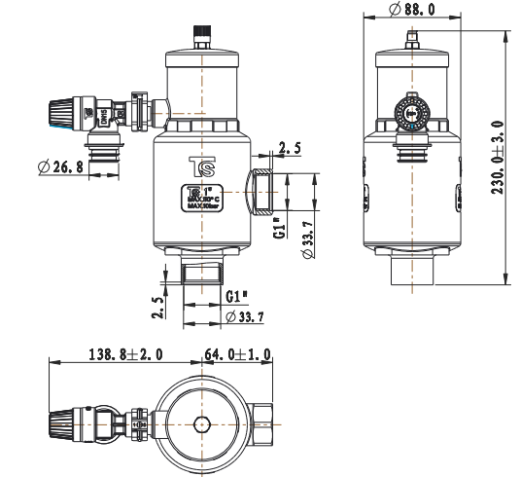

11.9 Maintenance for Safety valve in the outdoor unit
Operate the valve by turn the knob counter clockwise to ensure free water flow through discharge pipe at regular intervals to ensure it is not blocked and to remove
lime deposit.

12 Temperature and sensor resistance table
Except B5 PT sensor, the other sensors are NTC10K.

R25 ：10.0 kΩ±1% B25/50：3470K±1%

T (℃) | Rmin [ KΩ ] | Rnom [ KΩ ] | Rmax [ KΩ ]
-30 | 123.5 | 128.0 | 132.5
-29 | 117.0 | 121.1 | 125.3
-28 | 110.8 | 114.6 | 118.6
-27 | 105.0 | 108.6 | 112.2
-26 | 99.48 | 102.8 | 106.3
-25 | 94.33 | 97.47 | 100.7
-24 | 89.49 | 92.42 | 95.44
-23 | 84.92 | 87.66 | 90.47
-22 | 80.62 | 83.17 | 85.80
-21 | 76.56 | 78.95 | 81.39
-20 | 72.74 | 74.96 | 77.25
-19 | 69.12 | 71.20 | 73.33
-18 | 65.71 | 67.66 | 69.65
-17 | 62.50 | 64.31 | 66.17
-16 | 59.54 | 61.15 | 62.88
-15 | 56.58 | 58.16 | 59.78
-14 | 53.86 | 55.34 | 56.85
-13 | 51.29 | 52.67 | 54.09
-12 | 48.86 | 50.15 | 51.47
-11 | 46.56 | 47.77 | 49.00
-10 | 44.38 | 45.51 | 46.66
-9 | 42.32 | 43.37 | 44.45
-8 | 40.36 | 41.35 | 42.36
-7 | 38.51 | 39.43 | 40.37
-6 | 36.75 | 37.62 | 38.49
-5 | 35.09 | 35.89 | 36.72
-4 | 33.51 | 34.26 | 35.03
-3 | 32.01 | 32.71 | 33.43
-2 | 30.59 | 31.24 | 31.91
-1 | 29.23 | 29.85 | 30.48
0 | 27.95 | 28.53 | 29.11
1 | 26.73 | 27.27 | 27.81
2 | 25.57 | 26.07 | 26.58
3 | 24.47 | 24.94 | 25.41
4 | 23.42 | 23.86 | 24.30
5 | 22.42 | 22.83 | 23.25
6 | 21.47 | 21.86 | 22.24
7 | 20.57 | 20.93 | 21.29
8 | 19.71 | 20.04 | 20.38
9 | 18.89 | 19.20 | 19.52
10 | 18.11 | 18.40 | 18.69
11 | 17.37 | 17.64 | 17.91
12 | 16.66 | 16.91 | 17.16
13 | 15.98 | 16.22 | 16.45
14 | 15.34 | 15.56 | 15.78
15 | 14.72 | 14.93 | 15.13
16 | 14.13 | 14.32 | 14.51

17 | 13.57 | 13.75 | 13.93
18 | 13.04 | 13.20 | 13.37
19 | 12.53 | 12.68 | 12.83
20 | 12.04 | 12.18 | 12.32
21 | 11.57 | 11.70 | 11.84
22 | 11.13 | 11.25 | 11.37
23 | 10.70 | 10.81 | 10.93
24 | 10.29 | 10.40 | 10.50
25 | 9.900 | 10.00 | 10.10
26 | 9.522 | 9.621 | 9.721
27 | 9.160 | 9.259 | 9.359
28 | 8.814 | 8.931 | 9.012
29 | 8.483 | 8.581 | 8.680
30 | 8.166 | 8.264 | 8.362
31 | 7.863 | 7.960 | 8.058
32 | 7.573 | 7.669 | 7.766
33 | 7.295 | 7.391 | 7.487
34 | 7.029 | 7.123 | 7.219
35 | 6.774 | 6.868 | 6.962
36 | 6.529 | 6.622 | 6.716
37 | 6.295 | 6.387 | 6.479
38 | 6.071 | 6.161 | 6.253
39 | 5.855 | 5.945 | 6.035
40 | 5.649 | 5.737 | 5.826
41 | 5.451 | 5.538 | 5.626
42 | 5.260 | 5.347 | 5.433
43 | 5.078 | 5.163 | 5.249
44 | 4.903 | 4.987 | 5.071
45 | 4.735 | 4.817 | 4.900
46 | 4.573 | 4.654 | 4.736
47 | 4.418 | 4.498 | 4.579
48 | 4.269 | 4.348 | 4.427
49 | 4.126 | 4.203 | 4.282
50 | 3.988 | 4.064 | 4.141
51 | 3.855 | 3.930 | 4.007
52 | 3.728 | 3.802 | 3.877
53 | 3.606 | 3.678 | 3.752
54 | 3.488 | 3.559 | 3.632
55 | 3.374 | 3.445 | 3.516
56 | 3.265 | 3.334 | 3.404
57 | 3.160 | 3.228 | 3.297
58 | 3.059 | 3.126 | 3.194
59 | 2.962 | 3.027 | 3.094
60 | 2.868 | 2.933 | 2.998
61 | 2.778 | 2.841 | 2.905
62 | 2.691 | 2.753 | 2.816
63 | 2.607 | 2.668 | 2.730
64 | 2.526 | 2.586 | 2.647
65 | 2.448 | 2.507 | 2.567
66 | 2.373 | 2.431 | 2.490
67 | 2.301 | 2.357 | 2.415
68 | 2.231 | 2.287 | 2.343

69 | 2.164 | 2.218 | 2.274
70 | 2.098 | 2.152 | 2.207
71 | 2.036 | 2.088 | 2.142
72 | 1.975 | 2.027 | 2.080
73 | 1.917 | 1.976 | 2.019
74 | 1.860 | 1.910 | 1.961
75 | 1.806 | 1.855 | 1.904
76 | 1.753 | 1.801 | 1.851
77 | 1.702 | 1.749 | 1.797
78 | 1.653 | 1.699 | 1.746
79 | 1.606 | 1.651 | 1.697
80 | 1.560 | 1.604 | 1.650
81 | 1.515 | 1.599 | 1. 603
82 | 1.472 | 1.515 | 1.559
83 | 1.431 | 1.473 | 1.516
84 | 1.391 | 1.432 | 1.474
85 | 1.352 | 1.392 | 1.434
86 | 1.315 | 1.354 | 1.395
87 | 1.278 | 1.317 | 1.357
88 | 1.243 | 1.282 | 1.321
89 | 1.209 | 1.247 | 1.285
90 | 1.177 | 1.213 | 1.251
91 | 1.145 | 1.181 | 1.218
92 | 1.114 | 1.150 | 1.186
93 | 1.084 | 1.119 | 1.155
94 | 1.055 | 1.089 | 1.125
95 | 1.027 | 1.061 | 1.095
96 | 1.000 | 1.033 | 1.067
97 | 0.974 | 1.006 | 1.039
98 | 0.948 | 0.9801 | 1.013
99 | 0.9234 | 0.9548 | 0.9873
100 | 0.8994 | 0.9303 | 0.9621
101 | 0.8762 | 0.9065 | 0.9378
102 | 0.8537 | 0.8834 | 0.9141
103 | 0.8318 | 0.8611 | 0.8912
104 | 0.8106 | 0.8393 | 0.8689
105 | 0.7901 | 0.8182 | 0.8473
106 | 0.7270 | 0.7806 | 0.8378
107 | 0.7085 | 0.7611 | 0.8173
108 | 0.6906 | 0.7422 | 0.7974
109 | 0.6732 | 0.7239 | 0.7781
110 | 0.6563 | 0.7061 | 0.7594
111 | 0.6399 | 0.6888 | 0.7411
112 | 0.6240 | 0.6720 | 0.7235
113 | 0.6086 | 0.6557 | 0.7063
114 | 0.5936 | 0.6399 | 0.6896
115 | 0.5791 | 0.6246 | 0.6733
116 | 0.5650 | 0.6096 | 0.6576
117 | 0.5513 | 0.5951 | 0.6422
118 | 0.5380 | 0.5810 | 0.6273
119 | 0.5250 | 0.5674 | 0.6128
120 | 0.5125 | 0.5541 | 0.5988

Only for PT sensor

R25=50KΩ±2% B25/50=3950K ±2%

T (℃) | Rmin [ KΩ ] | Rnom [ KΩ ] | Rmax [ KΩ ]
-20 | 441.8 | 471.5 | 503.0
-19 | 417.9 | 445.5 | 474.7
-18 | 395.5 | 421.1 | 448.2
-17 | 374.4 | 398.2 | 423.4
-16 | 354.5 | 376.7 | 400.0
-15 | 335.8 | 356.4 | 378.1
-14 | 318.2 | 337.4 | 357.5
-13 | 301.6 | 319.4 | 338.1
-12 | 286.0 | 302.6 | 319.9
-11 | 271.3 | 286.7 | 302.8
-10 | 257.4 | 271.7 | 286.7
-9 | 244.3 | 257.6 | 271.5
-8 | 232.0 | 244.3 | 257.3
-7 | 220.3 | 231.8 | 243.8
-6 | 209.3 | 220.0 | 231.1
-5 | 198.9 | 208.8 | 219.2
-4 | 189.1 | 198.3 | 207.9
-3 | 179.8 | 188.4 | 197.3
-2 | 171.0 | 179.0 | 187.3
-1 | 162.7 | 170.1 | 177.8
0 | 154.8 | 161.7 | 168.9
1 | 147.4 | 153.8 | 160.5
2 | 140.4 | 146.3 | 152.5
3 | 133.7 | 139.2 | 145.0
4 | 127.4 | 132.5 | 137.8
5 | 121.4 | 126.2 | 131.1
6 | 115.7 | 120.2 | 124.8
7 | 110.4 | 114.5 | 118.7
8 | 105.3 | 109.1 | 113.0
9 | 100.4 | 104.0 | 107.6
10 | 95.84 | 99.14 | 102.5
11 | 91.49 | 94.55 | 97.68
12 | 87.35 | 90.20 | 93.09
13 | 83.43 | 86.06 | 88.74
14 | 79.70 | 82.14 | 84.62
15 | 76.16 | 78.42 | 80.71
16 | 72.80 | 74.88 | 77.00
17 | 69.60 | 71.53 | 73.48
18 | 66.55 | 68.34 | 70.14
19 | 63.66 | 65.31 | 66.97
20 | 60.91 | 62.42 | 63.96
21 | 58.28 | 59.69 | 61.09
22 | 55.79 | 57.08 | 58.38
23 | 53.42 | 54.60 | 55.79
24 | 51.15 | 52.24 | 53.34

T (℃) | Rmin [ KΩ ] | Rnom [ KΩ ] | Rmax [ KΩ ]
25 | 49.00 | 50.00 | 51.00
26 | 46.87 | 47.86 | 48.86
27 | 44.83 | 45.83 | 46.83
28 | 42.90 | 43.89 | 44.89
29 | 41.06 | 42.05 | 43.04
30 | 39.31 | 40.29 | 41.27
31 | 37.64 | 38.61 | 39.59
32 | 36.05 | 37.01 | 37.98
33 | 34.54 | 35.49 | 36.45
34 | 33.10 | 34.03 | 34.98
35 | 31.72 | 32.65 | 33.58
36 | 30.41 | 31.32 | 32.25
37 | 29.16 | 30.06 | 30.97
38 | 27.97 | 28.85 | 29.75
39 | 26.83 | 27.70 | 28.59
40 | 25.74 | 26.60 | 27.48
41 | 24.70 | 25.55 | 26.41
42 | 23.71 | 24.54 | 25.39
43 | 22.77 | 23.58 | 24.42
44 | 21.86 | 22.67 | 23.49
45 | 21.00 | 21.79 | 22.60
46 | 20.18 | 20.95 | 21.74
47 | 19.39 | 20.15 | 20.93
48 | 18.64 | 19.38 | 20.15
49 | 17.91 | 18.64 | 19.40
50 | 17.23 | 17.94 | 18.68
51 | 16.57 | 17.27 | 17.99
52 | 15.94 | 16.62 | 17.33
53 | 15.33 | 16.00 | 16.70
54 | 14.75 | 15.41 | 16.10
55 | 14.20 | 14.85 | 15.51
56 | 13.67 | 14.30 | 14.96
57 | 13.16 | 13.78 | 14.42
58 | 12.68 | 13.28 | 13.91
59 | 12.21 | 12.80 | 13.42
60 | 11.76 | 12.34 | 12.95
61 | 11.34 | 11.90 | 12.49
62 | 10.92 | 11.48 | 12.06
63 | 10.53 | 11.07 | 11.64
64 | 10.15 | 10.69 | 11.24
65 | 9.791 | 10.31 | 10.86
66 | 9.444 | 9.953 | 10.48
67 | 9.110 | 9.608 | 10.13
68 | 8.790 | 9.277 | 9.786
69 | 8.483 | 8.959 | 9.457
70 | 8.187 | 8.653 | 9.141
71 | 7.904 | 8.359 | 8.837
72 | 7.632 | 8.077 | 8.544
73 | 7.370 | 7.805 | 8.262

T (℃) | Rmin [ KΩ ] | Rnom [ KΩ ] | Rmax [ KΩ ]
74 | 7.119 | 7.544 | 7.991
75 | 6.877 | 7.293 | 7.731
76 | 6.645 | 7.051 | 7.480
77 | 6.421 | 6.819 | 7.238
78 | 6.207 | 6.595 | 7.005
79 | 6.000 | 6.380 | 6.781
80 | 5.801 | 6.173 | 6.565
81 | 5.610 | 5.973 | 6.357
82 | 5.426 | 5.781 | 6.157
83 | 5.249 | 5.596 | 5.963
84 | 5.078 | 5.418 | 5.777
85 | 4.914 | 5.246 | 5.598
86 | 4.756 | 5.080 | 5.424
87 | 4.604 | 4.921 | 5.258
88 | 4.457 | 4.767 | 5.096
89 | 4.316 | 4.619 | 4.941
90 | 4.180 | 4.476 | 4.791
91 | 4.048 | 4.338 | 4.647
92 | 3.922 | 4.205 | 4.507
93 | 3.800 | 4.077 | 4.372
94 | 3.682 | 3.953 | 4.242
95 | 3.569 | 3.833 | 4.116
96 | 3.459 | 3.718 | 3.995
97 | 3.354 | 3.607 | 3.877
98 | 3.252 | 3.499 | 3.764
99 | 3.153 | 3.395 | 3.655
100 | 3.058 | 3.295 | 3.549
101 | 2.967 | 3.198 | 3.447
102 | 2.878 | 3.105 | 3.348
103 | 2.792 | 3.014 | 3.252
104 | 2.710 | 2.927 | 3.160
105 | 2.630 | 2.842 | 3.070
106 | 2.553 | 2.760 | 2.984
107 | 2.478 | 2.681 | 2.900
108 | 2.406 | 2.605 | 2.819
109 | 2.337 | 2.531 | 2.740
110 | 2.269 | 2.460 | 2.665
111 | 2.204 | 2.390 | 2.591
112 | 2.141 | 2.323 | 2.520
113 | 2.080 | 2.259 | 2.451
114 | 2.022 | 2.196 | 2.384
115 | 1.964 | 2.135 | 2.320
116 | 1.909 | 2.076 | 2.257
117 | 1.856 | 2.019 | 2.196
118 | 1.804 | 1.964 | 2.137
119 | 1.754 | 1.911 | 2.080
120 | 1.705 | 1.859 | 2.025

13 Disposal and Recycling
The removal and disposal of the heat pump must be carried out by a qualified professional in accordance with local and national regulations.
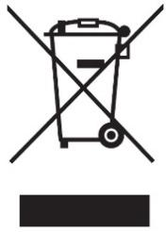

- Switch off the heat pump.
- Cut the mains supply to the heat pump
- Collect the refrigerant according to the applicable regulations
- Make sure that the refrigerant cannot escape into the open air.
- Disconnect the refrigerant lines
- Close the main water tap
- Drain the water from the installation.
- Disconnect all hydraulic connections.
- Dismantle the heat pump.
10.Scrap or recycle the heat pump in accordance with the applicable local and national regulations.

15 Electrical schematic diagram

