AIR TO WATER HEAT PUMP

Touch Screen Manual for Heat Pump Systen
V.2505

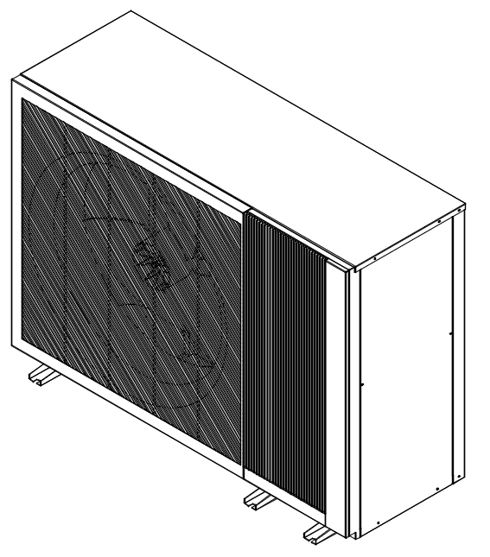

Heat Pump Models:
HSL08V-DPANW
HSL10V-DPANW
HSL12V-DPANW
HSL15V-DPANW

Before operating the system, please read these operating instructions thoroughly and keep them for future reference.



Index

1 Home Page 5
2 Function Overview 5
3 Mode Switching 5
4 Sleep Mode 6
4.1 Sleep Mode Activation (Switch) 6
4.2 Sleep Mode Time Configuration 6
4.3 Sleep Mode Compressor Maximum Operation 6
4.4 Sleep Mode Fan Maximum Operation Speed 6
5 Timer Mode 7
5.1 Timer Activation (Switch) 7
5.2 Timer Configuration 7
6 Function Menu 7
7 Heating/Cooling Circuit 1 (Heating) 8
7.1 Temperature compensation function 8
7.2 Heating Target Temperature 9
7.3 Real-Time Heating Operation Temperature 9
7.4 Current Ambient Temperature 9
7.5 Upper Limit for Water Temperature 9
7.6 Lower Limit for Water Temperature 9
7.7 Lower Limit for Ambient Temperature 9
7.8 Upper Limit for Ambient Temperature 9
8 Heating/Cooling Circuit 1 (Cooling) 9
8.1 Temperature compensation function 10
8.2 Cooling Target Temperature 10
8.3 Real-Time Cooling Operation Temperature 10
8.4 Current Ambient Temperature 10
8.5 Upper Limit for Water Temperature 10
8.6 Lower Limit for Water Temperature 10
8.7 Lower Limit for Ambient Temperature 10
8.8 Upper Limit for Ambient Temperature 10
9 Heating/Cooling Circuit 2 (Heating) 10
10 Heating/Cooling Circuit 2 (Cooling) 11
11 Domestic Hot Water Setting 12
11.1. Domestic Hot Water Temperature Differential Control 12
11.2. Hot Water Target Value 12
11.3. Hot Water Maximum Temperature Setting 12
11.4. Hot Water Circulation Function 12
11.5. Hot Water Circulation Pump Operation Time 12
11.6. Hot Water Circulation Pump Interval Time 12
12 Holiday Mode Setting 13

12.1. Holiday Mode Activation (Switch) 13
12.2. Holiday Mode Start Time Configuration 13
12.3. Holiday Mode End Time Configuration 13
12.4. Scheduled Startup Configuration 13
12.5. Heating Target Temperature Reduction 13
12.6. Cooling Target Temperature Increase 13
12.7. Hot Water Target Temperature Reduction 13
13 Hot Water Anti-Legionella Function Setting 14
13.1. Hot Water Anti-Legionella Function Activation (Switch) 14
13.2. Hot Water Anti-Legionella Target Temperature 14
13.3. Scheduled Anti-Legionella Time 14
13.4. Anti-Legionella Interval Time 14
14 Auxiliary Heat Source Settings 15
14.1. Boiler Configuration 15
14.2. Boiler Startup Outdoor Temperature Setting 15
14.3. Boiler Switchover Function 15
14.4. Auxiliary Electric Heating Configuration 15
14.5. Auxiliary Electric Heating Power 15
14.6. Hot Water Electric Heating Configuration 15
14.7. Hot Water Electric Heating Power 15
14.8. Defrost Electric Heating Configuration 15
14.9. Defrost Electric Heating Power 15
15 Energy Management 16
16 Solar Energy Application Settings 16
16.1. Solar Application Hot Water Switch 16
16.2. Water Pump Temperature Difference Off 16
16.3. Solar Pump Heating Upper Limit 17
16.4. Solar Pump Start Setting 17
16.5. Solar Pipeline Anti-Freeze Outdoor Temperature Setting 17
16.6. Solar Pump Anti-Freeze Interval Time 17
16.7. Solar Application Heating Switch 17
16.8. Solar Heating Shutdown Temperature Difference 17
16.9. Solar Heating Upper Limit 17
16.10. Solar Heating Start Setting Value 17
17 Running State 17
18 Fault Inquiry 20
18.1 Auto Reset Alarms 21
18.2 Manual Reset Alarms 22
18.3 Alarm Code And Description 22
19 Service Level Parameters 24
20 Factory Level Parameters 25
21 Pump Settings 25
21.1. Pump Models 26

21.2. Pump Configuration 26
21.3. Pump PWM Upper Limit 26
21.4. Pump PWM Lower Limit 26
22 SG-Ready Function 26
22.1. SG-Ready Function 27
22.2 SG Heat/Cool Temperature Range 27
22.3 SG Hot Water Temperature Range 27
23 One Click Exhaust 27
23.1. Cooling/Heating Circuit Exhaust Function Switch 28
23.2. Domestic Hot Water Circuit Exhaust Function Switch 28
23.3. Automatic Exhaust Time Setting 28
24 Installation Configuration 28
25 System Configuration 29
25.1. Time Setting 29
25.2. Off Screen Setting 29
25.3. Brightness Setting 29
25.4. Language Settings 29
26 App. Control Setup 30

1 Home Page
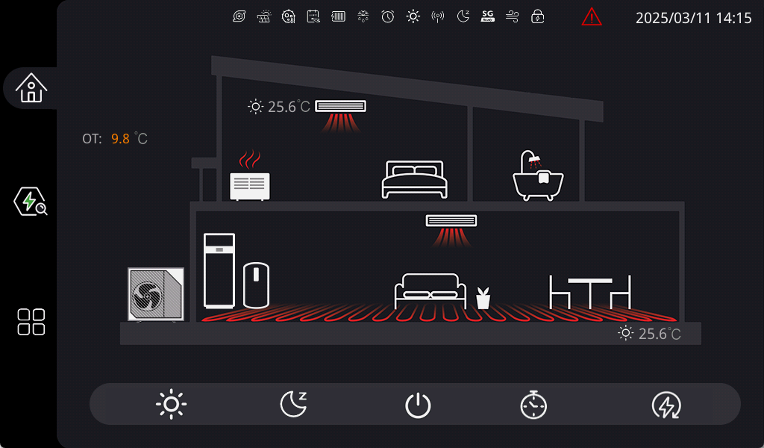

2 Function Overview

No. | Icon | Function
1 |  | Heating Mode
2 |  | Cooling Mode
3 |  | Heating + Hot Water
4 |  | Cooling + Hot Water
5 |  | Defrosting
6 |  | Anti-Legionella
7 |  | Holiday Mode
No. | Icon | Function
8 |  | Power Lock
7 |  | Hot Water Mode
10 |  | Electric Heating
11 |  | Fault Inquiry
12 |  | Timer Mode
13 |  | Power On/Off
14 |  | Operation Flow Diagram

3 Mode Switching
The unit offers five modes: Heating Mode, Cooling Mode, Hot Water Mode, Heating + Hot Water Mode, Cooling + Hot Water Mode. Upon selecting a mode, the system will stop operation briefly to switch modes. After switching, the refrigerant flow diagram will reflect the selected heating or cooling mode.

4 Sleep Mode



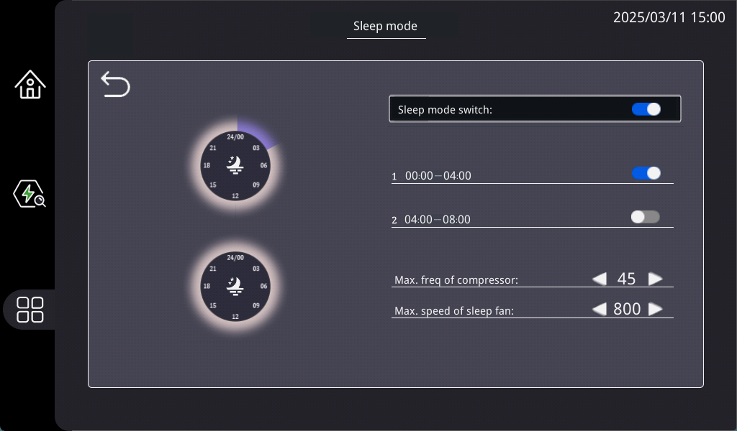

4.1 Sleep Mode Activation (Switch)
Sleep mode must be enabled for the system to transition into sleep mode at the configured time.

4.2 Sleep Mode Time Configuration
You can set two time intervals for sleep mode. Tap the time fields to access the configuration interface. The left field indicates the start time, and the right field indicates the end time.

4.3 Sleep Mode Compressor Maximum Operation
This feature configures the maximum compressor frequency during sleep mode. Adjustable range: 20Hz–90Hz (default: 70Hz).

4.4 Sleep Mode Fan Maximum Operation Speed
Configures the maximum fan speed during sleep mode.

Adjustable range: 300–350

(default:HSL08V-D/ HSL08V-D 300;

HSL12V-D/ HSL15V-D 350)

5 Timer Mode



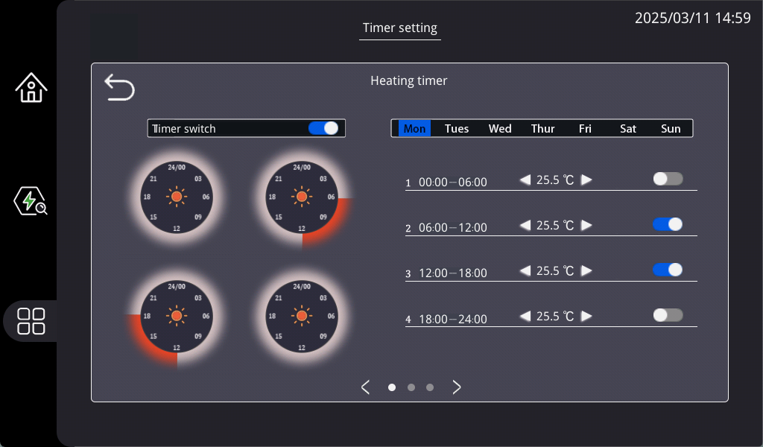

5.1 Timer Activation (Switch)
Timer mode includes three modes: Cooling Timer, Heating Timer, Hot Water Timer. Each has a dedicated interface accessible via a left/right toggle. Timer mode, time settings, and mode switching have independent toggle switches. Only enabled timers will operate based on the set schedule.

5.2 Timer Configuration
You can configure up to four time intervals. Tap the time fields to access the configuration interface.

6 Function Menu


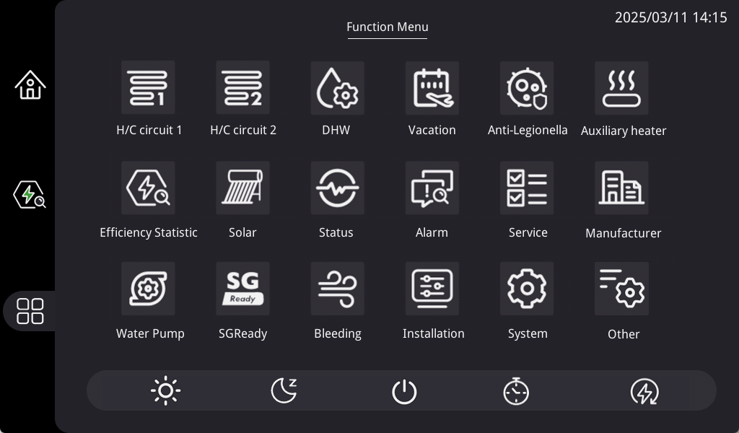

7 Heating/Cooling Circuit 1 (Heating)



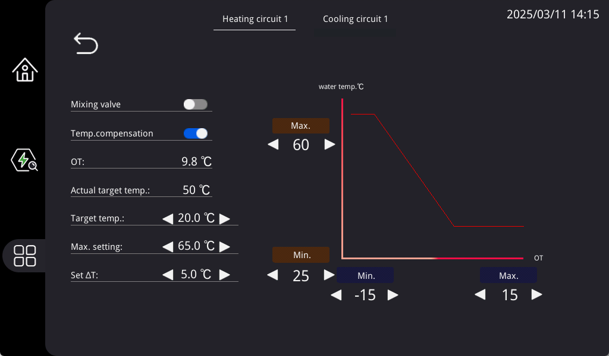

7.1 Temperature compensation function
When temperature compensation is enabled, the target temperature cannot be set. It will calculate the actual target temperature using formula 1 and display it to Target set temperature.

(Formula 1) Actual target temperature=upper limit of water temperature - (ambient temperature - lower limit of ambient temperature) * slope
(Formula 2) Slope=(upper limit of water temperature - lower limit of water temperature)/(upper limit of ambient temperature - lower limit of ambient temperature)

7.2 Heating Target Temperature
When temperature compensation is not enabled, this parameter can be set to change the target temperature.

7.3 Real-Time Heating Operation Temperature
Displays the real-time target heating temperature adjusted by the program based on temperature compensation and other restrictions.

7.4 Current Ambient Temperature
Displays the current ambient temperature.

7.5 Upper Limit for Water Temperature
Sets the upper limit for heating target temperature when temperature compensation function is active.

7.6 Lower Limit for Water Temperature
Sets the lower limit for heating target temperature when temperature compensation function is active.

7.7 Lower Limit for Ambient Temperature
Sets the lower limit for ambient temperature adjustment during temperature compensation.

7.8 Upper Limit for Ambient Temperature
Sets the upper limit for ambient temperature adjustment during temperature compensation.

8 Heating/Cooling Circuit 1 (Cooling)

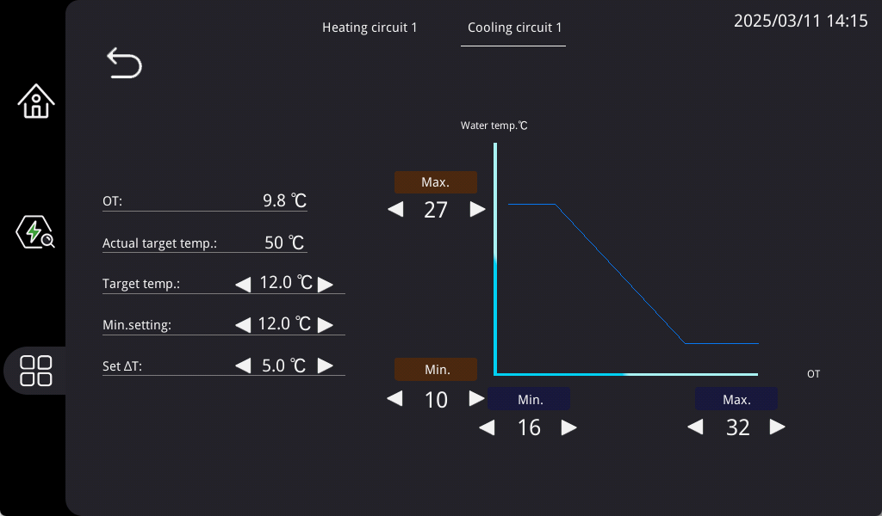

8.1 Temperature compensation function
When temperature compensation is enabled, the target temperature cannot be set. It will calculate the actual target temperature using formula 1 and display it to Target set temperature.

(Formula 1) Actual target temperature=upper limit of water temperature - (ambient temperature - lower limit of ambient temperature) * slope
(Formula 2) Slope=(upper limit of water temperature - lower limit of water temperature)/(upper limit of ambient temperature - lower limit of ambient temperature)

8.2 Cooling target temperature setting
When temperature compensation is not enabled, this parameter can be set to change the target temperature.

8.3 Real-Time Cooling Operation Temperature
Displays the real-time target cooling temperature adjusted by the program based on temperature compensation and other restrictions.

8.4 Current Ambient Temperature
Displays the current ambient temperature.

8.5 Upper Limit for Water Temperature
Sets the upper limit for cooling target temperature when temperature compensation function is active.

8.6 Lower Limit for Water Temperature
Sets the lower limit for cooling target temperature when temperature compensation function is active.

8.7 Lower Limit for Ambient Temperature
Sets the lower limit for ambient temperature adjustment during temperature compensation.

8.8 Upper Limit for Ambient Temperature
Sets the upper limit for ambient temperature adjustment during temperature compensation.

9 Heating/Cooling Circuit 2 (Heating)



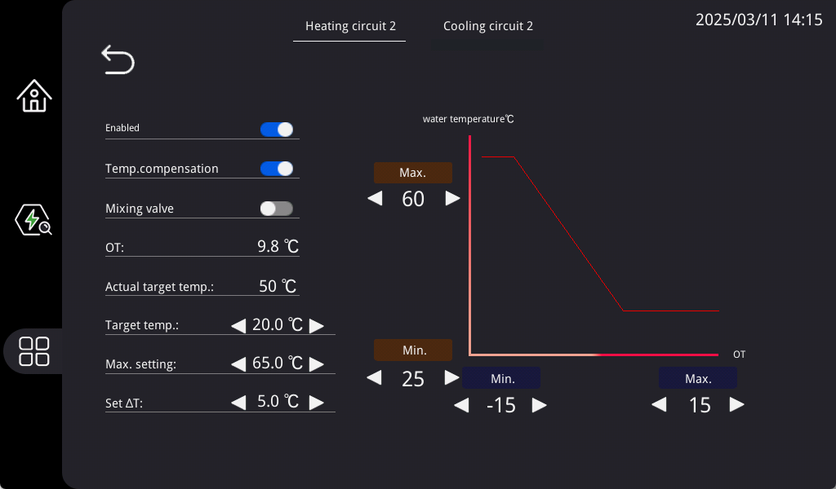
After activation, it is used to configure the heating temperature control and temperature compensation of the second zone. At the same time, circuit 1 will have an additional mixing valve option. Opening the mixing valve on either side will control the temperature in the low-temperature zone, while the other side will control the target temperature in the high-temperature zone. (For example, circuit 2 opens the mixing valve, all settings in circuit 2 control the temperature in the low-temperature zone, and all settings in circuit 1 control the temperature in the high-temperature zone)

10 Heating/Cooling Circuit 2 (Cooling)

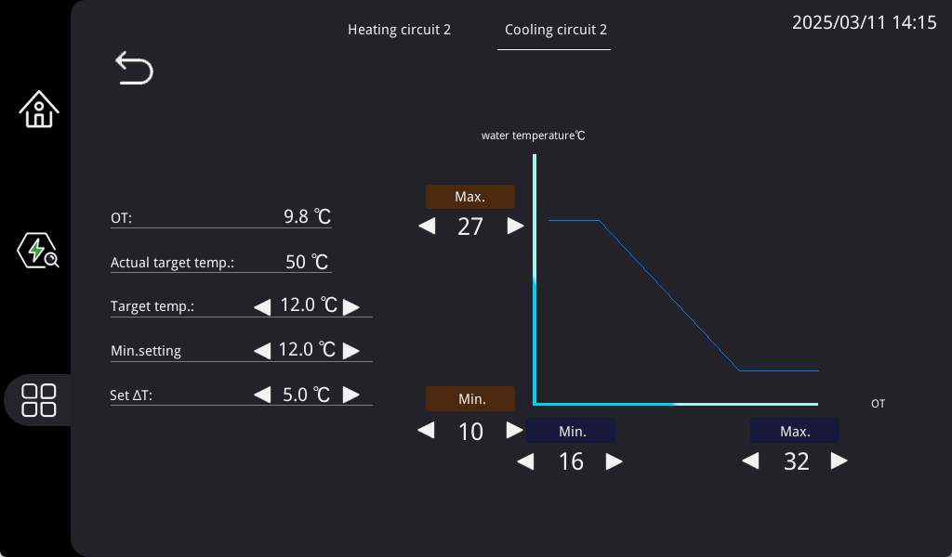
After activation, it is used to configure the cooling temperature control and temperature compensation of the second zone. At the same time, circuit 1 will have an additional mixing valve option. Opening the mixing valve on either side will control the temperature in the low-temperature zone, while the other side will control the target temperature in the high-temperature zone. (For example, circuit 2 opens the mixing valve, all settings in circuit 2 control the temperature in the low-temperature zone, and all settings in circuit 1 control the temperature in the high-temperature zone)

11 Domestic Hot Water Setting


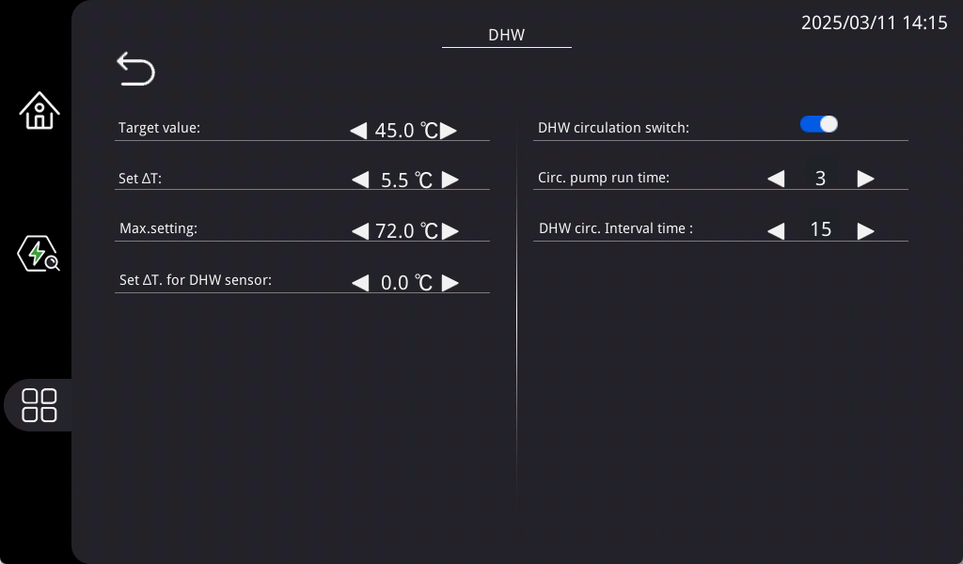

11.1 Domestic Hot Water Temperature Differential Control
ON: When the hot water temperature (HT) ≤ ST09 - ST10.
OFF: When the hot water temperature (HT) > ST09.
(Default: ST09 = 60°C, ST10 = 5°C)

11.2 Hot Water Target Value
Specifies the target temperature for domestic hot water heating, applicable for standalone operation or combined with electric heating.

11.3 Hot Water Maximum Temperature Setting
Defines the upper limit for domestic hot water temperature.

11.4 Hot Water Circulation Function
Activating the hot water circulation pump keeps water in the pipes at an appropriate temperature, minimizing waiting time for hot water and reducing water wastage. This ensures hot water is available on demand.

The hot water circulation pump operates only when the hot water switch is ON (during hot water heating or standby modes).

11.5 Hot Water Circulation Pump Operation Time
Specifies the duration of each operation cycle for the hot water circulation pump.

11.6 Hot Water Circulation Pump Interval Time
Specifies the interval time between consecutive operations of the hot water circulation pump.

12 Holiday Mode Setting


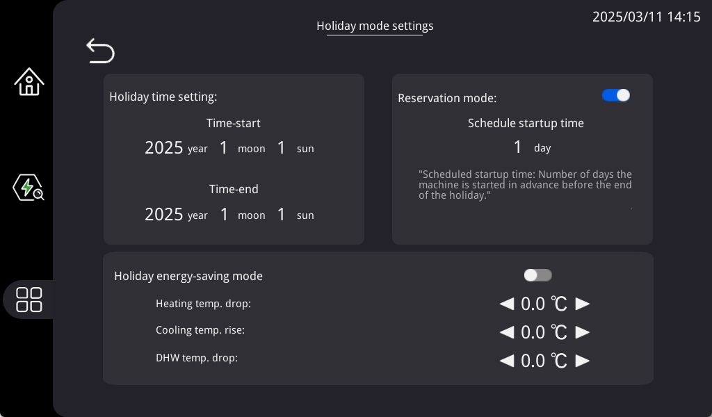

12.1 Holiday Mode Activation (Switch)
Allows the heat pump to operate in holiday mode.

12.2 Holiday Mode Start Time Configuration
Sets the start time for holiday mode.

12.3 Holiday Mode End Time Configuration
Sets the end time for holiday mode.

12.4 Scheduled Startup Configuration
If scheduled startup is enabled, the heat pump will automatically resume operation before the end of holiday mode to ensure sufficient heating and hot water supply.

12.5 Heating Target Temperature Reduction
Adjusts the heating target temperature by a preset reduction value when temperature reduction mode is enabled.

12.6 Cooling Target Temperature Increase
Adjusts the cooling target temperature by a preset increase value when temperature reduction mode is enabled.

12.7 Hot Water Target Temperature Reduction
Adjusts the hot water target temperature by a preset reduction value when temperature reduction mode is enabled.

13 Hot Water Anti-Legionella Function Setting



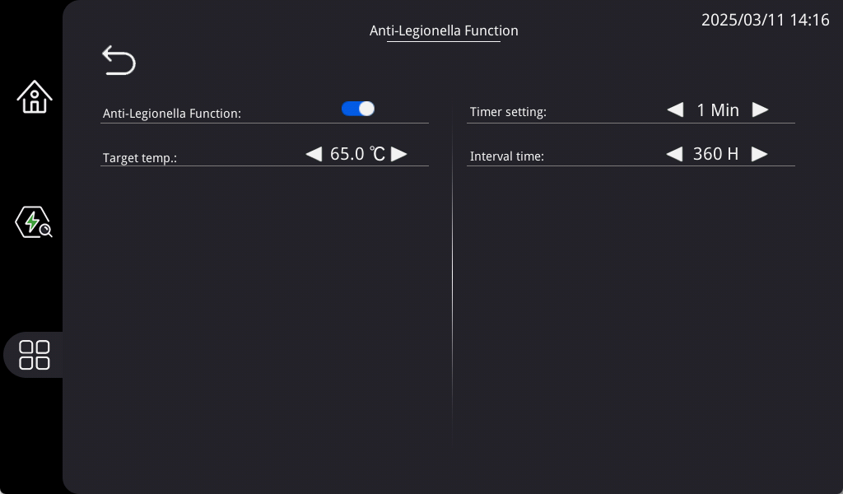

13.1 Hot Water Anti-Legionella Function Activation (Switch)
Enables the Anti-Legionella Function for hot water.

13.2 Hot Water Anti-Legionella Target Temperature
Specifies the target temperature for hot water anti-legionella, including temperatures achieved through heat pump and electric heating operation.

13.3 Scheduled Anti-Legionella Time
Sets the start time for the hot water anti-legionella function.

13.4 Anti-Legionella Interval Time
Defines the interval time between anti-legionella cycles for domestic hot water.

14 Auxiliary Heat Source Settings
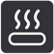

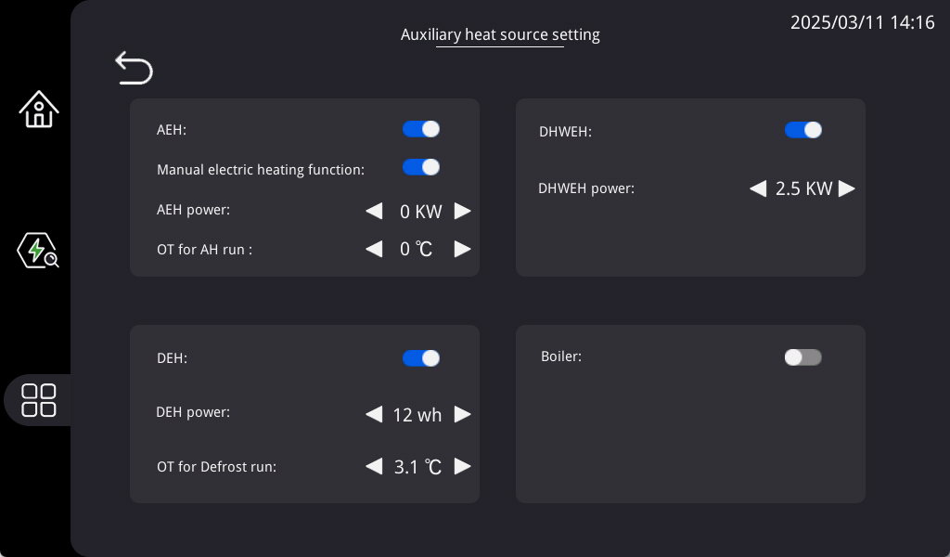

14.1 Boiler Configuration

Specifies whether a boiler is integrated into the system. Boiler-related settings take effect only if this option is configured.

14.2 Boiler Startup Outdoor Temperature Setting
The boiler activates when the outdoor temperature is less than or equal to this set value.

14.3 Boiler Switchover Function
The boiler replaces the compressor under two conditions:1.The current mode is heating. 2.The outdoor temperature is less than or equal to the boiler startup setting.

14.4 Auxiliary Electric Heating Configuration
Specifies whether auxiliary electric heating is integrated.

14.5 Auxiliary Electric Heating Power

14.6 Hot Water Electric Heating Configuration

14.7 Hot Water Electric Heating Power

14.8 Defrost Electric Heating Configuration

14.9 Defrost Electric Heating Power

15 Energy Management


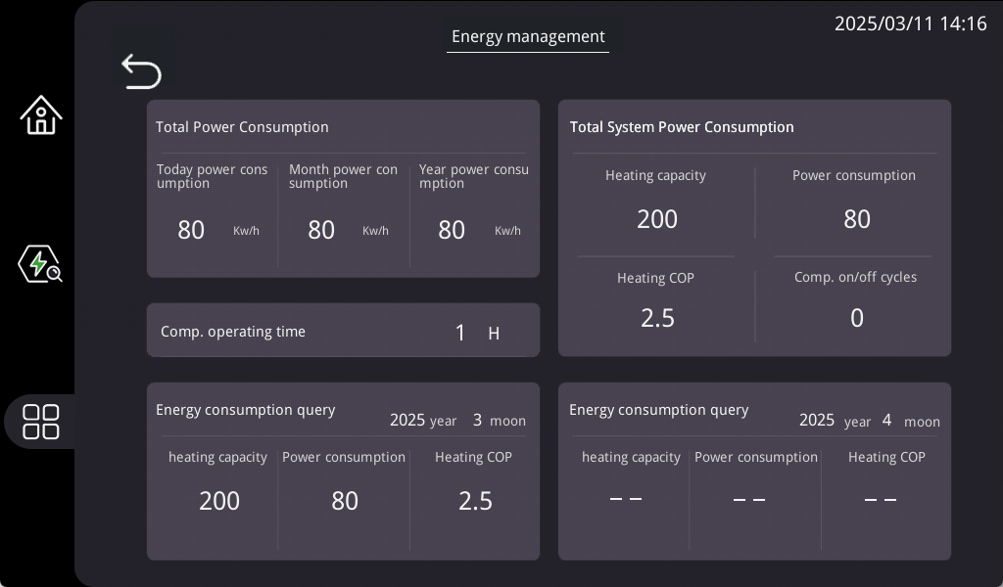

16 Solar Energy Application Settings


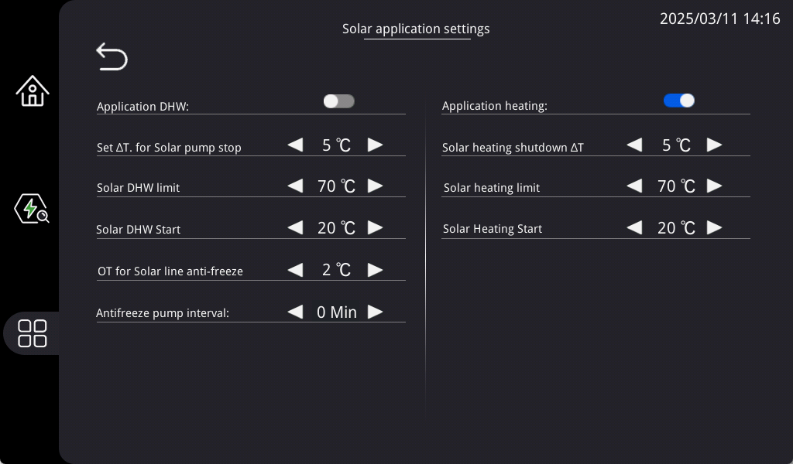

16.1 Solar Application Hot Water Switch
Activates solar water heating, independent of the current mode (heating/cooling) or the
system’s ON/OFF status. Only one solar application—hot water or heating—can operate at a time. Enabling solar hot water will automatically disable solar heating.

16.2 Water Pump Temperature Difference Off
Defines the temperature differential between the solar temperature (B3 sensor) and hot water. When the differential exceeds this set value, the solar function shuts off.

16.3 Solar Pump Heating Upper Limit
If the buffer tank temperature (B2 sensor) exceeds the solar heating upper limit for 5 minutes, the solar pump shuts off. Similarly, if the hot water temperature exceeds the solar heating upper limit, the solar pump shuts off.
(Default upper limit: 70°C; adjustable range: 40°C–90°C)

16.4 Solar Pump Start Setting
The solar pump activates when the temperature difference between the solar temperature (B3 sensor) and the buffer tank temperature (B2 sensor) exceeds the set activation threshold. The solar pump will not operate during cooling mode.

16.5 Solar Pipeline Anti-Freeze Outdoor Temperature Setting
When the outdoor temperature falls below the set anti-freeze value for 1 minute, the solar pump stops operating.

16.6 Solar Pump Anti-Freeze Interval Time
Specifies the interval time between anti-freeze operations for the solar pump. After the interval time is reached, the solar pump operates for 3 minutes before stopping. This repeats until the outdoor temperature rises above (anti-freeze value + 1°C).

16.7 Solar Application Heating Switch
Only one solar application—hot water or heating—can operate at a time. Enabling solar heating will automatically disable solar hot water.

16.8 Solar Heating Shutdown Temperature Difference
Specifies the temperature difference for shutting down the solar heating application.

16.9 Solar Heating Upper Limit
Defines the upper temperature limit for solar heating.

16.10 Solar Heating Start Setting Value
Specifies the temperature difference required to activate solar heating.

17 Running State
The running state interface consists of three pages. Navigate between pages by swiping the screen.



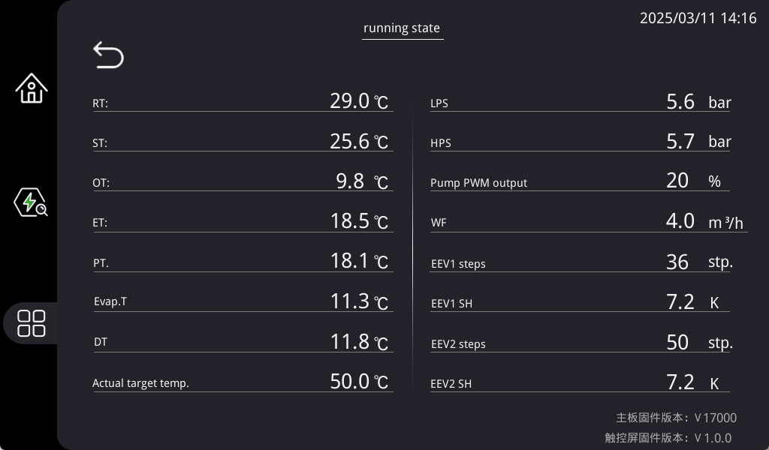

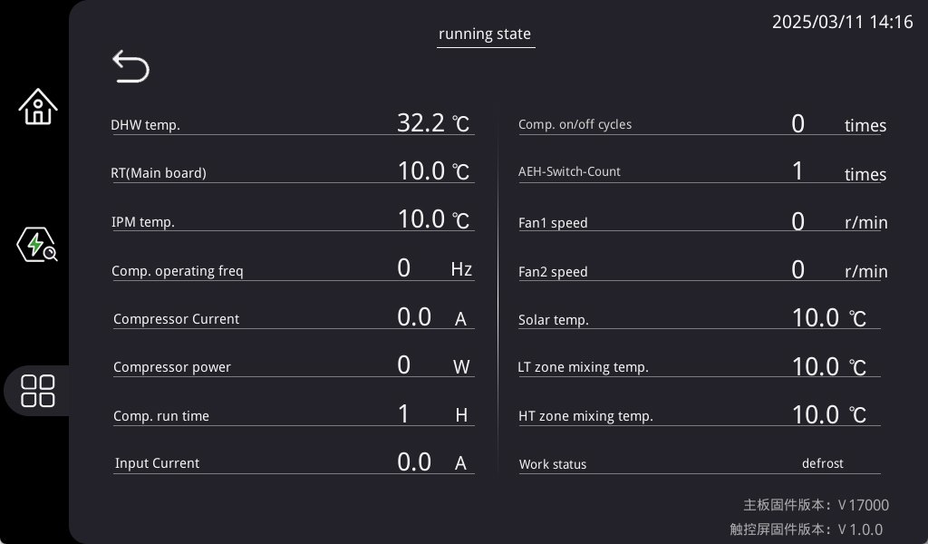

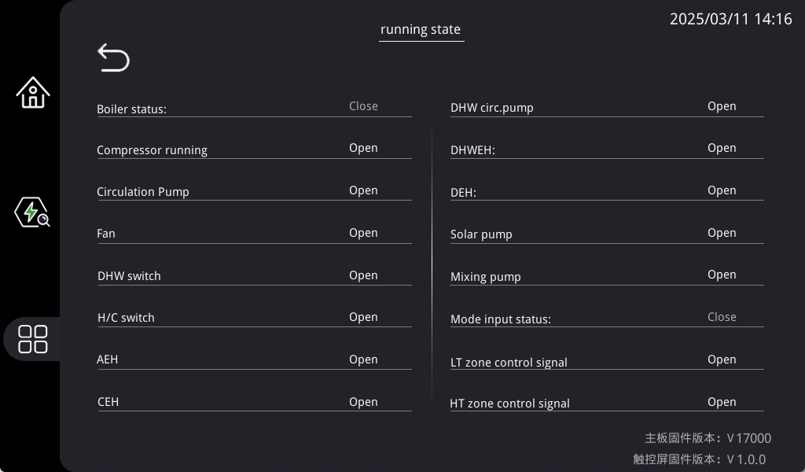
Press , it displays the unit measured temperature sensors value, digital switch on/off state, components on/off state.
No. | abbreviation | description
1 | RT | Indoor return water temperature
2 | ST. | Indoor outlet water temperature
3 | OT. | Outdoor temperature
4 | ET | Return air temperature
5 | PT | Exhaust temperature
6 | LPS | Low pressure
7 | HPS | High pressure
8 | water flow | Water flow feedback
9 | Evaporation temp. | Evaporating temperature
10 | Discharge temp. | Condensing temperature
11 | Fan1 speed | Fan 1 speed feedback
12 | Fan2 speed | Fan 2 speed feedback
13 | EEV1 steps | EEV1 opening degree
14 | EEV2 steps | EEV2 opening degree
15 | Mixing valve opening | Proportional water valve opening
16 | EEV1 SH | EEV1 Superheat
17 | EEV2 SH | EEV2 Superheat
18 | Comp. operating freq | Compressor frequency
19 | Solar Temp. | Solar temperature
20 | RT(Main board) | Buffer water tank temperature
21 | LT zone mixing temp. | Low temperature zone mixed water temperature
22 | HT zone mixing temp. | Temperature of mixed water in high temperature zone
23 | 4-way valve | four-way valve
24 | Pump running | Indoor water pump operation
25 | DHW switch | Hot water switch
26 | H/C switch | Heat pump startup
27 | DefrostEH | Defrosting electric heating
28 | AH | Auxiliary electric heating
29 | DHWEH | Hot water and electricity heating
30 | DHW circ. pump | Hot water circulating pump
31 | DHW 3-way value | Hot water three-way valve
32 | LT zone control signal | Low temperature zone control signal
33 | HT zone control signal | High temperature zone control signal
34 | Mixing pump | Partition water pump
35 | Solar pump | Solar Water Pump
36 | Work status | Host status

18 Fault Inquiry
When a fault occurs in the system, the fault event logs the trigger time based on the system's internal clock and displays the fault code as the warning message. Once the fault is resolved, the release time will be recorded in the designated column.


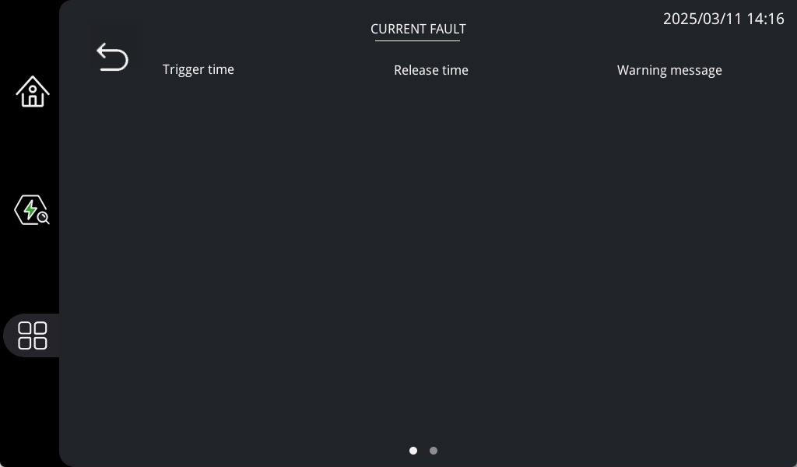

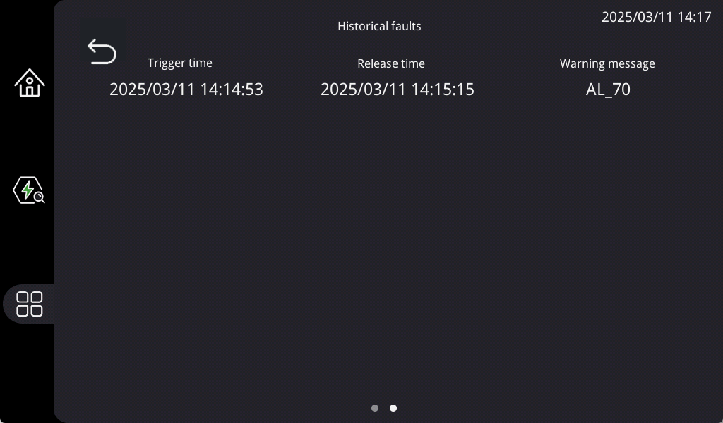
The Fault Inquiry interface can be navigated by swiping left or right. Swiping right will move to the second page, and when on the second page, swiping left will return to the first page. The first page is CURRENT FAULT,The second page is Historical faults.
The alarms are divided into two groups: auto reset alarms and manual reset alarms.
1.Auto reset alarm, the user is not required to acknowledge and reset it.
2.The unit will automatically restart once the alarm status disappears.
3.Once a manual reset alarm is detected, the system will stop automatically. The user needs to record and contact the supplier on actions what to do.
When an alarm is detected, the icon will continuously flash.

18.1 Auto Reset Alarms
The following are codes for auto reset alarms with their meanings.
Codes | Meaning
AL01 | Low pressure
AL02 | High pressure
AL03 | Low outlet water temperature (ST<AR01 default 5.5)
AL05 | High outlet water temperature (ST>AR03 default 72)
AL17 | Water flow is short
WN01 | Antifreeze
AL20 | Low evaporation temperature (only cooling mode)
AL21 | High discharge gas temperature
AL57 | inverter offline
AL30 | Touch screen and main board communication trouble.
AL00 | Communication failure between main control board and screen
ALEP | Main control board memory EPROM failure
AL79 | Water pump fault

Alarms relating to inverter board (auto reset)
AL98 | Inverter board fault alarm
AL100 | IPM overcurrent
AL101 | comp. drive failure
AL102 | comp. overcurrent
AL103 | power phase loss
AL104 | IPM current sampling error
AL105 | radiator overheat
AL106 | pre-charging failure
AL107 | DC bus overvoltage
AL108 | DC bus under voltage
AL109 | AC input under voltage
AL110 | AC input overcurrent
AL111 | voltage sampling error
AL112 | Fan motor 1 fault
AL113 | temp. sensor error
AL114 | Fan motor 2 fault
AL115 | communication fault
AL116 | IPM module overheat
AL117 | Fan motor 1 fault
AL118 | Fan motor 2 fault

18.2 Manual Reset Alarms
The following are codes for manual reset alarms with their meanings.
Codes | Meaning
AL18 | Low pressure alarms times within 24 hours is over the limit
AL19 | High pressure alarms times within 24 hours is over the limit
AL31 | Low evaporation temperature alarm times within 24 hours is over the limit

18.3 Alarm code and description
1.) Low pressure protection (Code: AL01)
After starting the compressor, it checks the low pressure after AR09 delay. If LPS≤AR31 (default 0.3) in continual 120 seconds, then compressor is switched off, 5 seconds later, fan motor is switched off, other parts keep their original state. Alarm code AL01 display on the touch screen. After LPS≥AR31+AR32 (default 0.3) in continual 10 seconds, the unit returns to normal operation.

2.) High pressure protection (Code: AL02)
It does not trigger high pressure protection on defrosting process and within 10 seconds after end of defrosting.
At other time if HPS≥AR33 (default 30) in continual 5 seconds, the compressor is switched off, after 5 seconds' delay, the fan motor is switched off, other parts keep their original state. Alarm code AL02 display on the touch screen. After HPS≤AR33-AR34 (default 3), the unit re turns to normal operation.

3.) Low pressure protection (serious) (Code: AL18)
In 24 hours' time, if AL01 is triggered over AR06 (default 4) times, manual reset alarm AL18 is triggered,
then compressor is switched off, 5 seconds later, fan motor is switched off, other parts keep their original state. Alarm code AL18 display on the touch screen.

4.) High pressure protection (serious) (Code: AL19)
In 24 hours’ time, if AL02 is trigger over AR07 (default 6) times, manual reset alarm AL19 is triggered,
the compressor is switched off, 5 seconds later, fan motor is switched off, other parts keep their original state. Alarm code AL19 displays on the touch screen.

5.) Water flow protection (Code: AL17)
A.) AR04 (default 120s) time delay after circulation pump is switched on and circulation pump PWM output is 100% in continual 5 seconds, if feedbacked pump flow is lower than minimum flow rate EV07(cooling/defrosting) or EV25 (heating) *0.8 in continual 5 seconds, AL17 alarm is triggered.
B.) On the running process, when pump PWM output is 100%, if feedbacked pump flow is lower than EV07 (cooling/defrosting) or EV25 (heating)*0.8 in continual 5 seconds, AL17 alarm is triggered.
the compressor is switched off, 5 seconds later, fan motor is switched off, other parts keep their original state. Alarm code AL17 displays on the touch screen. Unit could return to normal operation if feedbacked pump flow is over EV06/EV25 in continual 5 seconds.

6.) Indoor circuit anti-freezing protection (code：WN01）
1.) If pump has been switched off over 30 minutes and OT<2, pump is switched on and runs with PWM 100%. 180 seconds later, if RT>12, pump is switched off. If RT<10, WN01 warning is triggered and unit is switched on to run on heating mode until RT＞20℃ ,then warning is reset.
2.) If RT sensor is faulted, ST is used instead of RT for anti-freezing protection water temperature reference. If ST sensor is faulted too when OT<2, pump runs continually with PWM 100%.

7.) High discharge gas temperature protection（code:AL21）
If Discharge gas temperature PT>105 in continual 5 seconds, high Discharge gas temperature protection alarm AL21 is triggered,
the compressor is switched off, 5 seconds later, fan motor is switched off, other parts keep their original state. Alarm code AL21 displays on the touch screen.
It will recover to normal operation if PT<85 in continual 5 seconds.

8.) Low evaporation temperature protection (Code: AL20)
The protection function will be valid on COOLING mode .AL20 low evaporation temperature protection is triggered when condition below is met:
1.) LPS ≤-2 in continual 60 seconds；
2.)LPS≤-4 in continual 40 seconds；
3.)LPS≤-6 in continual 10 seconds；
4.) outlet water temp. < 8℃
the compressor is switched off, 5 seconds later, fan motor is switched off, other parts keep their original state. Alarm code AL20 displays on the touch screen. It will recover to normal operation 5 minutes later.
9.) Low evaporation temperature protection (serious) (Code: AL31)
In 24 hours’ time, if AL20 is trigger over 3 times, manual reset alarm AL31 is triggered,
the compressor is switched off, 5 seconds later, fan motor is switched off, other parts keep their original state. Alarm code AL31 displays on the touch screen.

10.) Low outlet water temperature protection (Code: AL03)
If ST≤AR01 (default 5.5) and LPS < 0℃ in continual 5 seconds, the compressor is switched off, after 5 seconds' delay, the fan motor is switched off, water pump runs with PWM 100%, other parts keep their original state. Alarm code AL03 displays on the touch screen. It records the instant inlet water temperature RT1 when unit just stops and returns to normal working after inlet water temperature RT≥RT1+ ST03.

11.) High outlet water temperature protection (Code: AL05)
If ST≥ AR03 (default 72) in continual 5 seconds, the compressor is switched off, after 5 seconds delay, the fan motor is switched off, water pump runs with PWM 100%, other parts keep their original state. Alarm code AL05 display on touch screen. It records instant inlet water temperature RT2 when unit just stops and returns to normal working after inlet water temperature RT≤RT2-ST04.

12.) Display offline - Touch screen and main board communication trouble.
After this trouble happen, unit still can work normally but the touch screen can not be used to operate the unit.

13.) Temperature Sensor fault (auto reset)
If the temperature sensor is below -35C or higher than 120C , sensor fault is triggered.
sensor | code | Unit's action to deal with the fault
inlet water  (RT) | AL71 | ST replaces RT as temperature control reference. control water temperature +5C on heating mode, -5C on cooling mode. If ST sensor faulted too, unit is switched off.
outlet water  (ST) | AL72 | Cooling mode is invalid  Heating and DHW mode is valid ,no high outlet water temperature protection and pump PWM = 100%.
ambient  (OT) | AL73 | T(heating)=ST02  Aux. electric backup heater, crankcase heater and anti-freezing function etc works without OT condition limitation.
hot water  (HT) | AL74 | Hot water mode is invalid. Alarm code does not display if SF05=0.
discharge  (PT) | AL75 | Switch off the unit
suction pressures  (LPS) | AL37 | Switch off the unit
discharge pressure (HPS) | AL38 | Switch off the unit
suction gas  (ET) | AL76 | Relative function is canceled.

19 Service Level Parameters
The service level parameter interface can be navigated by swiping left or right. Swiping right will move to the second page, and when on the second page, swiping left will return to the first page.



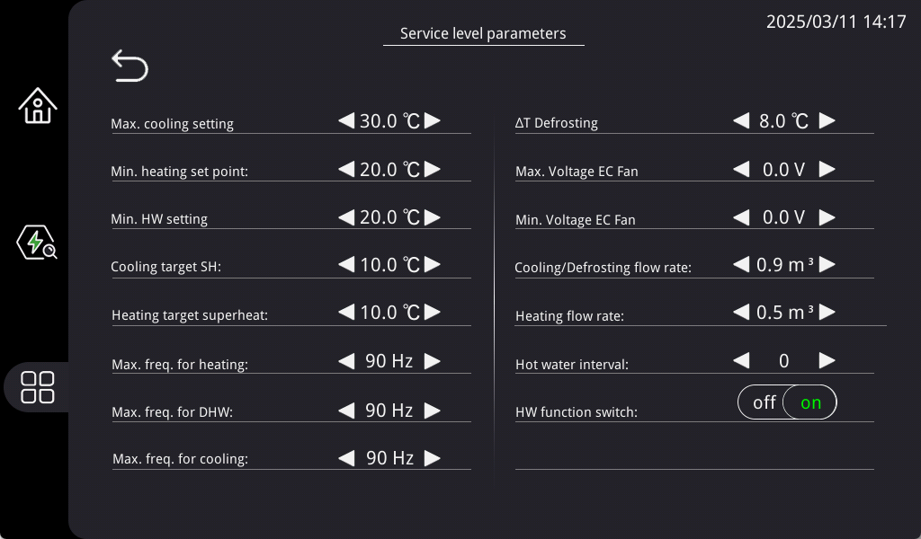
Installer would need to adjust some parameter value to let the unit run in the best conditions.

20 Factory Level Parameters


For safety purposes, accessing the factory level parameter settings requires a password. Only authorized personnel can modify these settings within the factory configuration interface.

21 Pump Settings


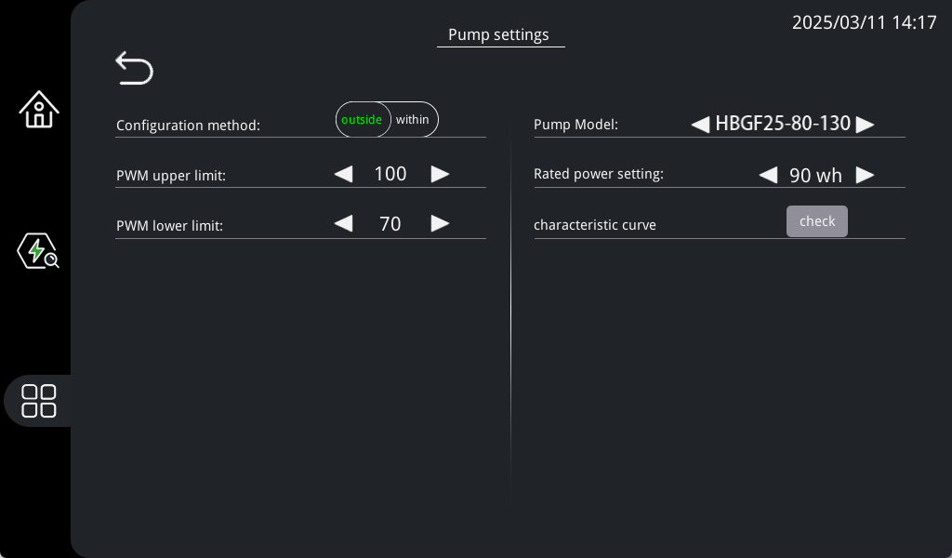

21.1 Pump Models
There are seven available pump models: APE25-8-130L, APF25-8-130E, APF25-10-130E, APF25-12-130E, HBF25-105-130, HBGF25-80-130, HBGF25-125-130, UPMF20-125-PCI.

21.2 Pump Configuration
Pump configuration options include: outside/ within

21.3 Pump PWM Upper Limit
Specifies the maximum output value of the pump.
Default: 100%
Adjustable Range: 10%–100%

21.4 Pump PWM Lower Limit
Specifies the minimum output value of the pump.

Default: 70%
Adjustable Range: 10%–100%

22 SG-Ready Function


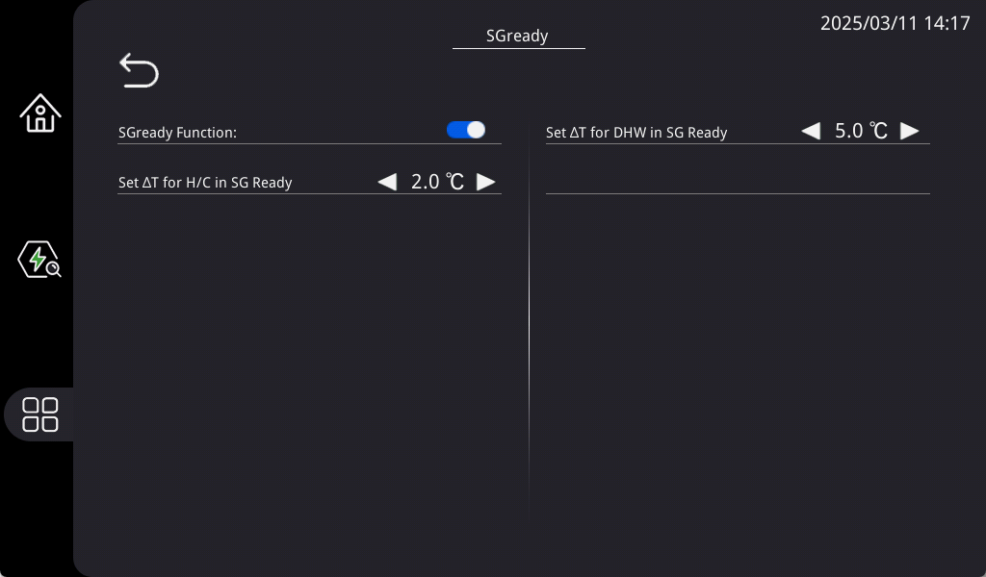

22.1 SG-Ready Function
The SG-Ready label, issued by the German Heat Pump Association, identifies heat pumps with customized interfaces capable of grid load management. This enhances grid utilization, contributing to the efficient and economical operation of grid infrastructure.

22.2 SG Heat/Cool Temperature Range
When grid load is low and the SG function is activated:
Heating: Target temperature is adjusted by adding the SG heating range. If the adjusted value exceeds the maximum heating setting, the system operates at the maximum heating setting.
Cooling: Target temperature is adjusted by subtracting the SG cooling range. If the adjusted value exceeds the minimum cooling setting, the system operates at the minimum cooling setting.
The startup condition is controlled based on the new target temperature.

22.3 SG Hot Water Temperature Range
When grid load is low and the SG function is activated:
Hot water is controlled based on the maximum hot water setting. After the heat pump completes heating, the electric heater raises the temperature to the target value.
The startup condition is controlled based on the new target temperature.

23 One Click Exhaust


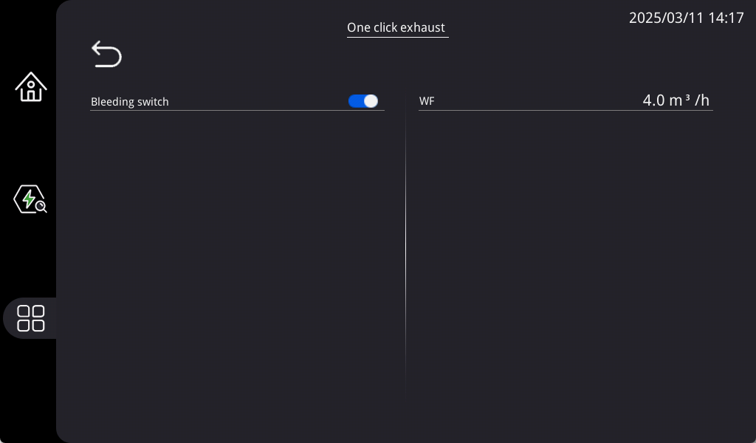

23.1 Cooling/Heating Circuit Exhaust Function Switch
When the exhaust function is activated, the system pump operates at high speed while the compressor and outdoor fan remain off. This ensures that no air remains in the water circuit, as air presence can reduce water flow. Excessive air can trigger a water flow fault (Fault Code: AL17) and degrade heating or cooling performance.

23.2 Domestic Hot Water Circuit Exhaust Function Switch
The one click exhaust for the domestic hot water circuit operates similarly to the cooling/heating circuit. Excessive air in the hot water pipes reduces the effective flow area, leading to decreased hot water flow, air blockages, and an inability to reach the target temperature.

23.3 Automatic Exhaust Time Setting
Specifies the duration for each exhaust operation.

24 Installation Configuration


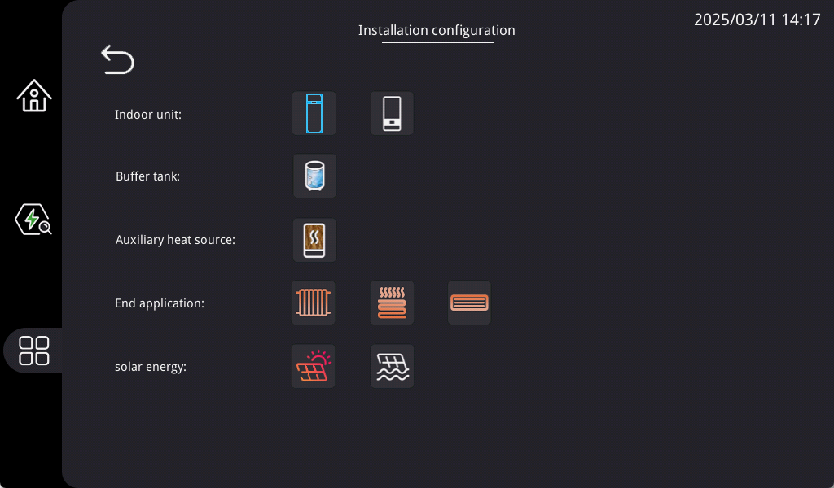

25 System Configuration



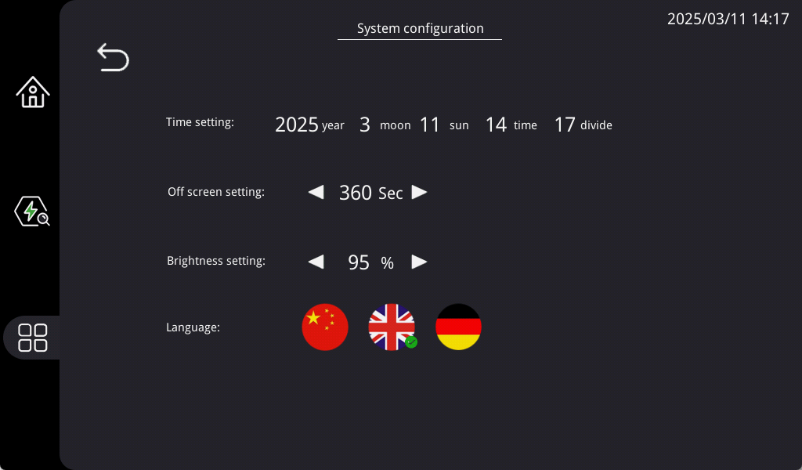

25.1 Time Setting
Configure the RTC (Real-Time Clock) to ensure accurate timing. Users must set the local time after the initial installation. RTC time settings are critical for features like hot water scheduling, vacation mode, and night mode timing.

25.2 Off Screen Setting
To extend the screen's lifespan and minimize unnecessary display activity, an off screen timer can be configured.
Users can define the screen sleep duration within a range of 30–180 seconds.
Default setting: 60 seconds.

25.3 Brightness Setting
Adjust the screen's backlight brightness to match user preferences.
Brightness adjustment range: 20%–100%.
Default setting: 90%.

25.4 Language Settings
The system supports five language options: English, German

26 App. control setup
Heat pump app control:
Tuya app install
You can download the App by searching “Tuya Smart” in mobile app stores or scanning the following QR code for Android system.


1.Click “Register” and read the Privacy Policy after it pops up. Click “Agree” and enter the registration page.
2.You can use email or mobile number as your account to register.
3.Enter the verification code and turn to the password setting page. Set your password as required and click “Done”.

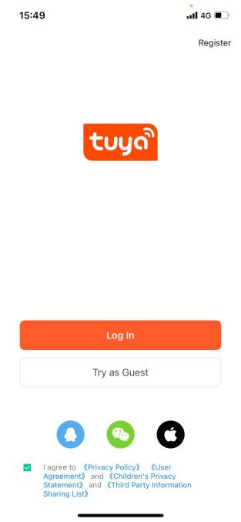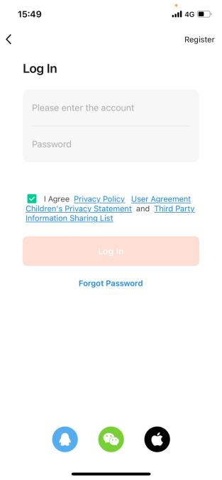

4.Open the "Tuya Smart" app, tap the "+" icon in the upper-right corner, select"Add Device", then choose"Smart Heat Pump (Wi-Fi)"under the "Large Appliances"category.

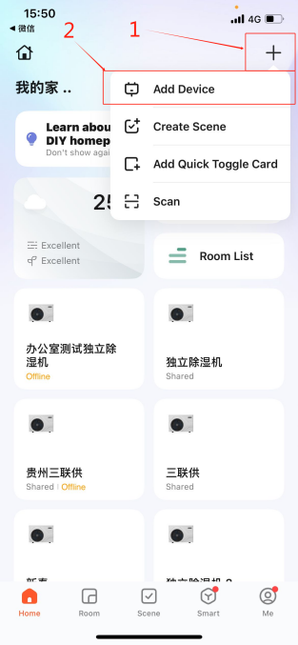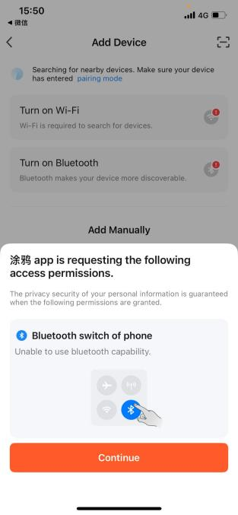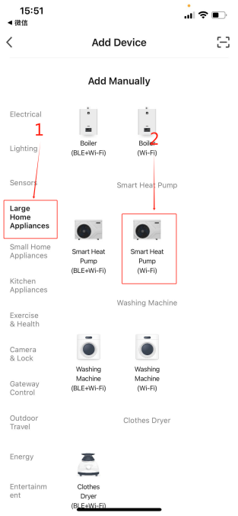

5.Enter your Wi-Fi network name (SSID) and password, then tap"Next".Tap "Confirm Indicator Blinking"to verify device is in pairing mode.

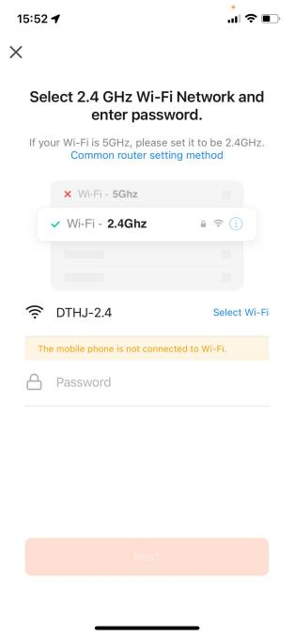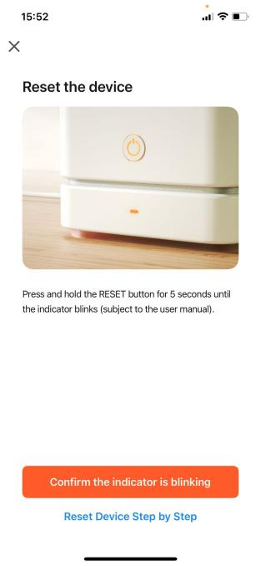
Note: Youmust select a 2.4GHz Wi-Fi network, otherwise the connection will fail.
6.Select "Slow Blink", then tap"Go to Connect".
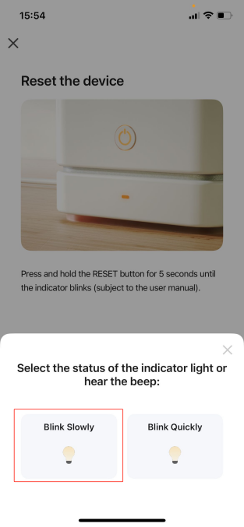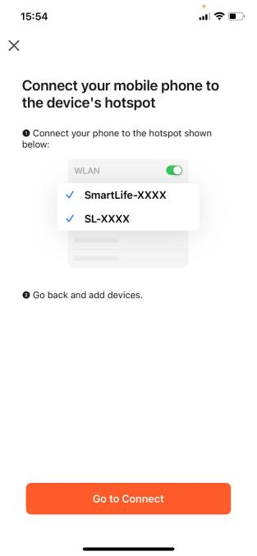

7.After successful Wi-Fi connection, a pop-up notification will appear. Upon completion, a  indicator in the top-right corner will confirm the connection.​
